.NET Core | Architecture, performance, scalability
Web APIs | Security, versioning, real-world design
Angular (v12–18) | Change detection, RxJS, performance
Database | Query optimization, indexing, transactions
Azure | Real usage (not just definitions)
CI/CD | End-to-end pipelines
Docker | Practical container usage
System Design | High-level thinking
t | Leadership, decision-making
❗ They don’t want definitions — they want “how you used it in production”.
Self-Introduction:
“I am Nirmala, thanks for giving me this opportunity. I am a Full-Stack .NET developer with 6.7 years of experience in designing, developing, and maintaining enterprise applications.
My primary expertise is in C#, ASP.NET Core, Web API, and SQL Server, and I have strong experience building scalable backend systems.”
“On the frontend, I have worked with Angular for building responsive and modular UI applications. I focus on clean architecture, reusable components, and performance optimization.”
“I have good experience with microservices, RESTful APIs, and asynchronous programming. I have worked on performance tuning, caching strategies, and handled production issues during peak traffic.”
“I regularly work with Git, CI/CD pipelines, Docker, and cloud environments like Azure. I understand the importance of logging, monitoring, and security in real production systems.”
“Apart from development, I actively participate in code reviews, mentor junior developers, and contribute to design discussions. I believe in writing clean, maintainable code and making decisions based on scalability and long-term impact.”
“I am looking for a role where I can contribute technically, take ownership of features, and help the team build reliable and high-quality software.

Raptor Work Management Architecture:
The Raptor Work Management Platform is an enterprise-scale, multi-tenant tax compliance system built on .NET 8 using a microservices architecture. It manages the entire lifecycle of tax work items—from creation through filing and payment—serving multiple clients with complete data read. Let me walk you through the key architectural components."
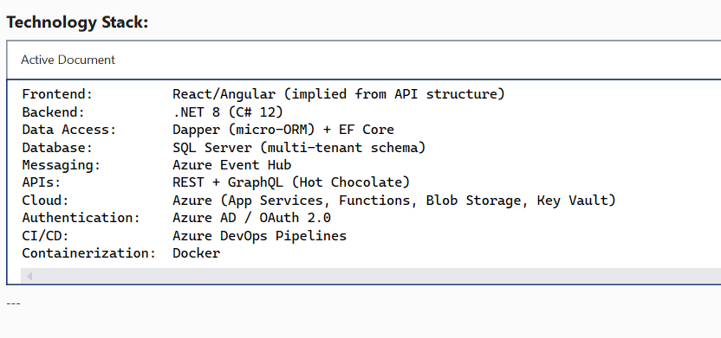
Microservices Architecture - We have six primary microservices, each owning its own bounded context. Each service is independently deployable to Azure App Services,
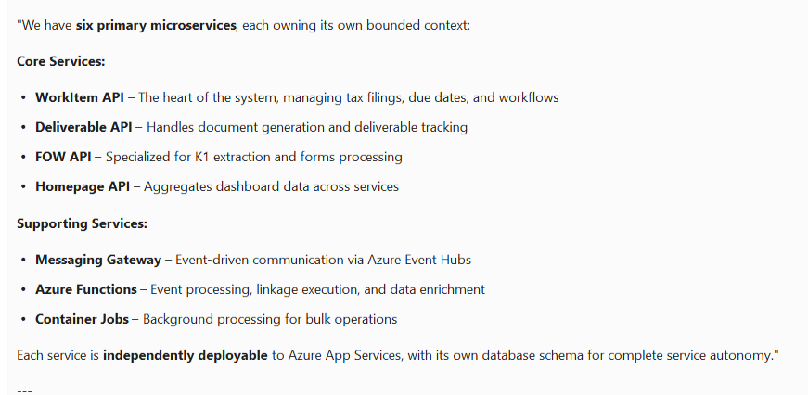
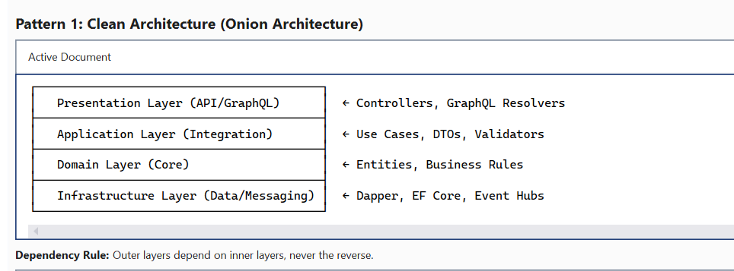
We follow clean architecture with strict dependency rules—domain layer has zero infrastructure dependencies

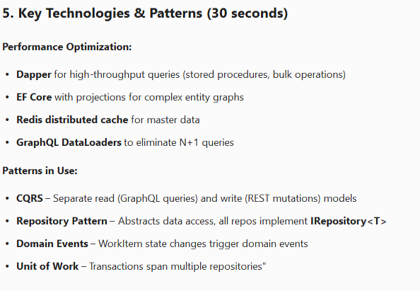

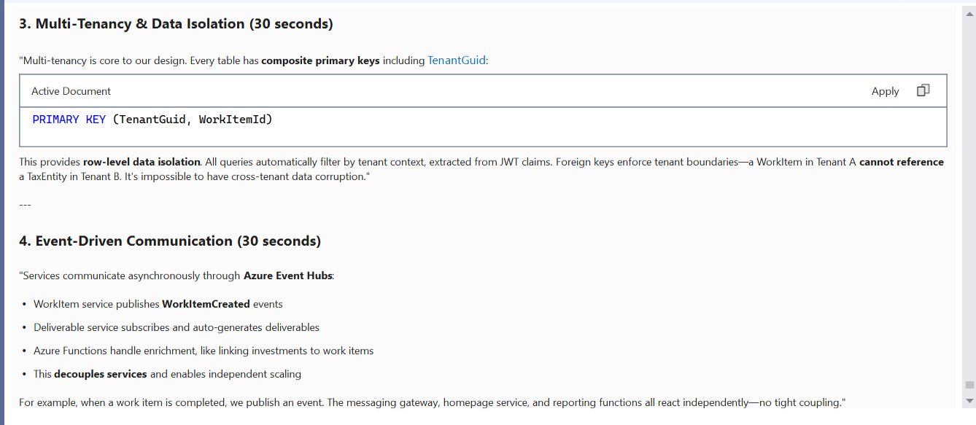

The latest stable version of C# is *📌 C# 13.0 — released with .NET 9.0 in 2024

How is .NET Core different from .NET Framework, and why is it preferred now?
“.NET Framework and .NET Core differ mainly in terms of platform support, architecture, performance, and future readiness.
.NET Framework was designed primarily for Windows-based, monolithic applications and works well for legacy systems like WebForms or heavy WCF services. However, it is now in maintenance mode, with no major new features being added.
.NET Core, on the other hand, was introduced to support modern application development. It is cross-platform, runs on Windows, Linux, and macOS, and is optimized for cloud and microservices architectures. Its modular design allows applications to carry only the required dependencies, enabling side-by-side versioning and faster deployments.
From a performance perspective, .NET Core is significantly faster due to an optimized Garbage Collector, JIT compiler, and Kestrel web server, which also helps reduce cloud infrastructure costs.
Another key advantage is built-in dependency injection, middleware pipelines, and environment-based configuration, which promote clean architecture and better testability.
Today, Microsoft’s clear direction is that all new development should be done on modern .NET, formerly known as .NET Core, while .NET Framework is mainly used for maintaining existing legacy applications.”

**********************************************************************************Explain Dependency Injection in ASP.NET Core. How have you used it?
Dependency Injection is an Inversion of Control (IoC) pattern where dependencies are provided to a class rather than the class creating them. This promotes:
- Loose Coupling: Classes don't create their dependencies
- 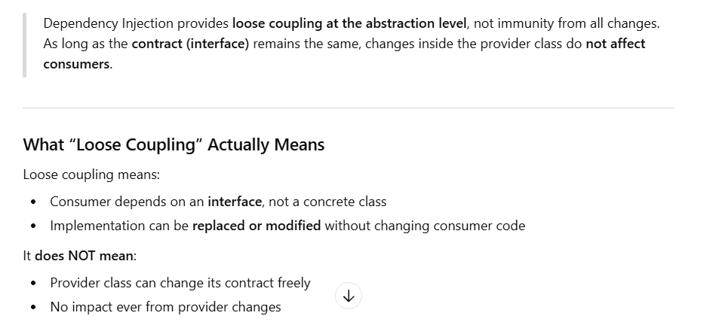
- Maintainability: Changes to dependencies don't require changes to consuming classes
- Lifecycle Management: Container manages object creation and disposal.
public void ConfigureServices(IServiceCollection services)
{
// Transient by default - new Instance every time
email service, validation service, and token generation service. These services do not maintain any internal state and operate purely on input parameters
services.AddHttpClient();
// Singleton - Created once, shared for application lifetime. • Single instance for entire app Shared across all requests .
MemoryCache, Configuration, Logging service

We use Singleton for stateless services or services that are expensive to create and are thread-safe. In our project, IMemoryCache is singleton because it's designed to be thread-safe and shared across all requests."

services.AddSingleton<IMemoryCache, MemoryCache>();

// Scoped - Created once per HTTP request - One instance per HTTP request
Shared across that request
Ex. dB Context, Repository, Business services.
services.AddScoped<IAppSettingsCache, AppSettingsCache>();
services.AddScoped<IClientDetails, ClientDetailsRepository>();
services.AddScoped<ICacheService, CacheService>();

// DbContext with scoped lifetime and resilience configuration. DbContext must be scoped because it's not thread-safe and tracks entity changes. If it were singleton, concurrent requests would corrupt the change tracker.
services.AddDbContext<CatalogDBContext>(options =>
options.UseSqlServer(Configuration["ConnectionStrings:CatalogDbConnection"], opts =>
{
opts.CommandTimeout(Convert.ToInt32(Configuration["CommandTimeout"]));
opts.EnableRetryOnFailure(
maxRetryCount: 2,
maxRetryDelay: TimeSpan.FromSeconds(30),
errorNumbersToAdd: [10053]); // SQL connection error
}), ServiceLifetime.Scoped);

// Hosted Service - Background service
services.AddHostedService<ClientDetailsService>();
}
*****************************************************************************
What DI lifetime bugs have you seen in production?/ What are common DI anti-patterns?
anti-patterns : means commonly used solution that looks correct but actually causes problems — bugs, poor performance, hard maintenance, or untestable code.
Common bug is injecting scoped dependencies into singleton services, causing stale context or runtime failure.Lifetime mismatch violates container constraints and thread safety assumptions.
Service Locator — injecting IServiceProvider and resolving from it manually. It hides dependencies, makes tests hard, and breaks the whole point of DI.
Captive dependency — registering a Singleton that depends on a Scoped or Transient service. This is critical because the Singleton captures the first instance forever, leading to disposed-context exceptions and per-request data leaking across all requests.
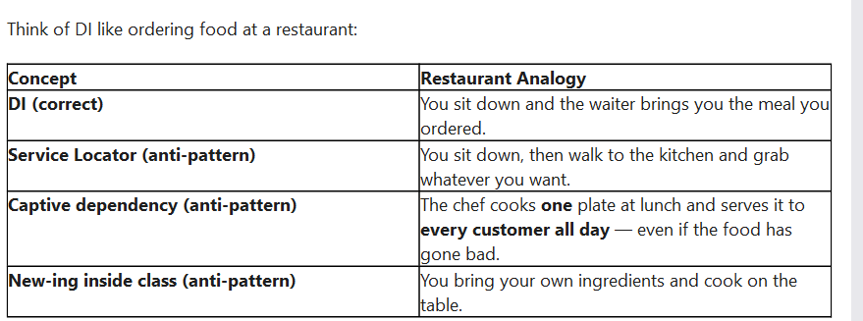
**************************************************************************
How does dependency injection work internally?
Internally, .NET Core’s DI container stores service registrations as service descriptors in the IServiceCollection. When the ServiceProvider is built, it compiles resolution logic for performance.
During runtime, when a service is requested, it recursively resolves constructor dependencies to build the object graph.
Lifetimes like Singleton, Scoped, and Transient are managed using internal dictionaries and scopes, where a new scope is created per HTTP request.

"We use a modular monolith architecture where each domain (WorkItem, Homepage, Deliverable) has its own startup class that registers its dependencies. This gives us microservices-like separation without the deployment complexity. Each module can be extracted to a separate service later if needed."

"We use AutoMapper with Expression Mapping which translates our mapping configuration into LINQ expressions. This means projections happen at the SQL level, not in-memory - significantly reducing data transfer and memory usage."

We use IHttpClientFactory to avoid socket exhaustion. Creating HttpClient with using statement doesn't dispose the underlying TCP connection immediately, leading to port exhaustion under load. The factory manages connection pooling for us."
"We use feature management for gradual rollouts. When we release a new feature, we enable, monitor metrics, then gradually increase. If issues arise, we can disable it instantly without redeployment."

"Health checks are crucial in our Azure Kubernetes deployment. AKS uses liveness probes to restart unhealthy pods and readiness probes to control traffic routing. We check database connectivity, external API availability, and cache health."
Critical Order Rules:
- Exception Handling First: Catches all downstream exceptions
- HTTPS Before Routing: Redirect to HTTPS before processing route
- CORS After Routing: Needs route information
- Authentication Before Authorization: Must authenticate before checking permissions
- Authorization Before Endpoints: Check permissions before executing controller
""Middleware order is critical. Exception handling comes first to catch all errors, authentication before authorization, and CORS after routing. We use conditional middleware with UseWhen for performance optimization."

We use URL path versioning because it's explicit and cacheable. Each version has its own Swagger document. When we deprecate a version, we mark it in Swagger and add a warning header, but keep it functional for 6 months to give clients time to migrate."

"Security is layered: Managed Identity for Azure, CORS for origin control, security headers for browser protection, and conditional Anti-XSS middleware for user input endpoints."
Middleware Pipeline Architecture
public void Configure(IApplicationBuilder app, IApiVersionDescriptionProvider provider)
{
// 1. Developer-specific
if (_WebHostingEnvironment.IsDevelopment())
app.UseDeveloperExceptionPage();

// 2. Azure App Configuration
app.UseAzureAppConfiguration();

// 3. HTTPS enforcement
app.UseHsts();
app.UseHttpsRedirection();

// 4. Routing
app.UseRouting();

// 5. CORS
app.UseCors(...);

// 6. Security headers
app.Use(async (context, next) => { /* headers */ });

// 7. Exception handling
app.UseMiddleware<ExceptionHandlerMiddleware>();

// 8. Module-specific middleware
this._WorkItemApi.Configure(app, this._WebHostingEnvironment);

// 9. Authentication/Authorization context
app.UseRaptorTokenMiddleware();
app.UseMiddleware<UserContextMiddleware>();
app.UseMiddleware<RaptorRoleContextMiddleware>();

// 10. Conditional middleware
app.UseWhen(context => context.Request.Path.Value.Contains("/api/clients/"),
appBuilder =>
{
appBuilder.UseMiddleware<RaptorClientContextMiddleware>();
appBuilder.UseMiddleware<AntiXssMiddleware>();
});

// 11. Swagger (conditional)
if (this.useSwagger) { /* ... */ }

// 12. Performance monitoring
app.UseMiddleware<ResponseTimeMiddleware>();

// 13. Authorization
app.UseAuthorization();

// 14. Endpoints
app.UseEndpoints(...);
}

**********************************************************************************Exception Handling in ASP.NET Core Web APIs - Deep Dive Analysis
// From Startup.cs - Middleware Pipeline
app.UseMiddleware<WorkManagement.Middleware.ExceptionHandlerMiddleware>();
Position in Pipeline: Placed early (after UseAzureAppConfiguration, before routing) to catch all downstream exceptions.
Try-Catch Block Around Entire Pipeline
Also has Domain-Specific Exceptions: // Work Item-related , task, notes, related,
Auth, validation exception
Consistent Error Response Structure
{
"Guid": "tracking-guid-for-support",
"Reason": "Detailed developer-friendly error message",
"ShortMessage": "User-friendly error message",
"ErrorCode": 1001
}
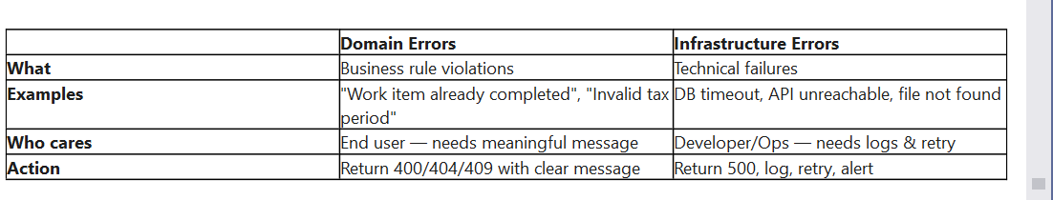
Domain errors should be predictable and mappable; infra errors may be transient and require resilience patterns.
Are we using Serilog?"
"No, we're not using Serilog. We use a custom logging abstraction called ILogHelper<T> from the EY Utils library (EY.TTT.Raptor.Utils.Logger). This provides several enterprise-specific features:
1. PII Sanitization: All logging methods like LogErrorSanitized() automatically scrub personally identifiable information before logging. This is critical for GDPR compliance and ensures logs can be shared with external support teams without exposing sensitive user data.
Why not Serilog? While Serilog is excellent for flexibility and multiple sinks, our custom ILogHelper is pre-configured for EY's enterprise security policies, has built-in PII scrubbing, and is standardized across all EY Raptor projects. It reduces configuration burden and ensures compliance out of the box."

1. Why Middleware vs. Filters?
Your Answer:
"We use middleware for global exception handling because it sits early in the pipeline and catches exceptions from all downstream components including routing, authentication, and authorization. Exception filters only catch exceptions from controller actions, missing errors in middleware, routing failures, or authentication issues. Our middleware approach provides complete coverage."
Why async/await improves scalability.
Async/await improves scalability by freeing up threads during I/O waits.
Instead of blocking a thread while waiting for I/O (database, HTTP, file system), the thread is returned to the thread pool and reused to serve other requests.
This allows the application to handle more concurrent requests with the same number of threads, which is critical in high-traffic, cloud-based systems.
*************************************************************************************
if we writing a method with async is await is mandeorty please explain differenet scenario?
No, await is not mandatory — but if you skip it, the method runs synchronously and the compiler gives you a warning.
There are three key scenarios: First, for simple pass-through methods, I skip async/await and return the Task directly to avoid state machine overhead.
Second, I always use async/await when there's a try-catch, using block, or multiple async calls — because without it, exceptions aren't properly caught and resources aren't properly disposed.
Third, I never use async void except in event handlers — it's dangerous because exceptions become unobservable and can crash the process.
For parallel operations, I start all tasks first and then await Task.WhenAll to run them concurrently."

*****************************************************************************************
How do you design a high-performance Web API?
“When I design a high-performance Web API, I focus on architecture, scalability, and efficient resource utilization rather than just fast code.
First, I start with a clean and well-defined API contract. I follow REST principles, use correct HTTP verbs and status codes, and apply proper versioning. A clear contract avoids unnecessary retries, reduces client misuse, and directly impacts performance.
From an architecture perspective, I always design stateless APIs. Authentication is token-based, usually using JWT, which allows the API to scale horizontally behind a load balancer. I ensure the entire request pipeline is asynchronous and non-blocking, using async and await end-to-end and avoiding blocking calls, which significantly improves throughput under high concurrency.
The most critical part of performance is data access. I optimize database queries by using proper indexing, pagination, and avoiding over-fetching. For read-heavy operations, I use AsNoTracking in Entity Framework Core or even Dapper for high-performance scenarios. I also actively avoid N+1 query problems and use projections to fetch only required fields.
Caching plays a major role in improving performance. I apply a multi-level caching strategy, including in-memory caching for frequently accessed data, distributed caching like Redis for shared data across instances, and HTTP caching headers such as ETag and Cache-Control to reduce repeated calls.
To optimize network usage, I keep payloads lean using DTOs, enable response compression like Gzip, and use efficient JSON serialization. Security is implemented carefully using OAuth or JWT with minimal claims, along with rate limiting to prevent abuse without affecting valid users.
For scalability and resilience, I design APIs to run in containers and scale horizontally. I use resilience patterns such as retries with exponential backoff, circuit breakers, and timeouts to handle downstream failures gracefully.
Finally, I strongly believe that performance is not complete without observability. I implement structured logging, metrics, and distributed tracing to monitor latency, error rates, and throughput. I also validate performance using load and stress testing tools. Overall, designing a high-performance API is a continuous process of measurement, optimization, and improvement.”*
What is Kestrel and how does hosting work?
Kestrel is the default cross-platform HTTP server in ASP.NET Core / .NET 8.
It handles HTTP/1.1, HTTP/2, and HTTP/3 natively, supports TLS, and runs on Linux, Windows, and macOS — perfect for containers and cloud-native deployments.
The hosting model in .NET 8 is the Generic Host wrapped by WebApplication. When I write WebApplication.CreateBuilder(), the framework sets up the configuration system, the DI container, the logging providers, the lifetime management, and Kestrel as the web server — all in one place.
The request flow is straightforward — Kestrel listens on a TCP socket, parses incoming HTTP requests using System.IO.Pipelines to avoid memory copies, builds an HttpContext, and dispatches it through the middleware pipeline
********************************************************************************** Request Lifecycle in ASP.NET Core – 3-Minute Spoken Answer (8+ Years)
“In ASP.NET Core, the request lifecycle is based on a middleware pipeline model, which gives fine-grained control over how an HTTP request is processed.
When a request comes in, it is first received by the Kestrel web server, which is the cross-platform, high-performance server used by ASP.NET Core. Kestrel forwards the request into the ASP.NET Core pipeline.
The request then flows through a series of middlewares, configured in the Program.cs file. Each middleware can perform actions before and after the next middleware is executed. Common middlewares include exception handling, HTTPS redirection, routing, authentication, authorization, and logging.
One of the early stages is exception handling middleware, which captures unhandled exceptions and ensures consistent error responses. After that, routing middleware analyzes the incoming request and matches it to a specific endpoint based on the URL and HTTP verb.
Once routing identifies the endpoint, authentication middleware validates the user identity, typically using JWT or cookies. Then authorization middleware checks whether the authenticated user has permission to access the requested resource.
After authorization succeeds, the request is passed to the endpoint execution stage, which usually means an MVC controller or a Minimal API handler. At this point, model binding occurs, where data from the request—such as route values, query strings, headers, and request body—is mapped to action method parameters.
Before the action executes, filters like action filters, authorization filters, and exception filters can run. These allow cross-cutting concerns such as validation, logging, or custom authorization logic.
The controller action or endpoint then executes the business logic, often calling services and repositories. The result is returned as an IActionResult or object, which goes through result execution, including formatting and serialization, typically to JSON.
The response then travels back through the middleware pipeline in reverse order, allowing middlewares to modify the response—for example, adding headers or logging response details—before Kestrel sends the final HTTP response back to the client.
One-Line Senior Summary (Very Impressive in Interview)
“ASP.NET Core processes requests through a configurable middleware pipeline, where each middleware can inspect, modify, or short-circuit the request and response before the endpoint executes.”

Concurrency Handling in .NET/ How did you handle high concurrent traffic in a .NET Core API?
In our Raptor Work Management API, we handle concurrency at multiple architectural layers to ensure both performance and data integrity.
starting with the database layer, we use Entity Framework Core with Scoped lifetime for our DbContext. This is critical because DbContext is NOT thread-safe. Each HTTP request gets its own context instance, which prevents concurrent threads from corrupting the change tracker. If we used Singleton lifetime, concurrent requests would cause race conditions and data corruption, memory leaks.
For async operations, we follow async/await patterns throughout the entire stack - from controllers down to repositories. This allows us to achieve 100x better scalability compared to synchronous blocking code because threads are released back to the thread pool during I/O operations instead of blocking.
For distributed concurrency, we use message queues through our MessagingGateway component, which decouples operations and provides at-least-once delivery guarantees. This is crucial for handling high-volume concurrent operations without overwhelming downstream systems.
At the caching layer, we use IMemoryCache as a Singleton with thread-safe operations. We also have a background hosted service that pre-warms the cache on startup, eliminating cache stampede scenarios where multiple threads simultaneously try to populate the same cache entry.
*******************************************************************************
Handling Pool Exhaustion & Leaks/How do you prevent thread pool starvation?
- Scoped DbContext:
- using var scope ensures scope disposal
. Explicit Timeout Configuration
Mitigation - Retry Logic:
Mitigation - Explicit Pool Configuration: : We can configure connection strings with explicit pool sizes: Max Pool Size=50 for tenant databases, Min Pool Size=5 to pre-warm, and Connection Lifetime=300 seconds to recycle connections. This prevents indefinite connection retention.

"SQL Server connection pooling allows 1000 concurrent requests to share ~100 pooled connections instead of creating 1000 new connections, with automatic retry logic for transient deadlocks.
"Server=...;Database=...;Min Pool Size=10;Max Pool Size=100;Pooling=true"
"Connection pooling is essential for handling concurrent load:
How it works:
"In our Raptor Work Management API, connection pooling is enabled by default through ADO.NET's SQL Client.
Current Configuration: Our connection strings don't explicitly specify pooling parameters, which means we're using the ADO.NET defaults: Pooling=true, Min Pool Size=0, and Max Pool Size=100.
How it works:
Each unique connection string gets its own pool
With our multi-tenant architecture, we have separate pools for:
Catalog database (metadata)
Each tenant's database (100+ separate pools)
Scoped DbContext lifetime means each HTTP request gets a fresh DbContext, but the underlying SQL connection is borrowed from the pool
When DbContext is disposed, the connection returns to the pool for reuse
Concurrency handling: Under 1000 concurrent requests across 100 tenants, each tenant's pool handles ~10 concurrent connections. The default max pool size of 100 provides plenty of headroom.
Recommended improvement: I would make the pooling configuration explicit with:
- Min Pool Size=2 for tenant databases (pre-warm connections)
- Max Pool Size=30 to limit per-tenant resource usage
- Connection Lifetime=300 seconds for periodic connection recycling
This would reduce the total potential connection count from 10,000 (100 tenants × 100 max) to 3,000 (100 tenants × 30 max) while still handling typical load patterns effectively.
Monitoring: We can track pool health through Application Insights custom metrics and ADO.NET performance counters to identify pool exhaustion or connection leaks."

Prevention - Scoped DbContext: We use Scoped lifetime for all DbContext instances, which ensures automatic disposal at the end of each HTTP request. The using statement pattern or dependency injection container automatically returns connections to the pool.
Detection - Health Checks: We've implemented CatalogDatabaseConnectionCheck that probes the database. If the health check starts failing with timeout errors, it's a strong indicator of pool exhaustion. We can enhance this with pool statistics monitoring.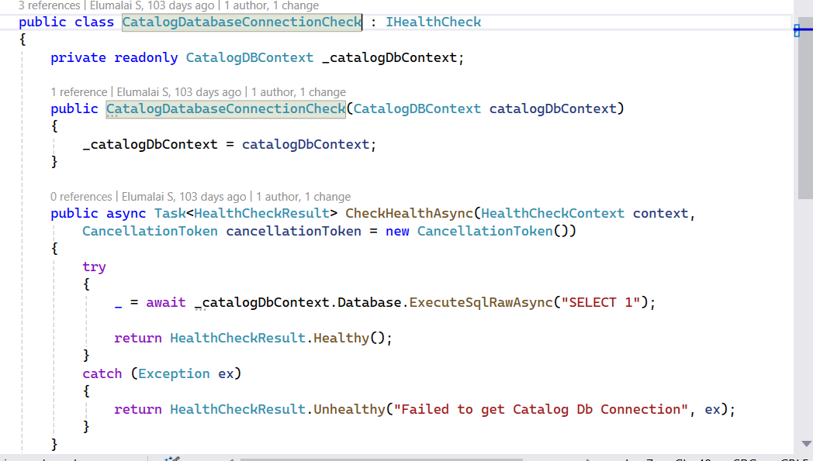

Describe a production performance issue you handled in a .NET API
“One significant production performance issue I handled was related to Entity Framework Core service provider exhaustion, which surfaced only in PROD under real user load.
After deployment, we started seeing errors originating from EF Core with a warning called ManyServiceProvidersCreatedWarning, which was getting promoted to an error in our environment. The warning indicated that EF Core had created more than 20 internal IServiceProvider instances, which can lead to serious performance degradation.
The root cause was tied to our GraphQL DbContext, where we had implemented a custom options extension to support both multi-tenant and single-tenant clients using the same DbContext. This extension injected client-specific values like tenant identifiers at runtime. While EF Core does cache service providers, in production we had many active tenants simultaneously, which resulted in too many unique DbContext option combinations, exhausting EF’s internal service provider cache.
This issue did not appear in QA or UAT because those environments never had enough concurrent tenant variations to cross the threshold. Production traffic patterns exposed the real scalability issue.
To fix this, we redesigned how EF Core cached its models by implementing a custom IModelCacheKeyFactory. Instead of creating a unique EF model for every request, we ensured that:
A unique EF Core model per tenant is compiled and cached. The cache key is deterministic and based on TenantGuid (tenant identity), ensuring:
- Each tenant's model has tenant-specific global query filters (WHERE TenantGuid = @TenantGuid)
- Models are cached and reused across requests for the same tenant
- Data isolation is guaranteed—tenants cannot access each other's data
- Performance is optimized—model compilation happens once per tenant, not per request"
This significantly reduced the number of internal service providers created by EF Core, stabilized memory usage, and eliminated the warning in production without suppressing it.
How do you handle breaking changes in APIs?
In production systems, I handle breaking changes through proper API versioning and backward compatibility.
feature flags can be used to manage breaking changes, but they do not replace API versioning.
Feature flags are best suited cffor controlling behavior or gradual rollout, not for changing API contracts.
For example, we use feature flags to enable new logic, change validation rules, or introduce optional response fields. This allows us to test changes safely and roll back instantly without redeployment.
However, if a change breaks the request or response contract—like removing a field or changing its type—we still use proper API versioning. Feature flags alone can’t protect external consumers from contract breaks.
what is means stateless API
A stateless API means the server does not store any client session or request state between requests.
Each request is independent and contains all the information required to process it, such as authentication tokens, request data, and headers.
Because the server does not rely on previous requests, any instance of the API can handle any request. This makes the system easier to scale, especially in cloud and load-balanced environments.
Where do you store state if the API is stateless?
any state that needs to be preserved is stored outside the API in external systems.
Type of State | Where It’s Stored
Authentication | JWT / OAuth tokens
User & business data | Database (SQL / NoSQL)
Temporary / fast access | Distributed cache (Redis)
Workflow / async tasks | Message queues
Configuration & secrets | Azure App Config / Key Vault

Describe a SQL performance issue you handled.
“We faced a SQL performance issue with our global search functionality.
The search was implemented across too many fields spanning multiple related tables, including filing details, taxonomy, payment details, legal entities, and user information.
Because of the extensive joins and text searches across so many columns, the query was causing performance degradation and occasionally failing during execution, especially under load.
To address this, I analyzed the query execution plan and identified that the multiple joins and string concatenations were preventing efficient index usage and leading to table scans.
We redesigned the search strategy by limiting the global search to a smaller set of high-value, frequently used fields such as WorkItemId, WorkItemName, OverallStatus, Entity details, and Assigned User.
This significantly reduced join complexity and improved index utilization.
On the UI side, we added a tooltip to clearly communicate which fields were included in the global search to manage user expectations.
After this change, query execution time improved dramatically, system stability increased, and the intermittent query failures were eliminated.”

Transaction Handling in .NET
we manage transactions in our Raptor Work Management platform, which is a production system handling complex deliverable creation workflows.
we uses the Unit of Work pattern implemented through the IUnitOfWork interface. This gives us explicit control over transaction boundaries, which is critical when dealing with complex business operations that span multiple repositories and aggregate roots.
Let me explain with a real example from our codebase. When creating deliverables in bulk, we have a sophisticated pipeline that processes multiple items, validates data, creates aggregate roots, and updates tracking records.
First, we explicitly begin a transaction using await _unitOfWork.BeginTransactionAsync(). This is important because we're not relying on EF Core's implicit transaction behavior. We need fine-grained control because our operation involves multiple steps that must all succeed, or all fail together.
We start the transaction, then create an upload tracking record to mark the operation as "Processing". Next, we iterate through items, creating deliverable aggregates for valid items and collecting validation errors for invalid ones. After processing, we persist the aggregates using AddRangeAsync, which stages them in EF Core's change tracker.
Here's a critical detail: We call SaveChangesAsync to write the deliverable data to the database, and only after that succeeds do we update the upload status to "Completed" or "CompletedWithErrors". This ordering is crucial because if we marked the upload as complete but the save failed, we'd have an inconsistent state. Our unit tests actually verify this ordering to ensure we never violate this rule.
Finally, we commit the transaction with CommitTransactionAsync. This makes all changes permanent atomically. If any exception occurs at any point, we catch it and call RollbackTransactionAsync, which undoes everything - the tracking record creation, the aggregate insertions, and any status updates. This ensures data consistency.
Now, regarding isolation levels - we use ReadCommitted as our default by EF context, which prevents dirty reads while allowing good concurrency. This means other transactions can't read uncommitted data from our transaction, but they can read data we've read if they access it after us. This balances data consistency with performance under high concurrent load.
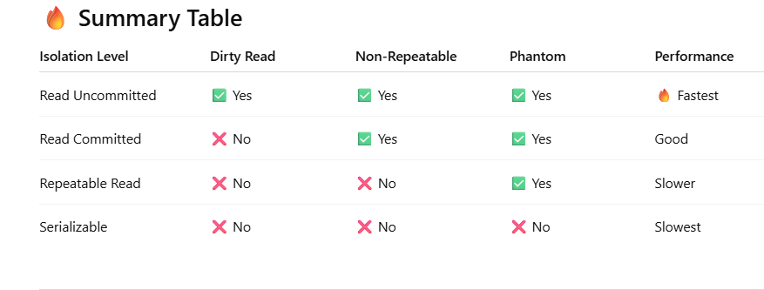
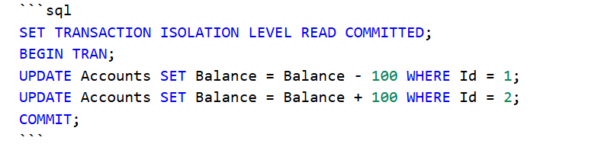
One interesting aspect of our implementation is the pipeline architecture you see in DeliverableCreationService.cs. We use Task.WhenAll to process multiple items in parallel, but the actual database transaction is sequential at the service level. This gives us parallelism for CPU-bound work like validation and business rule evaluation, while keeping database writes transactional and ordered.
An important principle we follow is transaction scope minimization. Notice how we validate requests before starting the transaction. We don't want to hold database locks while performing business rule validation or external API calls. The transaction only covers actual data mutations. This reduces lock contention and improves throughput under concurrent load.
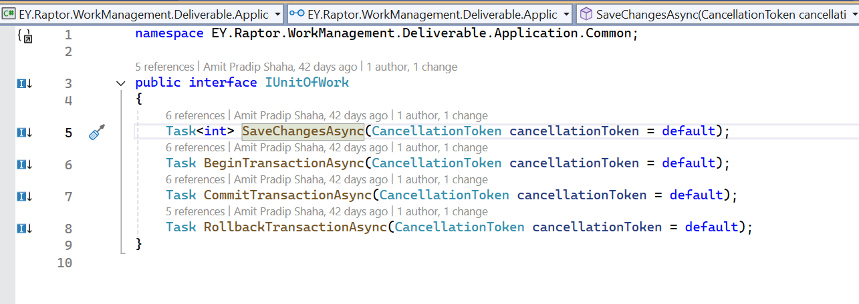
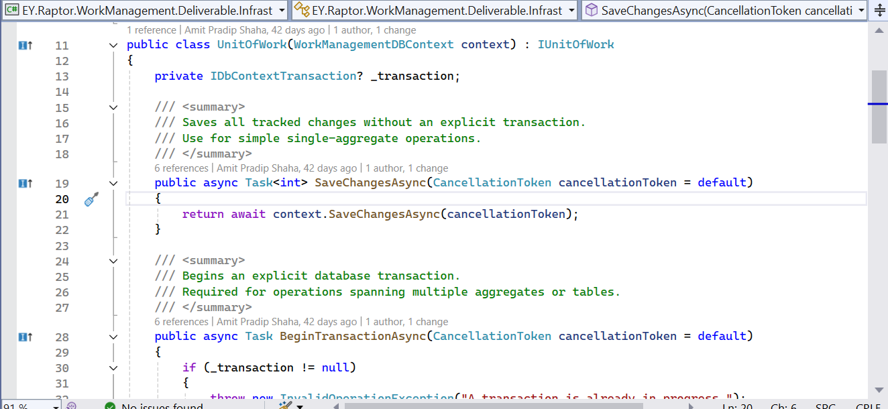

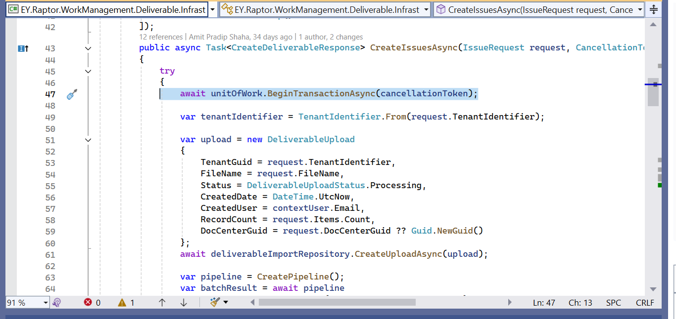

How do you ensure data consistency in distributed systems?
"We don't use distributed transactions (2PC) because they don't work well in cloud environments with HTTP APIs. Instead, we use event-driven eventual consistency with idempotent consumers and retry logic."
We use strong consistency within bounded contexts through explicit transactions and Unit of Work, but eventual consistency across services via Event Hub. This gives us ACID guarantees where critical, with scalability where needed.
"Idempotent event consumers are critical because Event Hub guarantees at-least-once delivery. We track processed timestamps and use unique constraints to handle duplicate events gracefully.""
"Multi-tenant physical database separation gives us strong consistency per tenant with zero risk of cross-tenant data contamination, at the cost of managing 100+ connection pools."
"We publish events after transaction commits, not before. This ensures the event represents a fact that actually happened, rather than an intention that might rollback."
"Our fire-and-forget pattern with IServiceScopeFactory creates a consistency boundary - the business operation succeeds when the transaction commits, and event publishing happens asynchronously without blocking the user.

. How do you handle long-running background tasks?
we handle long-running background tasks using three distinct patterns depending on the use case:
- IHostedService for startup tasks
- Azure Functions for event-driven processing - We use Azure Functions with Event Hub triggers for processing high-volume background tasks. Our Enrichment Function processes deliverable and task events from Event Hub for reporting and analytics.
- fire-and-forget with IServiceScopeFactory for post-transaction operations- In our Issue Service, after committing a transaction that creates deliverables, we publish domain events asynchronously without blocking the HTTP response.

- Why Fire-and-Forget?
  - User gets instant response (sub-500ms)
  - Deliverable creation succeeded and committed
  - Side effects (notifications, updates) happen asynchronously
- Why IServiceScopeFactory?
  - Main request's DbContext disposed after response sent
  - Background task needs fresh DbContext with new connection
  - scopeFactory.CreateScope() gets fresh Scoped services
- Connection Pool Management using var scope –
ensures disposal
- DbContext returns connection to pool
- No connection leaks even if observer fails

Pattern 1: IHostedService for Cache Warming (Startup Task)
Our Implementation:
We use IHostedService for a critical startup task - pre-warming our client details cache. This is essential because we have a multi-tenant architecture where each tenant has its own database. On application startup, we need to load all client-to-database mappings into memory cache.
IHostedService runs once on application startup.
Blocks application startup until cache is warm - this is intentional to prevent first-request latency.
Cache Priority: NeverRemove - ensures data stays in memory
Registration:
services.AddHostedService<ClientDetailsService>();

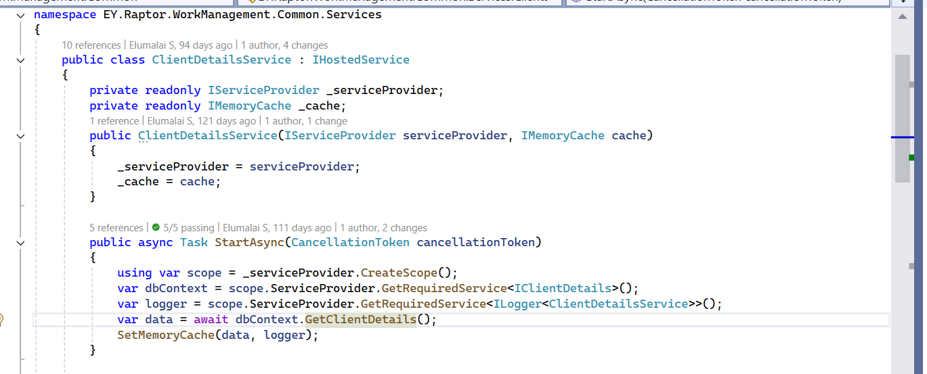

How do you handle breaking database schema changes?
In our Raptor Work Management platform, which is a multi-tenant system with 100+ tenant databases, handling breaking schema changes is critical. We use SQL Change Automation with a migration-based approach combined with backward compatibility strategies and feature flags.

We use SQL Change Automation (Redgate) with a migration-based workflow tracked in the __MigrationLog table:
We use the Expand-Contract pattern for breaking schema changes, where we first add new schema while keeping old schema working, migrate applications gradually, then remove old schema after validation.
All migrations are tracked in __MigrationLog with unique GUIDs, checksums, and sequence numbers. This prevents duplicate executions and provides complete deployment audit trail across 100+ tenant databases."
"Our migrations are idempotent with IF NOT EXISTS checks, making them safe to re-run and eliminating manual intervention on failures or database recoveries.
Feature flags control which schema version the application uses, enabling instant rollback by toggling a flag in Azure App Configuration without redeployment .
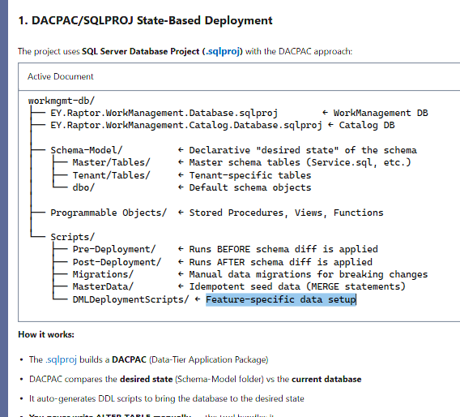
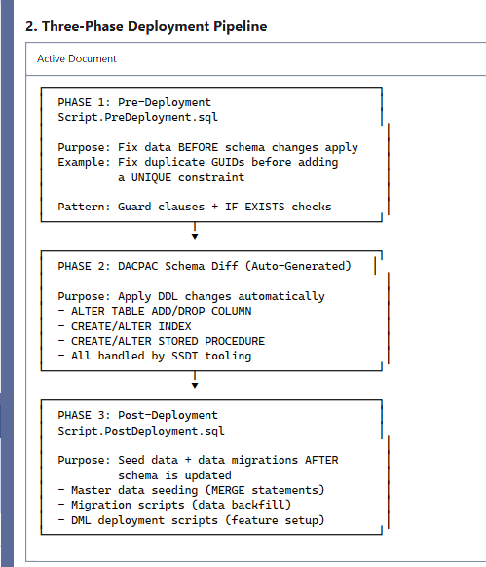
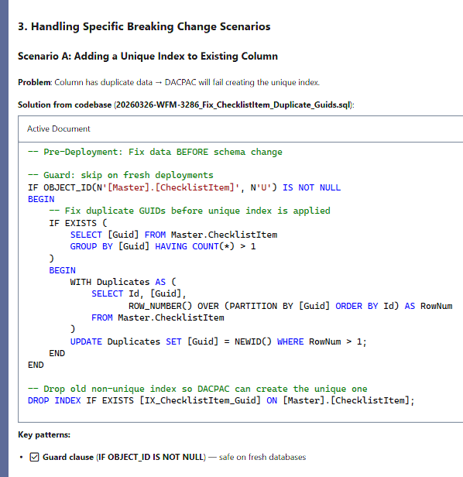

How do you secure a REST API?
we implement defense-in-depth security with multiple layers of protection. We use dual-token authentication (Azure AD JWT + Raptor custom token), role-based authorization, Anti-XSS middleware, security headers, CORS, and input sanitization.
We use dual-token authentication where Azure AD JWT proves who you are, and Raptor token determines what you can access. This separation of concerns allows us to leverage Azure AD for identity while maintaining fine-grained entity-level authorization in our custom token."
Our Anti-XSS middleware sanitizes both request body and query strings using the HtmlSanitizer library. We compare the original input with the sanitized version, and if they differ, we reject the request with a 400 Bad Request. This prevents script injection attacks at the middleware level before reaching controllers.
We use conditional middleware with UseWhen to apply Anti-XSS only to client-facing endpoints. This optimizes performance by skipping expensive sanitization for internal API calls while protecting user-input endpoints.
CORS - Origin Validation
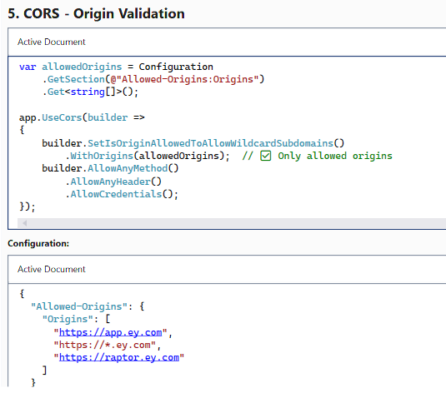
Security Headers - Browser Protection-
Security headers include HSTS with 1-year max-age,
CSP restricting resource origins,
X-Frame-Options for clickjacking prevention, and
X-Content-Type-Options to prevent MIME-sniffing attacks.

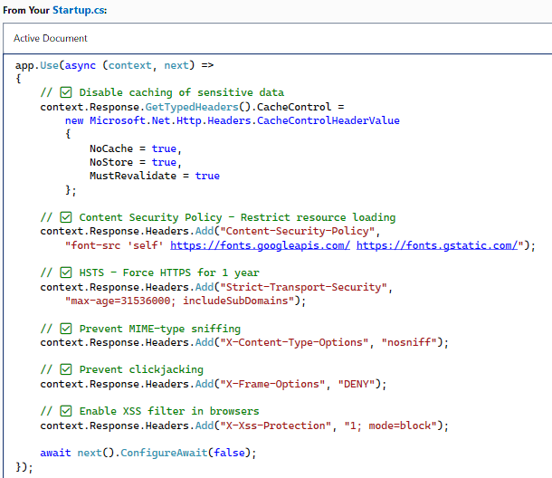
Swagger/OpenAPI Security Configuration
Middleware order is critical - HTTPS redirection comes first, then CORS, then authentication, then authorization. If authentication fails, we return 401 before executing expensive operations like input sanitization.
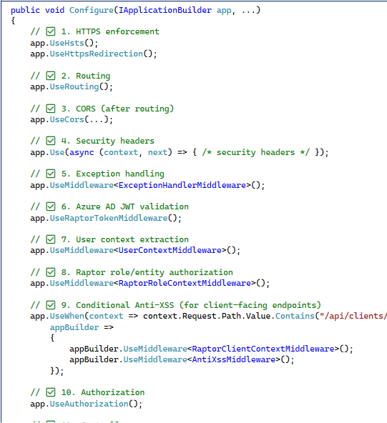
How does the Token-Based Authentication work?
Token-based authentication is a stateless mechanism where the server issues a cryptographically signed JWT token after successful authentication. In our EY Raptor Work Management API, we use a dual-token system: JWT bearer tokens from Azure AD for standard authentication and Raptor tokens for additional client context and scopes.
The flow works like this: The client authenticates with Azure AD, receives tokens, stores them securely, and attaches them to every API request via the Authorization: Bearer {token} header and custom X-Raptor-Token header. Our middleware pipeline validates token signatures using public keys, checks expiration, verifies issuer and audience, then extracts claims to populate the IContextUser service with user information like name, email, OID, roles, and entity permissions.
This enables stateless scalability across multiple Azure App Service instances, multi-tenant isolation with client-specific permissions, and cross-platform support for web, mobile, Excel add-ins, and PowerBI. We enforce authorization using [Authorize] attributes with role-based checks like [Authorize(Roles = "DeliverablesAdmin")].
JWT is the standard bearer token issued by Azure AD containing user identity and roles. Raptor Token is our custom encrypted token containing additional business context like client scopes, entity permissions, and feature flags specific to our application. We validate both: JWT for identity, Raptor Token for business authorization.
*****************************************************************
What JWT validation mistakes commonly cause vulnerabilities
Skipping issuer/audience checks, accepting unsigned tokens, or weak key rotation handling are common mistakes.
Proper signature and metadata validation is non-negotiable.
**********************************************************************
What is OpenID Connect and how is it different from OAuth?
OAuth 2.0 is an authorization framework — "what can this app do on behalf of the user."
OpenID Connect is an authentication layer built on top of OAuth 2.0 — "who is the user."
In short: OAuth 2.0 gets me a token to call an API; OpenID Connect gets me a verified identity for the user.

Explain CAP theorem with a real example
"The CAP theorem states you can only guarantee two of three properties in a distributed system: Consistency, Availability, and Partition Tolerance. Since partition tolerance is mandatory in distributed systems, you're really choosing between CP (Consistency) and AP (Availability)."
"In our Raptor platform, we use CP for critical operations like deliverable creation with ACID transactions. We sacrifice availability - if the database is down, requests fail - to guarantee consistency. Partial deliverables or inconsistent financial data are unacceptable."
"For non-critical operations like domain event publishing, we choose AP. After the deliverable is committed (CP), we fire-and-forget publish events. If Event Hub is down, we sacrifice consistency but maintain availability - the user gets instant success response."
"Our multi-tenant database mappings are strictly CP. We fail application startup if we can't load tenant-to-database mappings because serving requests with wrong mappings could cause data breaches. Security requirements override availability."
"The Anti-XSS middleware is CP - if we can't validate input safety due to system issues, we fail the request with 400 Bad Request rather than risk serving potentially malicious content. Security is non-negotiable."
What is eventual consistency?
Eventual consistency = AP systems (sacrifice strict C for A + P).
Eventual consistency is a consistency model used in distributed systems where, if no new updates are made to a data item, all replicas of that data will eventually converge to the same value — but not immediately.
"Given enough time and no new writes, all reads will return the latest written value.

A production API is slow only during peak hours. How do you debug it?
Approach is always - Observe → Isolate → Validate → Fix → Prevent
I start by checking APM metrics like request latency percentiles, throughput, error rates, CPU, memory, thread pool usage, and GC behavior during peak vs non-peak hours using tools like Application Insights.
I correlate slow requests with external dependencies—database calls, third-party APIs, caches, or message brokers. In most cases, the bottleneck turns out to be database contention, missing indexes, N+1 queries, or connection pool exhaustion.
I then verify whether the API is hitting thread pool starvation, blocking async calls, or excessive lock contention.
I also check infrastructure-level factors such as autoscaling rules, pod or instance limits, and network throttling. Many times the issue is that scaling reacts too slowly or is capped.
Finally, I reproduce the issue in a lower environment using load testing, validate the fix, and roll it out safely .
An API works fine locally but fails intermittently in PROD. Why?
“When an API works fine locally but fails intermittently in production, it usually indicates a difference in environment, scale, or concurrency, not a code logic issue.
Locally, we run with a single user, single instance, and minimal latency, whereas production introduces multiple instances, concurrent requests, network delays, and real infrastructure constraints.
The most common causes are race conditions, improper async usage, thread pool starvation, resource exhaustion, or dependency failures such as databases or third-party services behaving differently under load.
Configuration differences—like connection strings, timeouts, feature flags, or environment variables—also play a major role. Another frequent issue is stateful code that works locally but breaks in a scaled-out environment.
To debug this, I compare configurations, analyze production logs and metrics using APM tools, and try to reproduce the issue with load and concurrency testing. Intermittent production failures are almost always exposed only when real traffic, latency, and scale are involved.
How do you prevent cascading failures in microservices?
We prevent cascading failures through retry logic with exponential backoff - EF Core's EnableRetryOnFailure automatically retries transient errors like deadlocks with increasing delays, preventing temporary database issues
"Kubernetes health checks act as circuit breakers - when database connections fail, readiness probes fail, and traffic is automatically routed away from unhealthy pods. This prevents cascading timeouts where users repeatedly hit failing instances."
"Fire-and-forget domain event publishing implements graceful degradation. Critical operations like deliverable creation commit synchronously, but notifications happen asynchronously. Event Hub failures don't cascade to the deliverable creation flow."
Global exception middleware catches all unhandled exceptions and returns consistent JSON responses, preventing exceptions from reaching clients as HTML error pages which could crash client applications - a cascade from server to client tier."
Timeout controls at both connection (600s) and command (30s) levels prevent indefinite waits. Without timeouts, long-running queries could exhaust the thread pool, causing application-wide unresponsiveness - classic thread pool starvation cascade."
Scoped DbContext lifetime prevents cascading memory leaks and thread safety issues. Singleton DbContext would cause concurrent requests to corrupt shared state, leading to data inconsistency cascading across all users."

How do you design idempotent APIs?
An operation is idempotent if calling it multiple times with the same input produces the same result and has the same side effect as calling it once.
We use client-generated GUIDs as natural keys for deliverables and work items. The client generates the GUID before the request, so retries use the same GUID. Database unique constraints prevent duplicates, and we catch the constraint violation to return the existing entity. This makes POST operations idempotent without requiring additional infrastructure."
We add a requestId and sourceTimestamp to all Event Hub messages. Consumers check if they've already processed an event with a newer or equal timestamp for the same WorkItemGuid. We use a deduplication table with an idempotent MERGE statement that only updates if the new timestamp is newer. This handles Event Hub's at-least-once delivery guarante

What causes memory leaks in .NET APIs?
. In our Raptor Work Management platform, we prevent memory leaks through
proper service lifetime management,
explicit disposal patterns,
avoiding event handler leaks,
careful static field usage, - Static fields live for the application lifetime and prevent GC of anything they reference. We only use static fields for immutable objects like GeneratedRegex or synchronization primitives like SemaphoreSlim that don't hold references to request-scoped objects."
proper async/await patterns
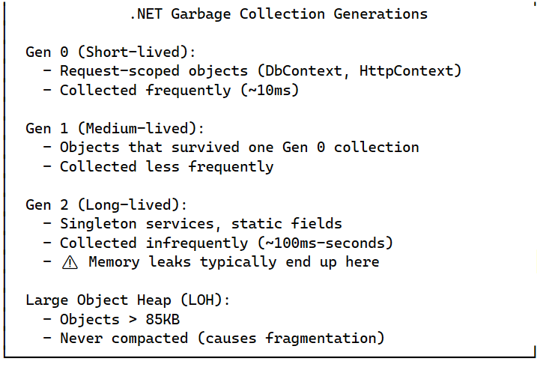
What happens if you forget to use AsNoTracking() in EF Core?
EF tracks all entities by default, which increases memory usage and slows read-heavy queries. For read-only scenarios, AsNoTracking improves performance and reduces memory pressure.
Difference between IEnumerable, IQueryable, and IAsyncEnumerable
IEnumerable, IQueryable, and IAsyncEnumerable differ mainly in where execution happens and how data is fetched.
IEnumerable executes in memory and is used when data is already loaded into the application.
IEnumerable<User> users = context.Users.ToList();
var activeUsers = users.Where(u => u.IsActive);
IQueryable represents a query expression that is executed by an external data source, typically a database, allowing filters to be translated into SQL.
IQueryable<User> users = context.Users;
var activeUsers = users.Where(u => u.IsActive);
IAsyncEnumerable is used for asynchronous streaming of data, where results are fetched incrementally without blocking threads, which is ideal for high-latency or large data scenarios.”
await foreach (var user in context.Users.AsAsyncEnumerable())
{ Process(user);}

IEnumerable represents a collection that can be iterated, while IEnumerator represents the actual iterator that moves through the collection.
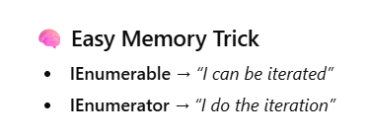

Difference between lock, Monitor, and SemaphoreSlim?
lock is for Monitor.Enter/Exit and is perfect for simple mutual exclusion in synchronous code. It's the fastest option but doesn't support async/await, making it unsuitable for modern async APIs.
Monitor provides lower-level control than lock, supporting timeouts with TryEnter, thread signaling with Pulse/Wait, and conditional waiting. It's useful for producer-consumer patterns but still doesn't support async.
SemaphoreSlim: A lightweight, in-process semaphore that limits concurrent access to N threads. is the only option that supports async/await via WaitAsync(). We use it in our Azure Functions to throttle concurrent executions, preventing resource exhaustion under high Event Hub load.
Always release SemaphoreSlim in a finally block. In production, we had an incident where exceptions caused semaphore leaks, eventually stopping all function processing. The finally block prevents this
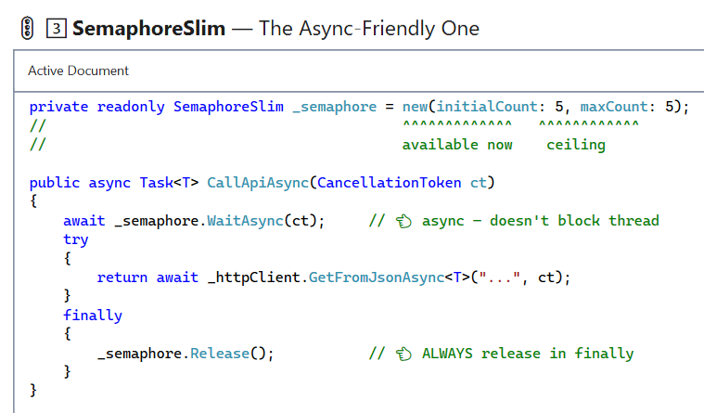
What causes memory pressure in ASP.NET Core?
Large object allocations,

improper caching,
static references, and
tracking too many entities.

How do you avoid N+1 query problems in EF Core?
Dapper with single SQL queries - For complex, read-heavy queries with many relationships, we use Dapper with hand-crafted SQL. In our WorkItemListReadOnlyRepository, a single query with LEFT JOINs loads the work item plus 11 related entities. We use Dapper's multi-mapping to construct the object graph in memory. This eliminates N+1 queries entirely - 1 query instead of potentially 1,000+ for 100 work items with relationships.
eager loading with Include/ThenInclude - we use Include and ThenInclude for eager loading. This generates a single SQL query with JOINs instead of separate queries for each relationship. The key is to use Include for direct properties and ThenInclude for nested properties. We add AsNoTracking() for read-only queries to avoid change tracking overhead.
projections with Select-loading only the needed fields into DTOs. This generates a single query selecting specific columns, reducing data transfer and memory usage.
AsNoTracking for read-only queries -This reduces memory usage by 50% (no snapshot storage) and improves query performance by 20-30%.
GraphQL DataLoaders

How do you design indexes for high-scale systems?
We design clustered indexes with TenantGuid first for data locality in our multi-tenant architecture. This ensures all work items for a tenant are physically adjacent on disk, enabling sequential I/O instead of random I/O - giving 100x performance improvement on tenant-filtered queries.
Composite Clustered Index for Multi-Tenancy:
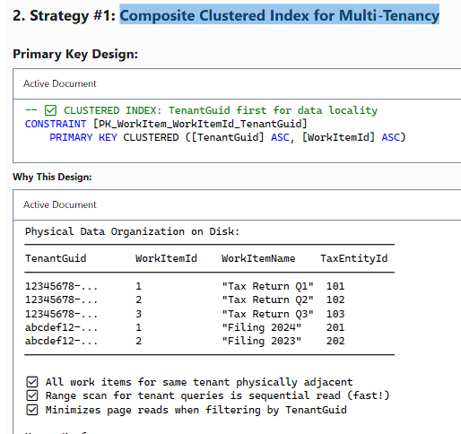
Filtered indexes on WHERE IsActive=1 AND IsDeleted=0 reduce index size by 10%, improve query performance by eliminating residual predicates, and reduce maintenance overhead because inserts to deleted rows don't touch the index - since 90% of our work items are active and 99% of queries filter on this.
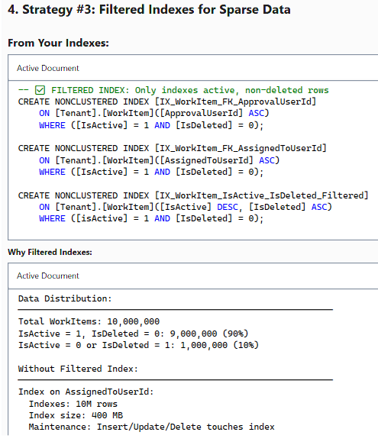
Index column order is critical - we put most selective columns first. In multi-tenant systems, TenantGuid is extremely selective, so we include it early in composite indexes. This enables index seeks instead of scans, giving 10-100x performance improvement.
We use naming conventions like IX_WorkItem_ListQuery to make index purpose immediately obvious during maintenance and query plan analysis
Covering indexes with INCLUDE clauses eliminate key lookups by storing SELECT columns directly in the index. We balance this against storage costs - for our frequently-used work item list query running 10,000 times daily, the 4GB index size is worth the 25x performance improvement.
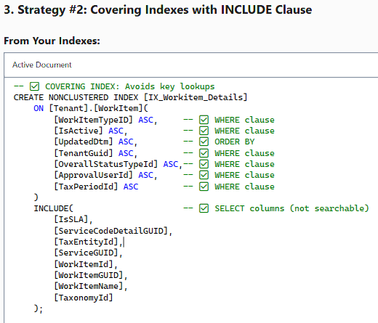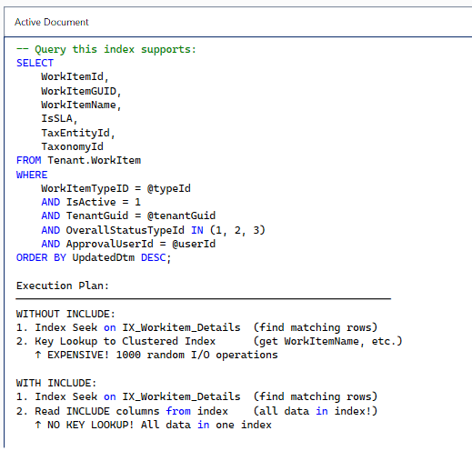
How many Clustered and Non-Clustered Indexes can you have per table?
In SQL Server, you can have exactly ONE clustered index per table (because it determines the physical order of data), but up to 999 non-clustered indexes per table (1 clustered + 999 non-clustered = 1000 total indexes). However, in practice, you rarely need more than 5-10 well-designed indexes per table due to maintenance overhead on INSERT/UPDATE/DELETE operatio.
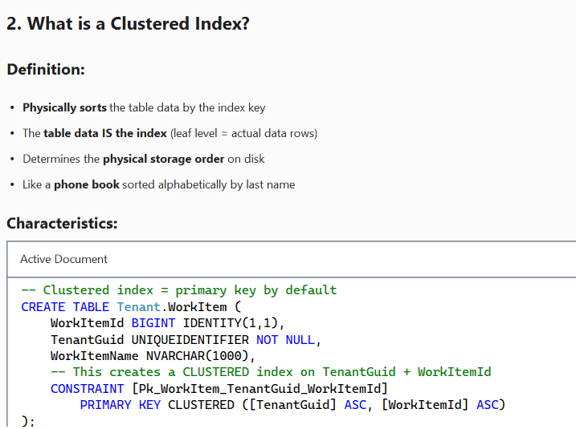
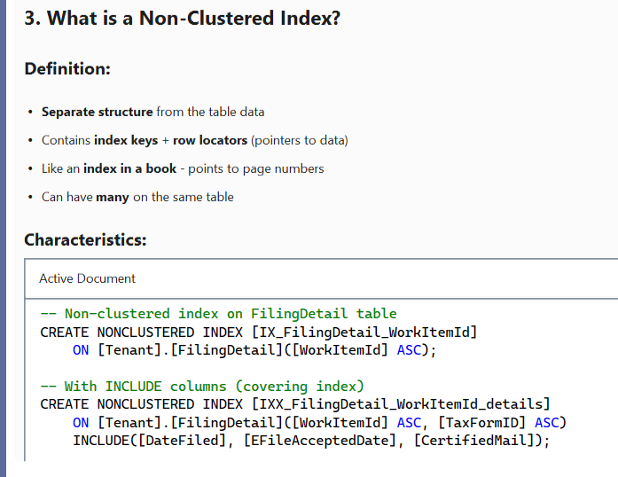

Difference between DELETE, TRUNCATE, and DROP
- "DELETE is a DML operation that removes specific rows based on WHERE clause, fires triggers, respects foreign keys, and fully logs each row deletion. We use it for selective data removal with audit requirements."
- "TRUNCATE is a DDL operation that deallocates all data pages, resets identity seed, doesn't fire triggers, and has minimal logging. It's 10-100x faster than DELETE but can't be used with foreign keys or WHERE clauses. We use it for staging tables and session data."
- "DROP TABLE is a DDL operation that removes the entire table structure including data, indexes, triggers, and constraints. We use it in migration scripts with careful dependency ordering - drop foreign keys first, then child tables, then parent tables."

How do you handle read vs write scaling?
In our Raptor Work Management platform with 100+ tenant databases and thousands of concurrent users, read and write operations have fundamentally different scaling requirements. Reads dominate (90%+ of traffic) and can be scaled horizontally with caching, while writes must maintain consistency and often require ACID guarantees. We implement CQRS pattern separation, read-only repositories with Dapper,
in-memory caching,
dedicated read models, and
database-per-tenant isolation.
Fire & forgot
CQRS Pattern - Separate Read and Write Models:
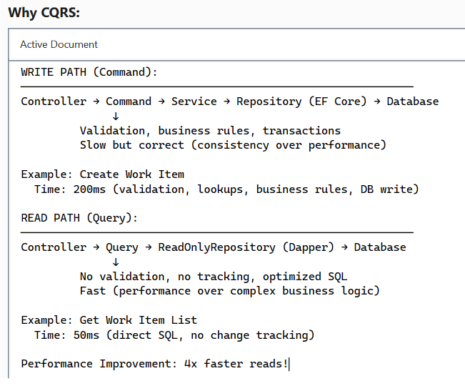
We implement CQRS pattern with separate read and write models. Write operations use EF Core with full change tracking, validation, and business rules, prioritizing consistency over performance. Read operations use Dapper with hand-optimized SQL queries, no change tracking, and denormalized read models. This gives us 4x faster reads while maintaining write integrity
Our read-only repositories use Dapper with hand-optimized SQL queries instead of EF Core. For the work item list, one SQL query with 11 LEFT JOINs loads all related data, mapping to flat read models (DTOs) with no navigation properties. This eliminates N+1 queries, change tracking overhead, and gives us full control over query optimization. A complex query returning 1000 rows takes 50-100ms instead of 500ms+ with EF Core.
design pattern in dot net core:
Design patterns are reusable solutions to common software design problems.
In .NET Core, many patterns are built-in or naturally supported using DI, middleware, and configuration.
Structural- repository pattern we are using.
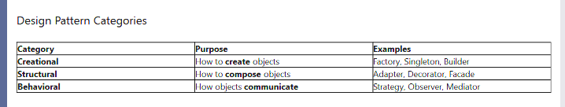
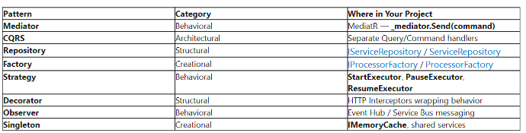
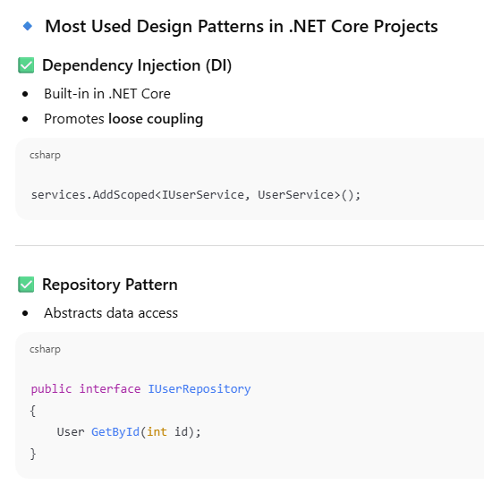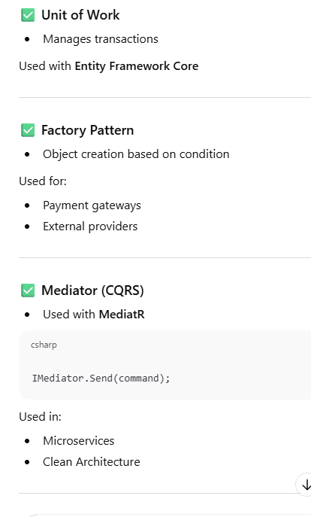
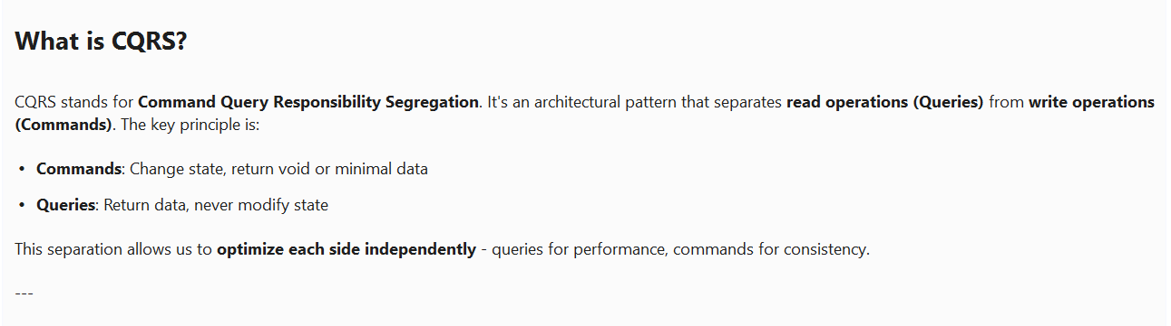
How do Strategy and Factory work together?
My project uses this exact combination in the ProcessorFactory pattern:
Together: Factory selects the right Strategy, Strategy executes the logic.
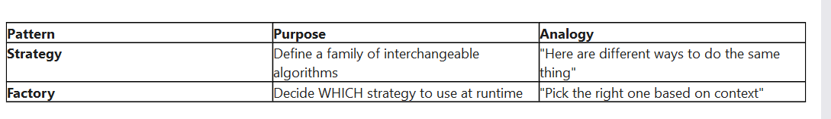
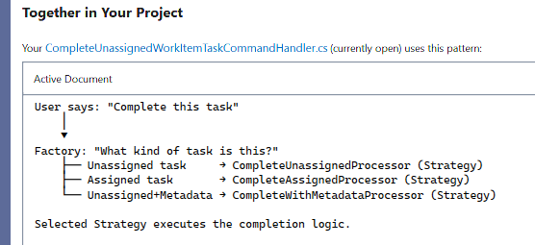
"Strategy and Factory work together beautifully — Factory decides WHICH algorithm to use, Strategy executes it.
In our project, when a user starts, pauses, or resumes a task, the MediatR handler asks the ProcessorFactory for a TaskStatusLogProcessor, and inside that processor, the right executor strategy is selected based on the ExecutorType.
Each executor is its own class with single responsibility — StartExecutor, PauseExecutor, Resume Executor.
To add a new action, I just create a new executor class and register it in DI — no existing code is modified. This follows the Open/Closed Principle and makes each strategy independently testable."
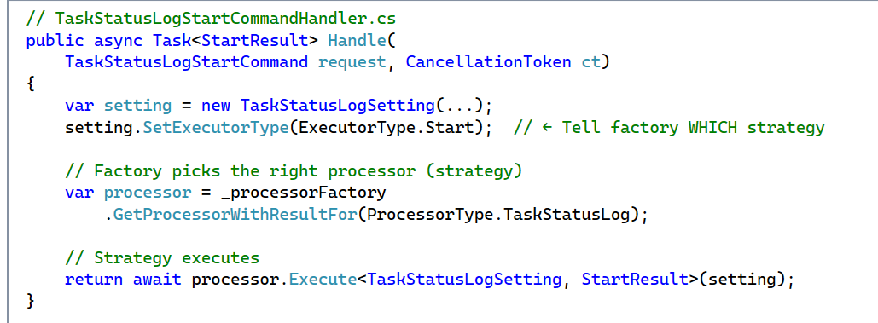
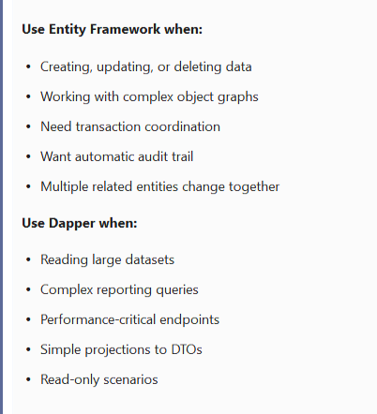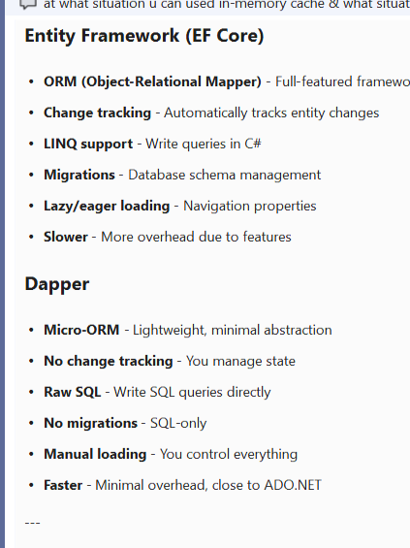
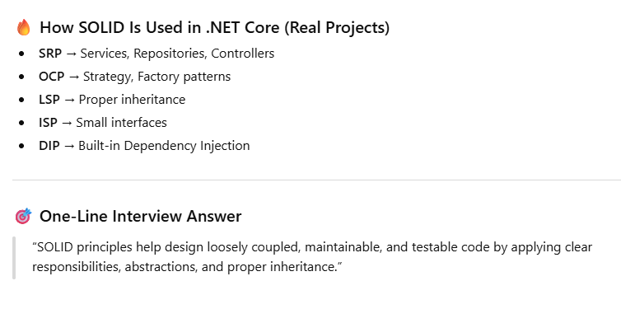

What is parameter sniffing and how do you fix it?
Parameter sniffing is a SQL Server query optimization behavior where the query optimizer 'sniffs' parameter values during the first execution to generate an execution plan. While this usually improves performance, it can cause severe performance problems when the initial parameter values aren't representative of typical values. In our Raptor Work Management platform with 100+ tenant databases and complex stored procedures, we've encountered and solved parameter sniffing issues.
OPTION (RECOMPILE) forces SQL Server to create a fresh execution plan on every execution. This eliminates parameter sniffing but adds 5-50ms compilation overhead
OPTIMIZE FOR UNKNOWN tells the optimizer to ignore parameter values and use column statistics instead, creating a plan optimized for 'average' values. This gives consistent performance for high-frequency OLTP queries where recompilation overhead is unacceptable.

How do you decide the order of columns in a composite index?
The fundamental rule for composite index column order is: equality before range, most selective first. Equality predicates (=) should come before range predicates (>, <) because range columns stop index seeks and force scans for subsequent columns.
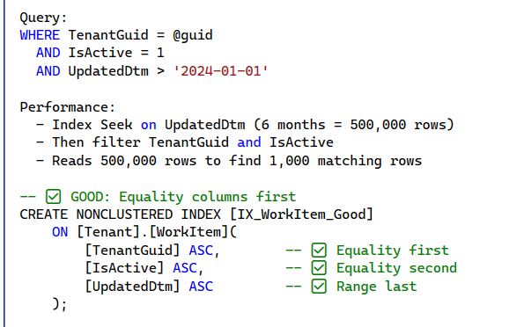
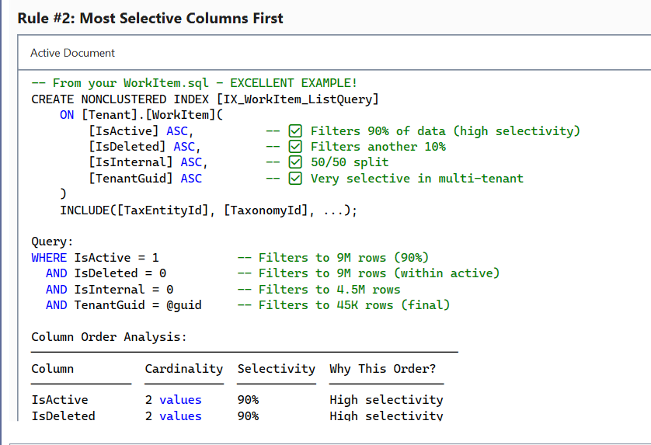
Difference between logical and physical reads?
Logical reads are reads from SQL Server's buffer pool in memory (0.01ms), while physical reads are reads from disk (5-15ms on SSD). Physical reads are 500-1,500x slower, so minimizing them through indexing and query optimization is critical for performance."
We use WITH (NOLOCK) in reporting stored procedures to avoid shared locks. This prevents blocking, keeps pages in the buffer pool longer, and improves buffer pool hit ratio - reducing physical reads over time.
Our temp table pattern in usp_GetWorkitemDetails materializes filtered data once (500 logical reads), then reuses it multiple times with zero additional reads from base tablesThis reduces total logical reads by 66% compared to re-joining base tables repeatedly.
Covering indexes with INCLUDE clauses eliminate key lookups, reducing logical reads by 95%. A query without covering index does 1,010 logical reads (10 index seek + 1,000 key lookups). With covering index, it's 50 logical reads - all sequential from one index."
We monitor logical and physical reads using SET STATISTICS IO in development and DMVs in production. A query with high logical reads (>10,000) indicates poor indexing. High physical reads (>10% of logical) indicates cold cache or buffer pool pressure."

When would you avoid using transactions?
Read-only queries don't need transactions - they add 5-10ms overhead and hold shared locks longer, reducing concurrency
Never include external API calls within database transactions. We commit database writes first (100ms), then make external calls outside the transaction. If email/Slack services fail, we log errors but don't rollback the database - separation of concerns.
Long-running operations should use minimal transactions.
Azure Functions processing Event Hub batches avoid transactions to allow independent event processing with partial failure tolerance.
We use one transaction for all database writes (deliverables, validation errors, status updates), commit it, then publish domain events in a background task without a transaction. This gives eventual consistency for events while maintaining ACID for database writes.
Transaction overhead includes BeginTransaction (5ms), lock acquisition (variable), and CommitTransaction (5-10ms). For read-only queries executing 1,000 times per second, avoiding transactions saves 10-20 seconds of database time per second - enabling 2x higher throughput
What causes index fragmentation and how do you handle it?
Index fragmentation is when the logical order of index pages doesn't match the physical order on disk, causing random I/O instead of sequential I/O. In production, we've seen 67% fragmentation on IX_WorkItem_ListQuery causing query times to increase from 50ms to 2,500ms - a 50x degradation."
"The primary cause is page splits during random INSERTs or UPDATEs to variable-length columns. Our clustered index PK_WorkItem_WorkItemId_TenantGuid uses TenantGuid first with sequential WorkItemId second, ensuring new inserts go to the end of each tenant's range, minimizing page splits."
We monitor fragmentation using sys.dm_db_index_physical_stats. Our threshold: < 10% fragmentation is acceptable, 10-30% requires REORGANIZE, > 30% requires REBUILD. We only defragment indexes with 1,000+ pages because smaller indexes don't benefit from maintenance."

How do you design DB for high availability?
We use Azure SQL Database which provides built-in 99.99% SLA with 3 automatic replicas and synchronous replication. If the primary fails, Azure automatically fails over to a secondary replica within 30 seconds with zero data loss - completely transparent to the application."
Our WorkItem table uses a composite clustered index with TenantGuid first, ensuring all data for the same tenant is physically stored together. This provides data locality for sequential I/O, enables tenant-level backup/restore, and makes it easy to migrate hot tenants to dedicated databases for scale-out."
We implement a Connection Catalog pattern that routes each tenant to their specific database, allowing us to distribute 100+ tenants across multiple Azure SQL databases for geo-distribution, blast radius containment, and independent failover."
Entity Framework Core is configured with EnableRetryOnFailure for automatic retry on transient errors. Combined with connection pooling (Min=10, Max=200), this provides seamless recovery during Azure SQL failover - users don't experience errors, requests automatically retry and succeed."
Our WorkFlowTaskDetail table uses SQL Server Temporal Tables which automatically maintains a complete change history. If data is accidentally deleted, we can query the table as it existed 15 minutes ago and restore specific rows in 2 minutes with zero downtime - no full database restore needed.
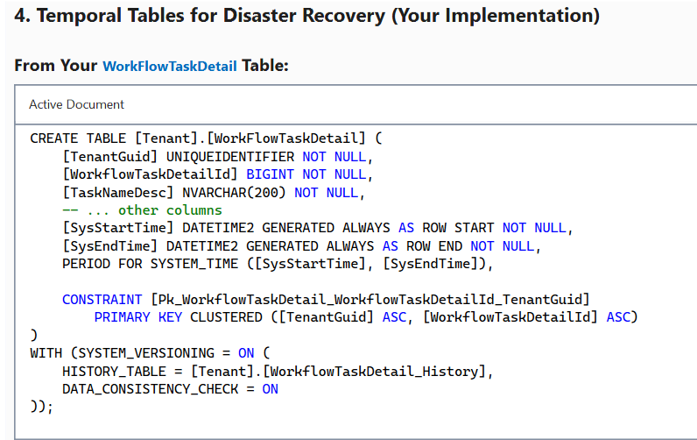
For high availability, I'd implement read-only replicas using ApplicationIntent=ReadOnly connection strings to offload heavy reporting queries to secondary replicas. This keeps the primary database focused on writes and provides faster failover since replicas are already warm."
Multi-database architecture with TenantGuid-first clustering enables tenant migration without downtime - we backup tenant data, restore to new database, update Connection Catalog, and delete from old database. Other tenants are completely unaffected, and there's no application code change required."
How do you ensure DB security?
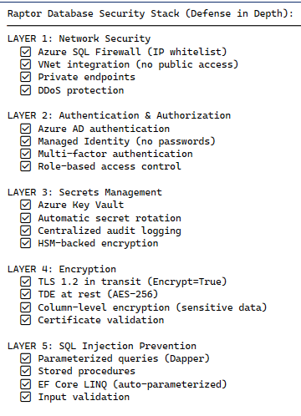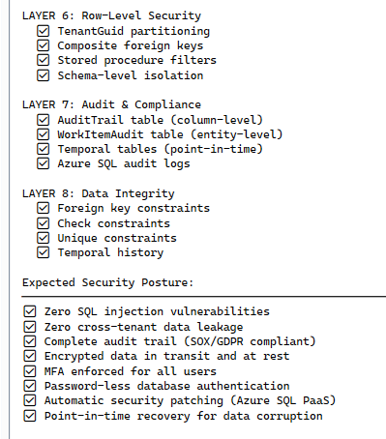
Angular app becomes slow when table rows increase. How do you fix it?
When an Angular application renders large datasets in tables/grids, performance degrades significantly due to excessive DOM manipulation, change detection cycles, and memory consumption. Users experience lag, slow scrolling, and unresponsive UI.
In our enterprise application handling 10,000+ work items, we implemented a layered optimization strategy: server-side pagination (100 records/page), infinite scroll with throttling, trackBy functions for grid rows, OnPush change detection for child components, and GraphQL field selection to reduce payload size. This reduced initial load time from 8 seconds to under 2 seconds and eliminated scroll lag. The key was measuring with performance profiling tools before and after each optimization to ensure measurable impact
1. Server-Side Pagination
Fetch data in smaller chunks (100 records per page by default)
Track current page number and page size in NgRx state
Load additional pages on-demand via infinite scroll
Its reduces initial load time and memory footprint by loading only what's visible.
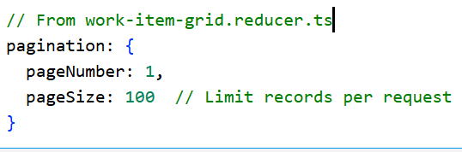
2. Infinite Scroll with Throttling/Debouncing-
3.TrackBy Function for ngFor Optimization
Kendo Grid uses trackBy function to identify unique rows
Angular reuses existing DOM nodes instead of recreating them.
Dramatically reduces DOM manipulation when data updates; Angular only updates changed rows.
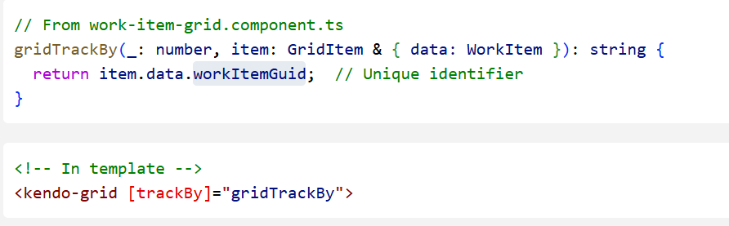
OnPush Change Detection Strategy
Applied to child components to skip unnecessary change detection cycles
Components only re-render when inputs change (by reference)
Reduces change detection overhead from O(n) to O(1) for optimized components; improves rendering performance up to 10x.
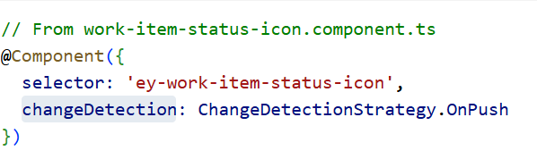
GraphQL with Field Selection:
Only request fields needed for visible columns
Dynamic field selection based on column visibility state
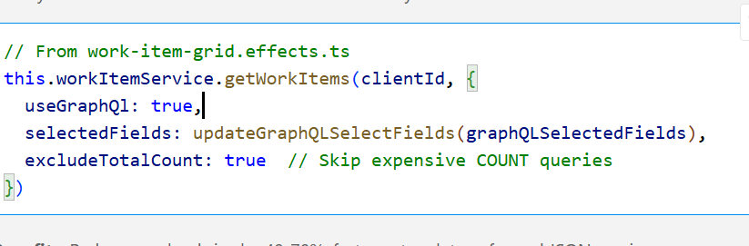
State Management with NgRx
Centralized state for grid data, filters, pagination
efficient state diffing; prevents unnecessary re-renders across the component tree.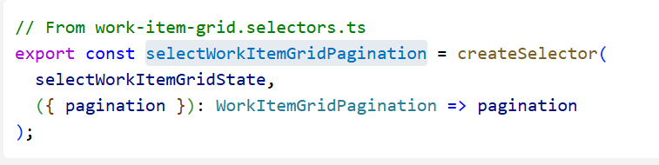

Difference between Default and OnPush change detection?
Angular uses Change Detection to synchronize the component's data model with the view. The framework offers two strategies: Default and OnPush.
Default Change Detection Strategy
Angular checks every component in the component tree on every browser event (clicks, mouseover,timers, HTTP requests, etc.)
Runs change detection top-down through the entire component tree
Checks all bindings in templates to detect changes
- Pros: Works reliably out-of-the-box; no manual intervention needed
- Cons: Inefficient for large component trees; checks unchanged components unnecessarily
. OnPush Change Detection Strategy
- Angular skips change detection for the component unless specific conditions are met
- Component is marked "dirty" and re-checked only when:
  - @Input reference changes (new object/array reference)
  - Events originate from the component or its children (click, submit)
  - Manualtrigger via ChangeDetectorRef.detectChanges() or markForCheck()
  - Async pipe receives new observable value.
- . I used OnPush for presentation components like status icons, confirmation modals, and search inputs—components that receive data via @Input bindings from NgRx selectors.
When do you manually trigger change detection and why?
cascading dropdown dependencies. We have complex forms where selecting a Jurisdiction dynamically populates Tax Forms, or choosing a Tax Year filters Tax Periods. Since we use Kendo UI dropdowns—third-party components that manage internal state—Angular's change detection doesn't automatically capture when we programmatically update the dependent dropdown's data source. After updating selectedJurisdiction, I call changeDetectorRef.detectChanges() to force immediate re-rendering of the Tax Form dropdown.
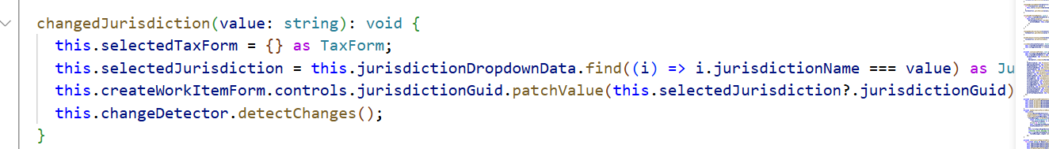

What is Zone.js and how does it affect performance?
Zone.js is a JavaScript library that implements execution contexts called "zones" to track and intercept asynchronous operations. Angular uses Zone.js as its automatic change detection mechanism by monkey-patching browser APIs to detect when asynchronous tasks complete and trigger UI updates.
Think of Zone.js as Angular's "surveillance system" that watches for any activity that might change application state and automatically refreshes the view.
it creates significant performance overhead—every patched async operation triggers a full change detection cycle across the component tree.
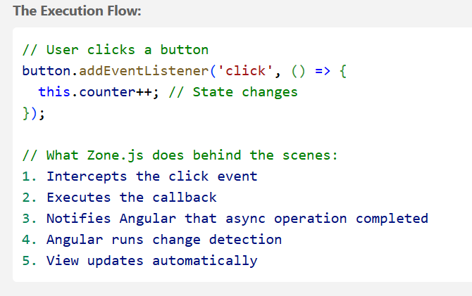
How do you prevent memory leaks in Angular?
Memory leaks in Angular applications occur when objects, subscriptions, event listeners, or timers aren't properly cleaned up when components are destroyed.
This causes memory to accumulate over time, leading to performance degradation, browser crashes, and poor user experience
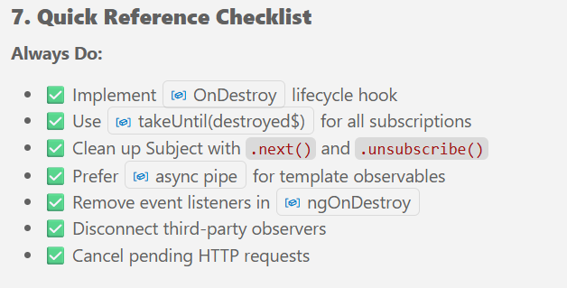
takeUntil Pattern with Subject (PRIMARY METHOD)
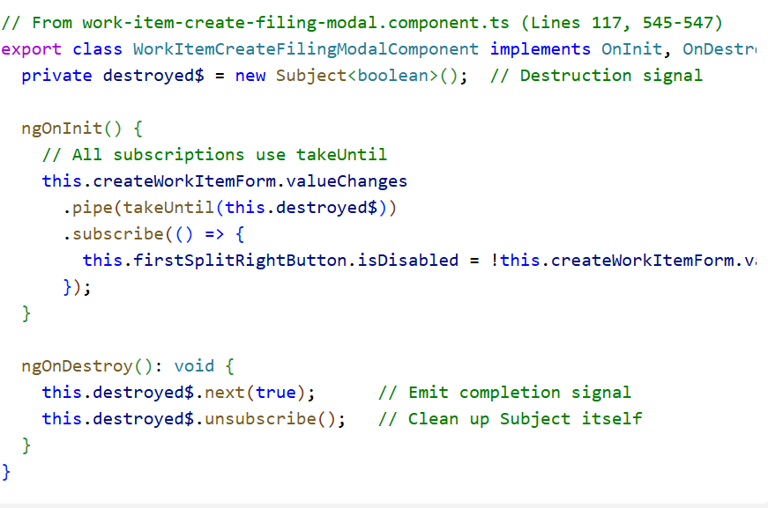
Every component declares a private destroyed$ Subject, and all subscriptions use takeUntil(this.destroyed$).
In ngOnDestroy, we emit true and unsubscribe from the Subject itself. This pattern scales beautifully—our grid manager component has 10+ NgRx selectors, all cleaned up with a single cleanup statement
- Multiple Subscriptions with Single Cleanup-
- multiple subscriptions managed with 1 cleanup statement
- No need to track individual subscription references
- Prevents forgetting to unsubscribe from any single subscription

Async Pipe (BEST FOR TEMPLATES) -This eliminates an entire class of potential leaks because Angular handles subscription lifecycle automatically.
Our grid component uses this for column definitions, loading states, and pagination—zero manual cleanup required.

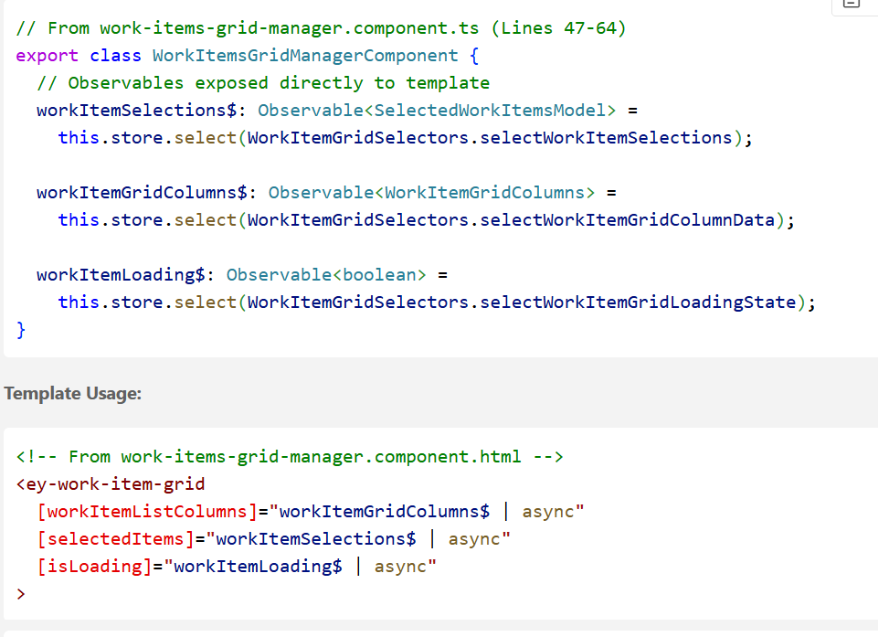

Automatic subscription on component init
Automatic unsubscription on component destroy
No ngOnDestroy needed for these observables
OnPush change detection compatible.
HTTP Request Cancellation
in a micro-frontend environment with client switching, we track active HTTP requests by URL and client GUID. When components destroy or users switch clients, we emit cancellation tokens via Subject to abort pending requests.
This prevents memory leaks from stale HTTP responses and eliminates race conditions where old data overwrites newer state.

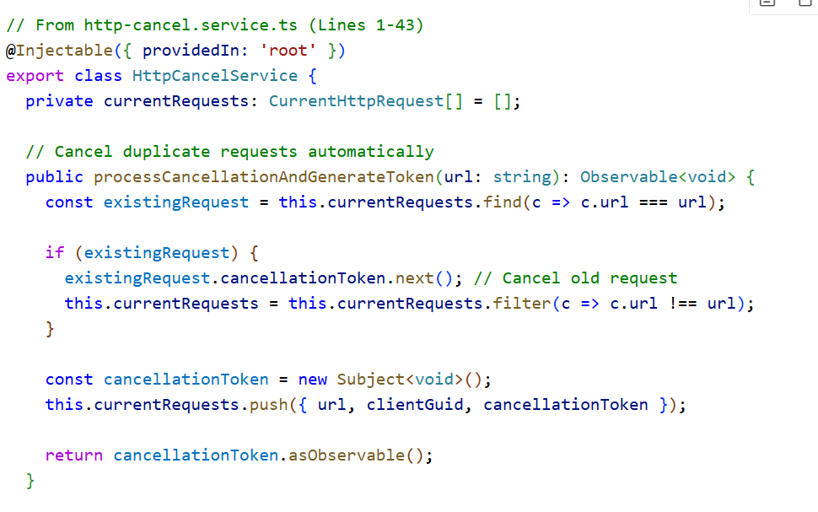
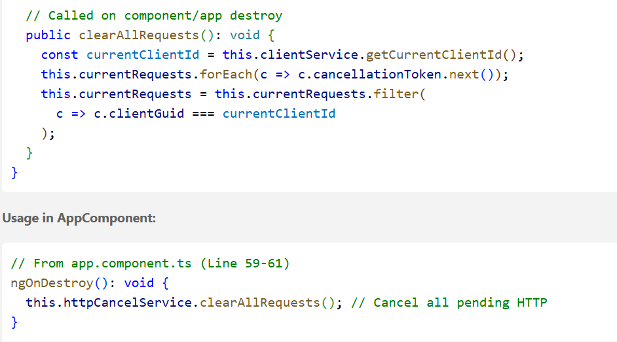
Difference between Subject, BehaviorSubject, and ReplaySubject?
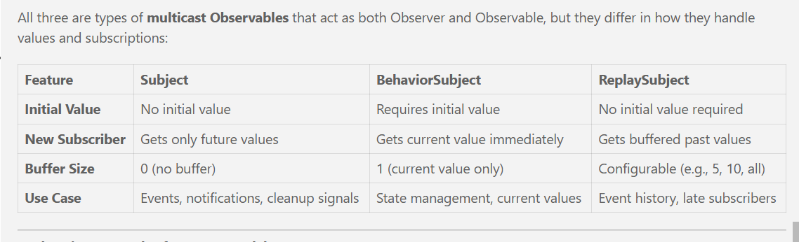
Subject-Simple event notification without needing to store state.
Cleanup signals don't need state - just trigger unsubscription once.
BehaviorSubject? Scroll position is state. Late subscribers need the current position, not historical values. 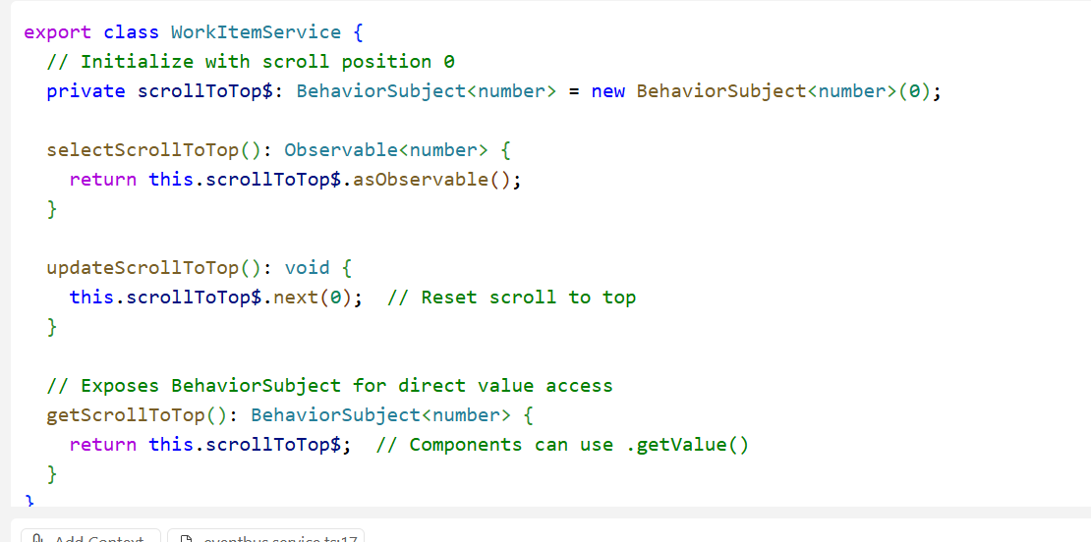
ReplaySubject - Event History for Late Subscribers
When new subscribers need to receive recent past events they missed.
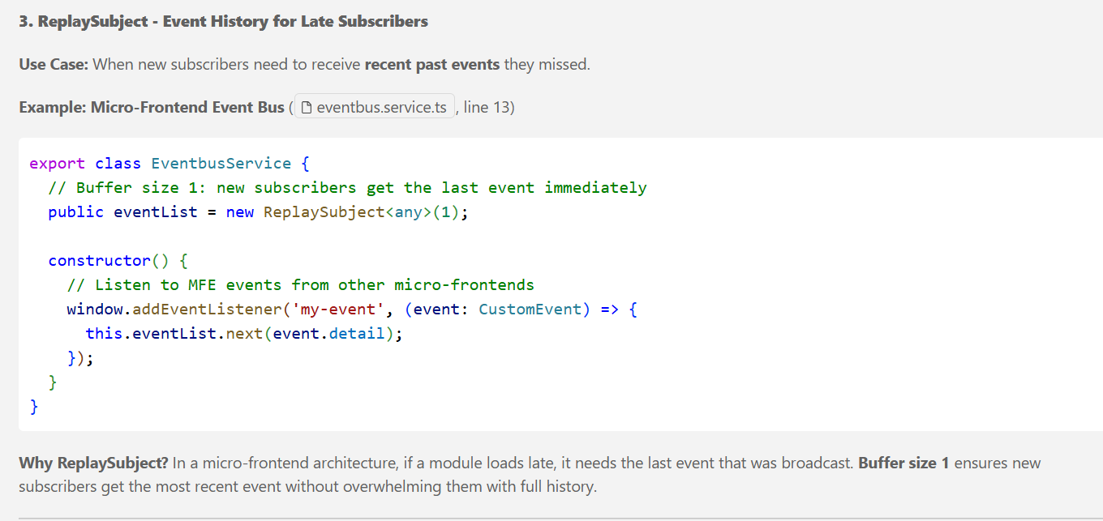
How do you handle multiple API calls efficiently in Angular?
Using forkJoin for parallel calls,
switchMap for dependent calls, Chaining with switchMap (Token-then-Request Pattern)- Second API depends on the result of the first
combineLatest for streams that update independently.
Dispatching Multiple Actions (Fire-and-Forget Independence)
Sequential Calls with concatMap (Dependent Requests)
Use forkJoin
Executes calls in parallel, emits once all calls complete, Reduces total load time
If one call fails, the entire request fails- Use catch Error per API when partial data is acceptable
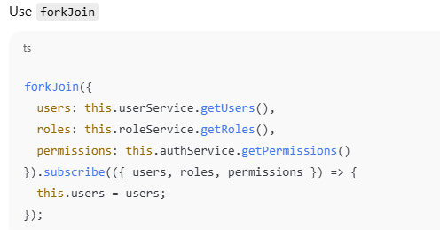
Dispatching Multiple Actions (Fire-and-Forget Independence): Parallel Independent API Calls - Multiple Dispatch
Parallel execution: All 5 API calls happen simultaneously
Smart caching: checkCache: true prevents redundant API calls
Independent failure: If jurisdictions fail, users still load
NgRx state management: Each effect updates its own slice of state
Single API Call → Multiple Actions (Shared Response)
Use Case: One API call provides data for both charts AND status summary
What's the difference between switchMap and concatMap?
"In my current project, we use switchMap for user-driven filter/search operations in our work item grid. When users type in the search box or change filters, we cancel previous API requests and only process the latest one. This prevents stale data from appearing and reduces server load.
For example, if a user types 'ABC' quickly, switchMap cancels the API calls for 'A' and 'AB', ensuring only the 'ABC' results are shown.
On the other hand, we use concatMap for bulk operations like marking multiple work items as complete. Here, we queue operations sequentially to ensure each completes successfully before starting the next. This prevents race conditions and guarantees data integrity.
The key difference: switchMap cancels previous inner observables, while concatMap queues and waits. It's similar to .NET's CancellationToken vs Sequential await
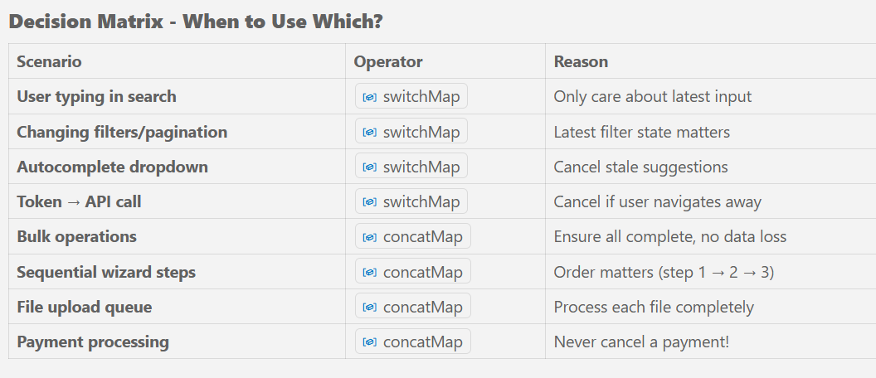

API is called multiple times unintentionally. How do you fix it?"
debounceTime for user input, throttleTime for events, switchMap for cancellable operations, and custom cancellation tokens for HTTP interceptors."
Search Box (Rapid Typing):
We use debounceTime(300) and distinctUntilChanged() to wait 300ms after the user stops typing before firing the API call. This reduced search API calls by 80% in production.
Dropdown Caching (Modal Reopens):
We implemented a smart caching mechanism in NgRx effects using iif() with a checkCache flag. When a modal opens, it checks if data is already in the store. First load calls the API, subsequent loads use cached data. This eliminated 5 redundant API calls when users opened the same modal multiple times.
Filter Changes (Grid Refresh):
We use switchMap in our NgRx effects to automatically cancel previous API requests when users change filters rapidly. Only the latest filter state triggers a completed API call. This is critical for performance when users interact with multiple filters.
Duplicate URL Prevention (HTTP Interceptor):
We built an HttpCancelService that maintains a map of in-flight requests by URL. If the same URL is requested before the previous call completes, we cancel it using RxJS takeUntil. This is implemented in an HTTP interceptor, so it works application-wide.
Infinite Scroll (Rapid Scroll Events):
We use throttleTime(250) to limit scroll events to at most 4 per second, preventing excessive 'load more' API calls during rapid scrolling.
Client Switching (Cleanup):
When users navigate between micro-frontends or switch clients, we call clearAllRequests() in the component's ngOnDestroy() to cancel all pending API calls, preventing stale data and wasted resources.
Angular UI freezes while API is loading. How do you fix it?
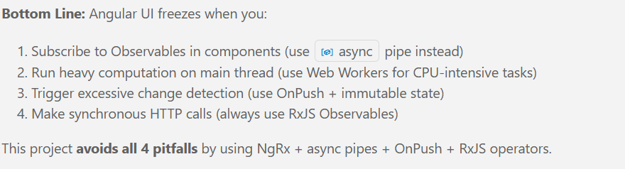
switchMap: Cancels previous pending requests automatically (prevents race conditions)
Loading Indicators with Overlays (Visual Feedback)- Non-blocking visual feedback tells users the app is working (not frozen). The spinner is a CSS animation (runs on compositor thread, not main thread).
Prevent Duplicate/Rapid API Calls (Throttling)
Debounce User Input (Reduce API Spam)
Lazy Load Heavy Components (MFE Architecture)- Heavy MFE components load asynchronously on-demand instead of blocking initial app load.

How do you reduce initial bundle size in Angular?
AOT (Ahead-of-Time) Compilation-
Compiles Angular templates at build time (not runtime)
Eliminates Angular compiler from production bundle (~1-2 MB saved)
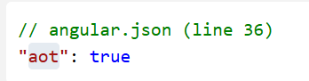
BuildOptimizer + Tree Shaking:
Tree-shakeable services are Angular services that can be automatically removed from the bundle if they're not used anywhere in your application. This is a build optimization technique that reduces bundle size.
Ex. If you import { map } from 'rxjs/operators' . But only use `map`, all other 100+ operators are excluded from bundle.
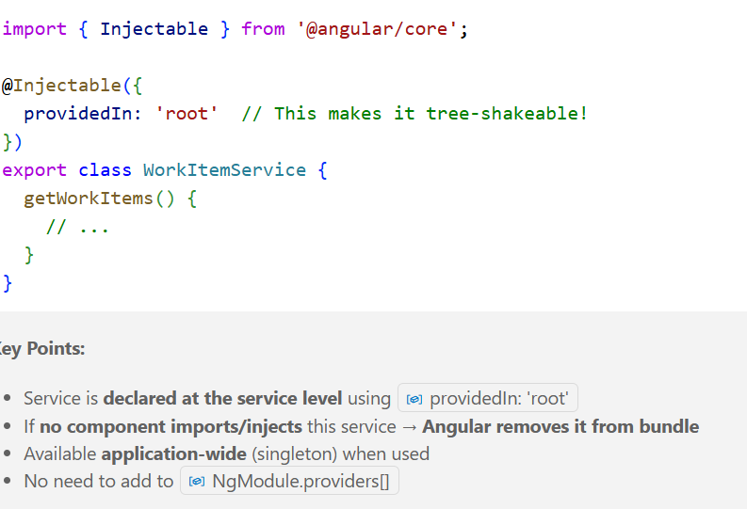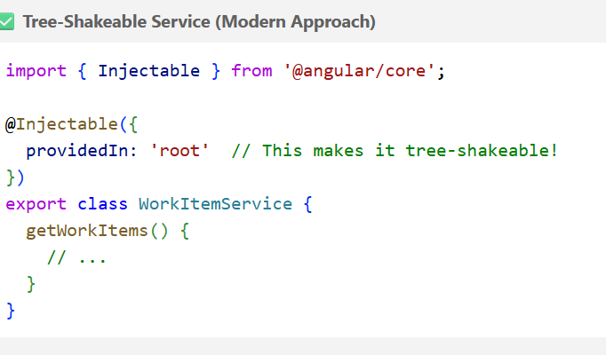
Environment-Specific Builds (Development vs Production)
Micro-Frontend (MFE) Architecture for Code Splitting-Core shell loads first (~2-3 MB)
,Feature MFEs load on-demand from CDN
Vendor Chunk Separation (Third-Party Libraries Caching)- Separates your code (main.js) from third-party code (vendor.js),
Users download vendor chunk once, reuse from cache
Shared Modules (Avoid Duplicate Code) -Components/directives declared once, used everywhere
Prevents duplicate code across lazy-loaded modules
What are standalone components and why are they useful?
Standalone components (Angular 14+) are self-contained components that don't require NgModules. They declare their own dependencies using the imports property, reducing boilerplate and improving tree shaking.
improve lazy loading and build performance.”
How do Signals improve performance?
Signals provide fine-grained reactivity, updating only the exact parts of the UI that depend on changed values. This eliminates unnecessary change detection cycles, enables zoneless mode (removing Zone.js overhead), and caches computed values. This results in 10-100x faster updates for complex UIs.
How do you handle errors globally in Angular?
Global ErrorHandler - Catches all uncaught exceptions,
logs to Azure Application Insights .
Uses RaptorUiErrorHandler from @ey-fso-tax/raptor-appinsightlogger-ui package
HTTP Interceptors - Handle authentication (AD tokens, RUM tokens), add headers, manage retries
NgRx Effects with catchError - Convert HTTP errors into Redux actions(state management), prevent effect chain breaking.
BaseAlertService - Display user-friendly notifications, parse multiple error formats
private subject = new Subject<Alert>();
this.baseAlertService.error(errMessage)
Q: How do you ensure frontend and backend stay in sync?
Strongly-typed TypeScript models - Mirror backend DTOs, compile-time safety
Shared enums - Synchronized constants prevent magic strings
API versioning - Multiple versions (v1, v2, v3) coexist for gradual migration
GraphQL selective fields - Backend can add fields without breaking clients
Environment-based configs - Each environment points to matching backend
Centralized API services - Single source of truth for endpoints
HTTP interceptors - Enforce required headers/authentication
Automated error handling - Type-safe error responses catch contract violations
How do you structure a large Angular application?
Core Module - Singleton services (providedIn: 'root') for HTTP interceptors, authentication, and utilities—imported once in AppModule.
Shared Module - 30+ reusable UI components (grid, charts, forms)—imported by feature modules.
Feature Modules - Self-contained features with their own components, services, models, and NgRx store—27 components in WorkItems feature.
NgRx Store - Centralized state with Actions/Effects/Reducers/Selectors pattern—like CQRS in .NET. Similar to MediatR with CQRS pattern—commands (actions), handlers (reducers), queries (selectors).
MFE Architecture - Micro-frontends load dynamically via custom elements—independent deployment.
Barrel Exports - index.ts files aggregate exports—single import for multiple models.

How do you manage global state in Angular?- uses NgRx (Redux pattern for Angular) for enterprise-grade state management.
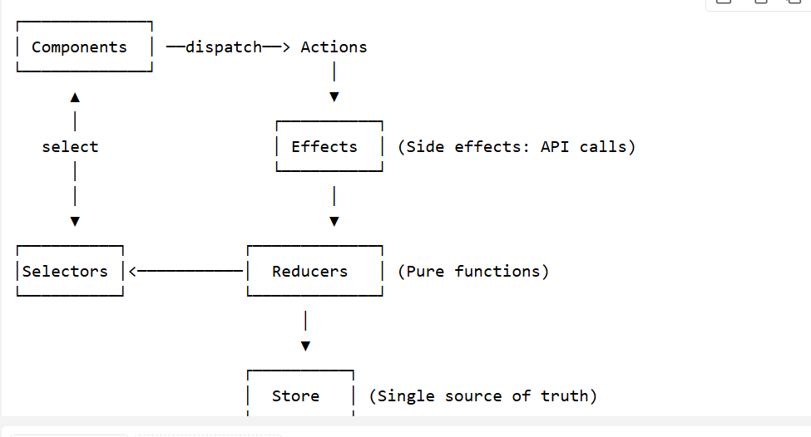
Components - Dispatch actions for user interactions, select observables from store, use async pipe in templates.
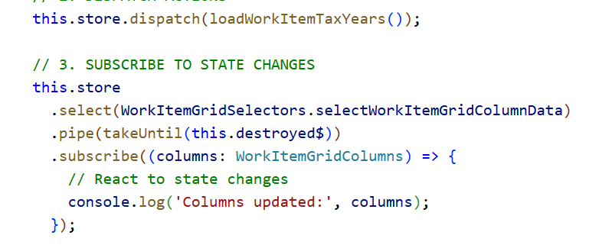
Actions - Type-safe commands describing events (loadWorkItems, updatePagination). 15+ actions per feature.
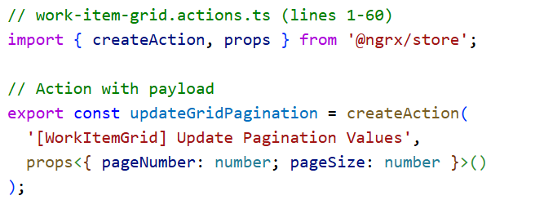
Reducers -similar to Command Handlers in CQRS—receive command, return new state.
Pure functions that update state immutably based on actions. Enforce strictStateImmutability in production.-
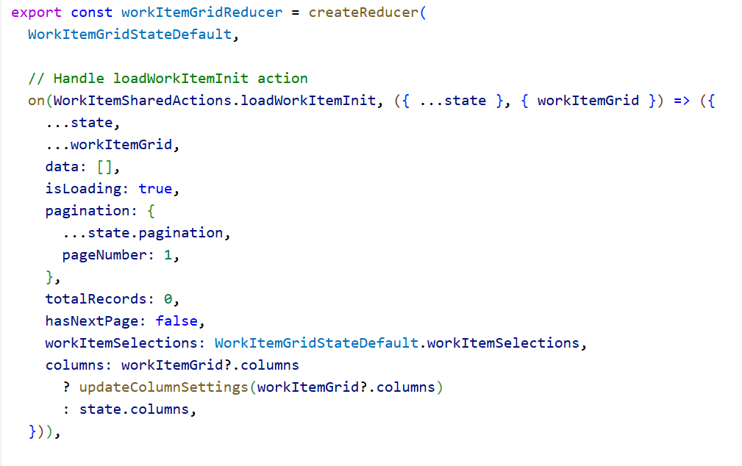
Selectors –
Memoization - Results cached, recompute only when inputs change
Prevents unnecessary recalculations.
Similar to IQueryable LINQ expressions—lazy evaluation, composable.
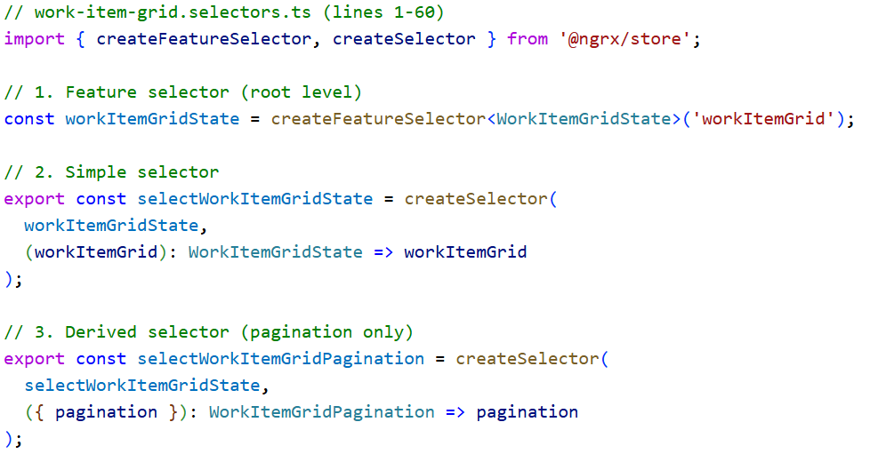
Effects - Handle side effects (API calls, logging, notifications). Use RxJS operators like switchMap, catchError, tap.
- API Call Effect - Listen for action → call API → dispatch success/failure
- Notification Effect - Listen for action → show toast → no dispatch
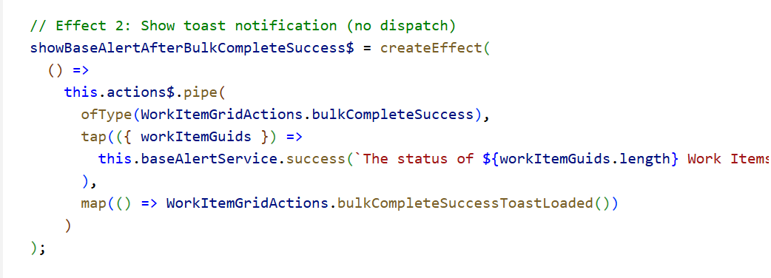

How do you handle role-based access control (RBAC) in Angular?
In Angular, RBAC is implemented through environment-based role configuration,
JWT token decoding for user roles,
permission services that validate role membership, and
conditional UI rendering using observables with async pipe.
We store allowed roles in environment configs, extract user roles from authentication tokens, check permissions in services/components, and hide/disable UI elements based on role permissions using *ngIf directives and reactive state management with NgRx."
How do you secure Angular applications?
Angular security involves multiple layers:
Authentication & Authorization using JWT tokens with HTTP interceptors, implement HTTP interceptors to automatically attach authentication tokens to API requests
XSS protection through Angular's built-in sanitization and strict TypeScript, Angular provides automatic sanitization for templates—no need for manual DomSanitizer unless using innerHTML or bypassSecurityTrust*.template interpolations by default: {{ userInput }} is auto-sanitized
CSRF protection Angular's HttpClient automatically handles CSRF using the cookie-to-header token patternHTTPS enforcement,
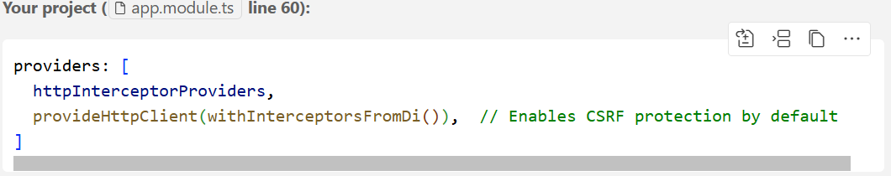
environment-based configuration for secrets,
role-based access control (RBAC),
AOT compilation,- compilation prevents template injection attacks and improves performance.
request cancellation to prevent race conditions, Automatically cancel in-flight HTTP requests to prevent stale data and memory leaks.
global error handling with Application Insights. We also implement secure build configurations, dependency scanning, and MFE isolation using Web Components."
What is RxJS, and how does Angular utilize it?
RxJS is a library for reactive programming using observables. Angular uses RxJS for handling asynchronous data streams, such as HTTP requests, WebSockets, or user input events. Angular’s HttpClient returns observables, and developers can apply RxJS operators like map, filter, and mergeMap to process the stream.
What are the main building blocks of an Angular application?
1. Modules (@NgModule)
Organize application functionality into cohesive blocks In project:
Root Module: bootstraps the application, Feature Modules: WorkItemsModule for work items functionality,Shared Module: SharedModule for reusable components,Core Module: CoreModule for singleton services
- 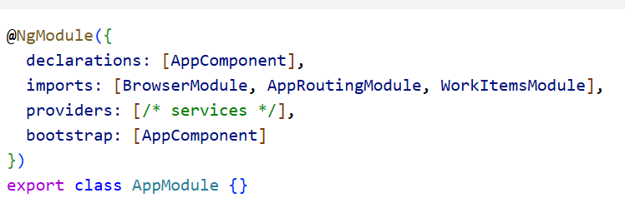
2. Components (@Component)
UI building blocks with templates, styles, and logic In this project:
Root Component: AppComponent with selector 'ey-root', Feature Components: WorkItemsGridManagerComponent, modals, forms, Shared Components: AppLoaderComponent, CardComponent, IconComponent
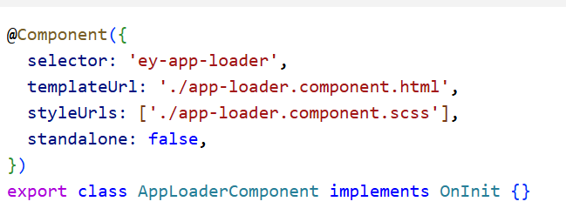
3. Services (@Injectable)
Business logic, data access, and shared functionality In this project:
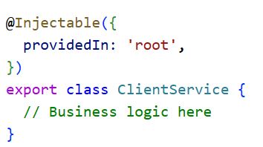
4. Dependency Injection & Providers
Supply dependencies to classes In this project:
Root level: HTTP interceptors, error handlers, Module level: Document handler configuration, Component level: DatePipe for specific components ,Custom Providers: Window provider, popup container provider
5. Routing (@angular/router)
Navigation between views In this project:
- App Routing: AppRoutingModule defines main routes
- Feature Routing: WorkItemsRoutingModule for work items routes
- Router Outlet: <router-outlet></router-outlet> in root template
- 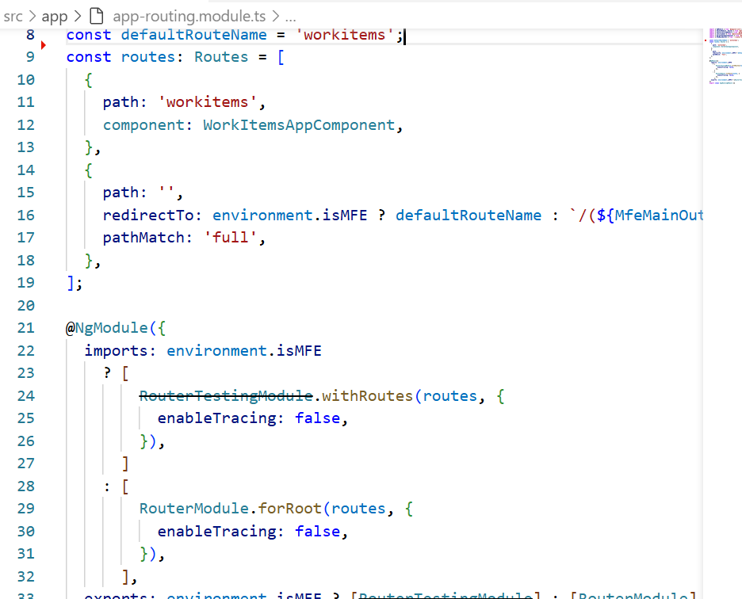
6. Directives
Purpose: Add behaviour to DOM elements in this project:
Attribute Directives, Structural Directives: Built-in *ngFor, *ngIf

7. Pipes (@Pipe)
Purpose: Transform displayed data In this project:
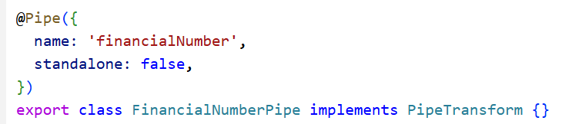
8. HTTP Interceptors
Purpose: Intercept and modify HTTP requests/responses.
9. State Management (NgRx)
HTTP Request Lifecycle in Angular :
Angular starts from main.ts. This is the real entry point of the application. In main.ts, Angular bootstraps the application
During bootstrapping, Angular creates the platform, initializes Zone.js, sets up the dependency injection container, and prepares the change detection mechanism.
Agular creates the root component. The component lifecycle starts with the constructor for dependency injection, followed by ngOnInit for initialization logic, and then view-related hooks once the template is rendered. At this stage, Angular compiles the templates using AOT, binds the data, and replaces the <app-root> element with the actual rendered DOM.
If routing is enabled, Angular evaluates the current URL, resolves route guards and resolvers, and lazy-loads modules or components as needed. This helps keep the initial bundle size small and improves startup performance.
Once the application is rendered, Angular enters its normal runtime mode. User interactions, HTTP responses, timers, and observable emissions trigger change detection. Angular updates only the affected parts of the UI to keep the view in sync with the data.
Phase 1 - Request Initiation Angular uses RxJS Observables for reactive programming. When a component needs data, it typically dispatches an NgRx action. For example, in this project, when loading work items, we dispatch loadWorkItemInit, which triggers an Effect that calls our WorkItemService. The service uses Angular's HttpClient to create a POST request to our API endpoint.
Phase 2 - HTTP Interceptor Chain: This is Angular's equivalent to .NET middleware pipeline, but processes in outside-in order. In this project, we have three interceptors: First, ADInterceptor handles Azure AD authentication, then RaptorInterceptor adds business-specific tokens, and finally ClientIDInterceptor adds tenant-specific headers. Each interceptor can modify the request, add headers, or even cancel it.
Phase 3 - Request Management: -we have automatic request cancellation through HttpCancelService. Unlike .NET where you manually pass CancellationTokens, Angular uses the takeUntil operator with RxJS Subjects. If a user navigates away or makes a new request to the same endpoint, the previous request is automatically cancelled to prevent race conditions.
Phase 4 - Network Execution: Angular's HttpClient handles the actual HTTP call, providing strong typing - similar to .NET's typed HttpClient but more seamless with TypeScript integration.
Phase 5 - Response Processing: Responses flow back through interceptors in reverse order. Our NgRx Effects handle success and failure cases, dispatching appropriate actions. Success updates the store state, while errors are caught using the catchError operator and handled by our BaseAlertService for user feedback.
explain angular hook life cycle in detail.
constructor
Used only for dependency injection, not for initialization logic.
ngOnChanges
Triggered when @Input values change; used to react to parent-driven data updates.
ngOnInit
Used for component initialization like API calls and setting initial state.
ngDoCheck
Used for custom change detection (rarely used due to performance impact).
ngAfterContentInit
Called after projected content (ng-content) is initialized.
ngAfterContentChecked
Runs after every check of projected content (avoid heavy logic).
ngAfterViewInit
Used when DOM or child components are ready (ViewChild, third-party libs).
ngAfterViewChecked
Runs after every view check (use cautiously to avoid performance issues).
ngOnDestroy
Used for cleanup—unsubscribe observables, clear timers, remove listeners.

What are Containers?(Docker)
When programmers develop applications, they usually do it on their local machines, that is, their own local development environments. However, the application’s code needs to be moved into production for it to be rolled out to the end customers and that is when the real problem arises. It might happen because of a lot of reasons. For instance, it might happen that the local development environment and the production environment have different operating systems, etc. This is where the superpower of Containers really comes into play in the development of applications – to solve the issue of portability of code from the local environment to the production environment.
- It allows us to package our applications with all the dependencies and distribute them as individual bundles.
- Docker guarantees that our application will run in the same way on every Docker instance.

Containers allow developers to package up their application, including all of the bins and libraries on which the code is dependent, into a small container image. In the production environment, these containers can be run on any server which supports a containerization platform.
****************************************************************************
What is Kubernetes?
Docker is an amazing open standard for packaging and distributing containerized applications, there are also a few problems with it. For instance, how can we coordinate and schedule all of these Docker containers? Also, how can we seamlessly upgrade an application without any interruption of service? Monitoring the health of an application to know when something goes wrong and seamlessly restarting it was also an issue that needed to be resolved as the downtime involved in restarting the application would lead to a bad user experience. This is where container orchestration or management platforms like Kubernetes, Docker Swarm, etc. come into the picture.
Kubernetes (also known as K8s) is an open-source container orchestration platform that was released by Google in 2014. . It is designed to automate and centrally manage containerized applications.
Kubernetes ensures that all the Docker containers that execute various workloads are scheduled to run physical or virtual machines and are packed efficiently following the constraints of the deployment environment and the cluster configuration. Apart from that, Kubernetes also keeps an eye on all running containers and replaces dead, unresponsive, or otherwise unhealthy containers, and provides metrics related to these containers
- Service Discovery and load balancing: Kubernetes offers a feature that assigns the containers with their own IP addresses and a unique Domain Name Server (DNS) name. These can be used to balance the load on them.
- Auto Scaling: Kubernetes, based on CPU usage, can also provide the vertical and horizontal scaling of applications which can be triggered using the command line.
- Storage Orchestration: Kubernetes supports storage orchestration or management by enabling the user to mount the network storage system as a local file system.
- Batch execution: Managing both batch and Container Image (CI) workloads along with replacing containers that fail is also one of the interesting features which Kubernetes has to offer.
- Configuration Management and Secrets: In Kubernetes, each and every classified information, for instance, keys and passwords are stored under a module known as Secrets. These can be used especially while configuring the application without having to reconstruct the image.
What is horizontal scaling vs vertical scaling?
Up = bigger machine; Out = more machines.

Vertical scaling makes one server bigger (simple, but limited and expensive);

horizontal scaling adds more servers behind a load balancer (complex, but elastic and fault-tolerant). Load balancer, stateless services, shared cache (Redis), distributed config are needed for horizontal scaling.

raptor-workmgmt-api is built for horizontal scaling — stateless APIs, Azure Functions, Service Bus consumers,
migration toward Cosmos DB — while SQL Server remains primarily vertically scaled.

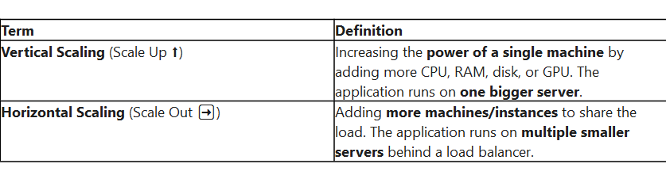
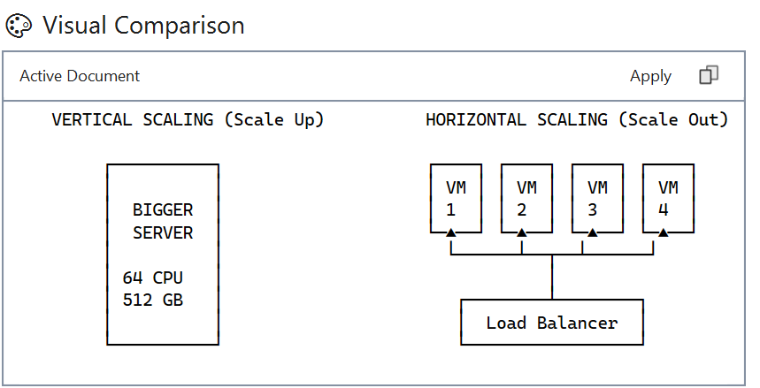

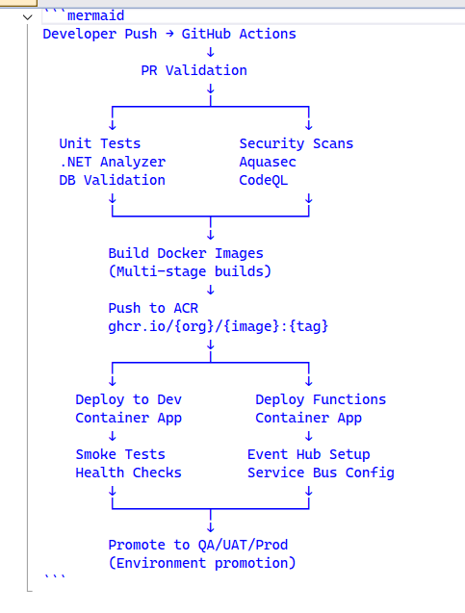
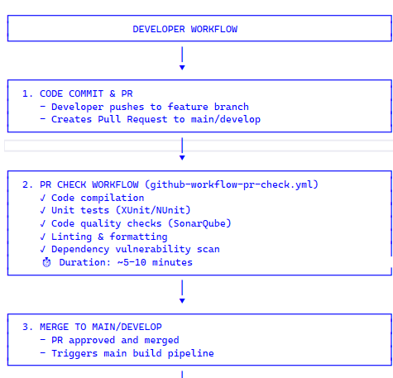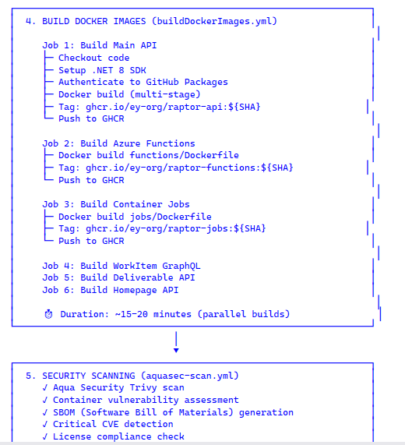
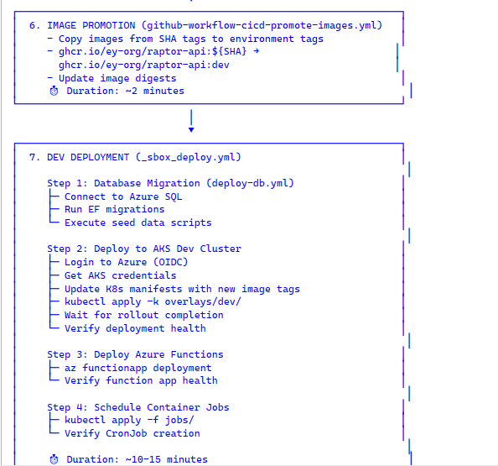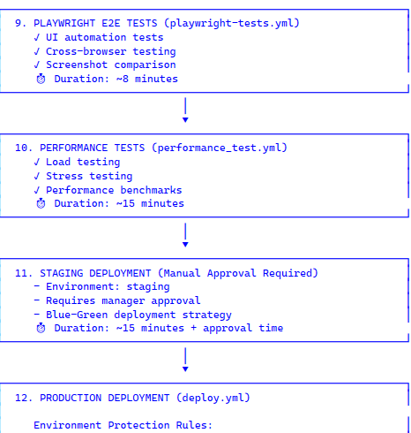
### Q1: Explain the multi-stage Docker build strategy.
We use a 4-stage build process:
1. **Base**: Runtime-only image (mcr.microsoft.com/dotnet/aspnet:8.0)
2. **Build**: SDK image for compilation, includes restore and build
3. **Publish**: Optimized publish output without dev dependencies
4. **Final**: Production image with published artifacts only

**Benefits:**
- Reduces final image from ~2GB to ~200MB
- Eliminates build tools from production (security)
- Faster deployment and scaling
- Layer caching optimization

### Q2: How do you handle database migrations in CI/CD?
We use a separate workflow (`deploy-db.yml`) that runs before application deployment:
1. Execute EF Core migrations via `dotnet ef database update`
2. Use Azure SQL with connection string from Key Vault
3. Run idempotent migration scripts
4. Maintain rollback scripts for each migration
5. Use transactional DDL where possible
6. Separate job (`build-db.yml`) for SQL database projects

### Q3: Describe your deployment strategy for zero-downtime deployments.
We use **Canary Deployment** with **Rolling Updates**:
1. **Rolling Update Configuration:**
- `maxSurge: 1` - One extra pod during update
- `maxUnavailable: 0` - No pods go down until new one is ready
2. **Canary Release:**
- Deploy to 10% of pods → Monitor 5 min
- Scale to 50% → Monitor 10 min
- Full deployment → 100%
3. **Health Checks:**
- Liveness probe: `/health/live`
- Readiness probe: `/health/ready`
- Initial delay: 30s, period: 10s
4. **Automatic Rollback:**
- Triggered if readiness probes fail
- `kubectl rollout undo deployment/raptor-workmgmt-api`

### Q4: How do you manage secrets and sensitive configuration?
Multi-layered approach:
1. **Build-time:**
- GitHub Secrets for CI/CD credentials
- Build args for NuGet authentication (no hardcoded PATs)
2. **Runtime:**
- Azure Key Vault for all application secrets
- Managed Identity (OIDC) for authentication
- Kubernetes Secrets (sealed-secrets) for cluster-specific config
- CSI Driver to mount Key Vault as volumes
3. **Best Practices:**
- Secret rotation every 90 days
- Audit logging on all secret access
- Never commit secrets to Git (git-secrets pre-commit hook)

// 1. Remove Duplicates (Preserve Order)
I’m using a HashSet for O(1) lookups and preserving order using a List.
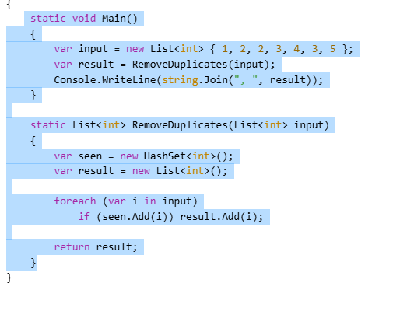
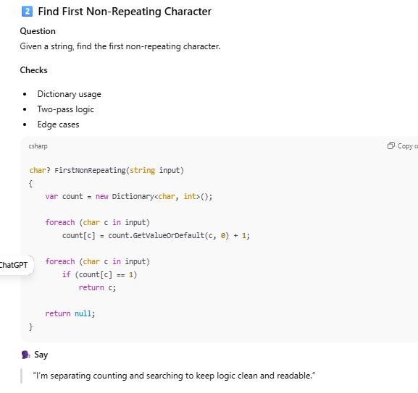
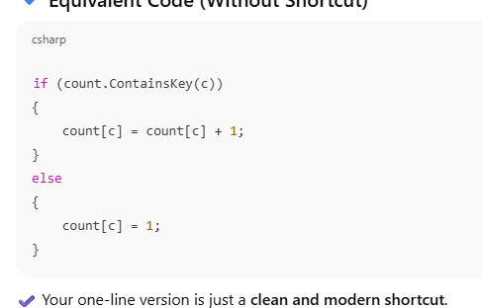
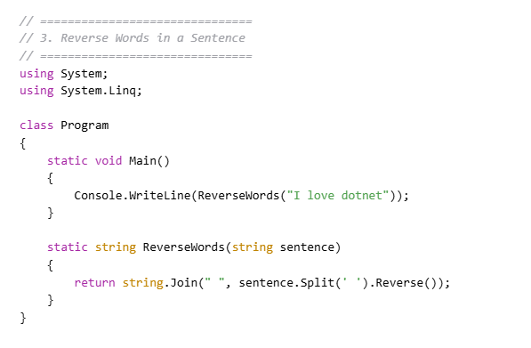
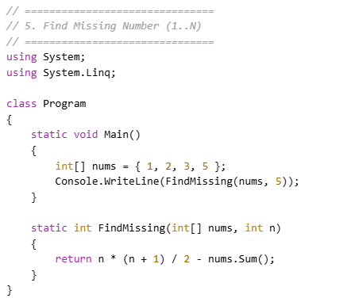
)Write a code for Repeated Word Count In A String Using C#
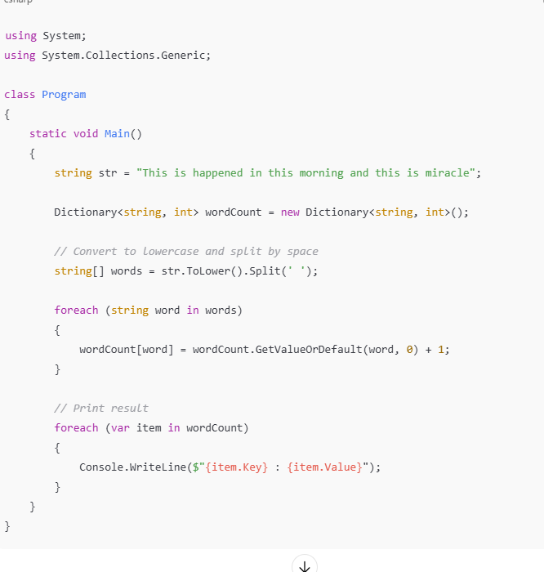
3)write a for to find All Possible Substrings Of A Given String In C#?
input: abcd
output: a ab abc abcd b bc bcd c cd d
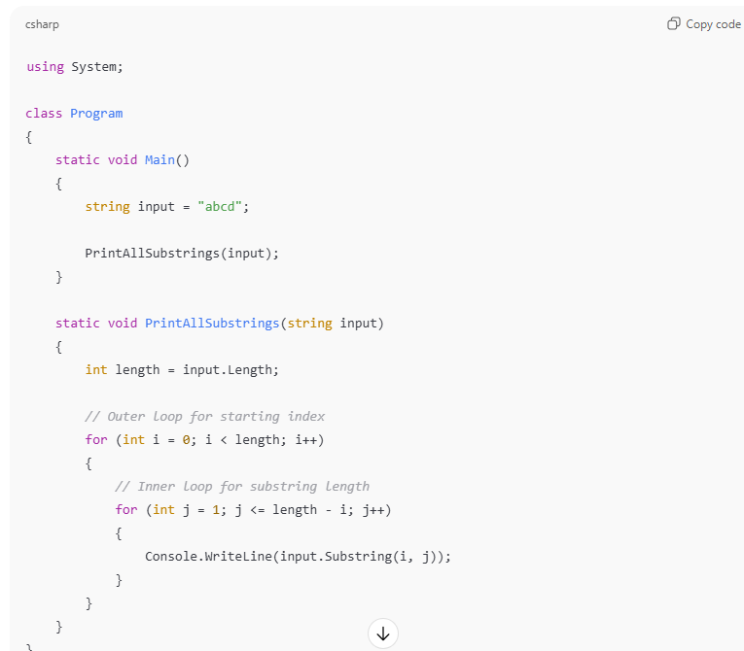
“Substring(startIndex, length) extracts a portion of a string starting at a given index for a specified number of characters.”
4)write a code to Reverse the string without change word position in c#
input: my name is abc
output: ym eman si cba
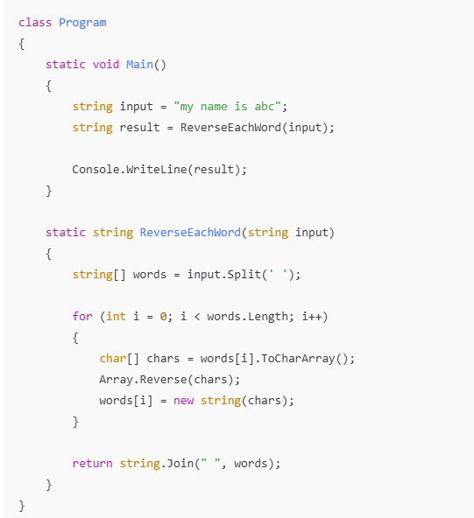

How do you handle pressure and deadlines?
“I stay calm and focus on priorities. First, I break the work into small tasks and identify what is most important.
I communicate clearly with my team if there are risks or dependencies.
I follow a plan, avoid last-minute surprises, and ask for help when needed.
Under pressure, I focus on delivering quality work without compromising stability
. Why should we hire you as a senior developer?
You should hire me because I bring strong technical skills along with real production experience.
I design clean, scalable solutions and write maintainable code.
I take ownership of my work, support my team, and help juniors grow.
I also communicate clearly with stakeholders and focus on delivering quality solutions on time.
I always think about long-term impact, not just quick fixes.
. Describe a time you failed or made a mistake
.”Early in my career, I once pushed a change without fully testing an edge case. It caused a minor issue in production.
I immediately informed the team, fixed the issue quickly, and added proper test cases to prevent it from happening again. Since then, I always ensure better testing and reviews before deployment. That experience helped me become more careful and responsible
🔹 5. How do you mentor junior developers?
“ mentor junior developers by guiding them step by step. I explain the logic behind the code, not just the solution.
I encourage clean coding, best practices, and writing readable code. I do regular code reviews, give constructive feedback, and help them understand mistakes.
I also support them with debugging, design discussions, and real-time examples from production. My goal is to help them become confident, independent developers.”
- How do you handle disagreement with architects or managers?
I handle disagreements professionally and respectfully.
First, I listen carefully to understand their point of view.
Then I share my perspective with clear technical reasons and data.
I focus on what is best for the project, not personal opinions.
If needed, I suggest alternative solutions and align with the final decision once it is made.
What is the difference between Singleton design pattern and Static class in C#?
Static classes are best for stateless utility logic.
Singleton is a design pattern that gives controlled access to a single instance, supports DI, testing, and better architectural flexibility.”
If you do not specify an access modifier for a class, what is the default access modifier?
internal by default.
This means the class is accessible only within the same assembly, not outside it.
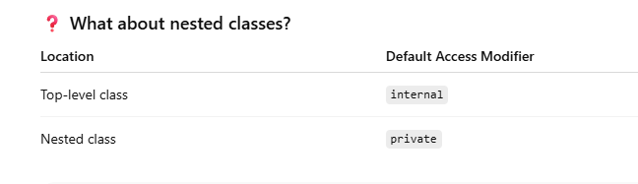
Can a class have more than one destructor in C#?
In C#, a destructor is used to clean up unmanaged resources.
A class can have only one destructor.
Since the garbage collector manages object finalization, C# restricts classes to a single destructor to keep cleanup predictable.”
Why we need finally block in the real-time project?
In real-time projects, finally ensures critical cleanup like
closing connections,
Closing Files / Streams
releasing resources, logging, and
resetting state always happens, which prevents memory leaks and production issues.”
can we pass parameters to Static Constructors?
No. You cannot pass parameters to a static constructor in C#.
Is called automatically by the CLR
Executes only once per type
Runs before the first use of the class
Used when-Initializing static fields, Loading configuration, One-time setup logic

What is Deferred Execution in LINQ?
Deferred Execution means that a LINQ query is not executed when it is defined, but is executed only when it is actually enumerated.
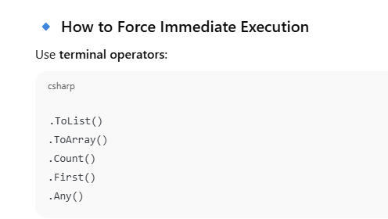
“In APIs, I often force execution using ToList() before returning data to avoid deferred queries executing outside the DbContext lifecycle.”
can we declare static method in interfaces?
Yes, in modern C# (8/11+), interfaces can have static methods with implementation. These methods are called via the interface type, not instances, and are useful for helpers, factories, or generic constraints.
Static methods in interfaces are accessed using the interface name itself, not through instances or implementing classes.
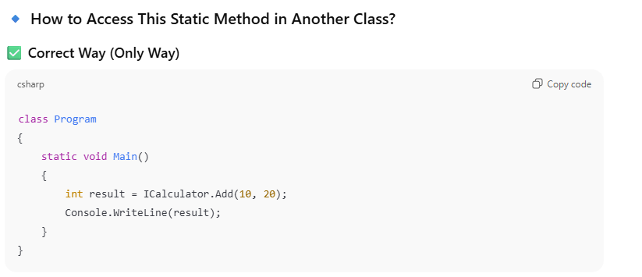
difference between Var vs dynamic?
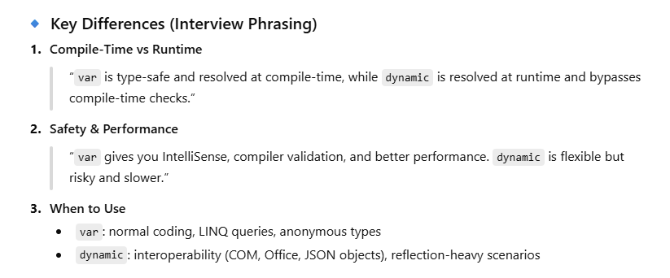
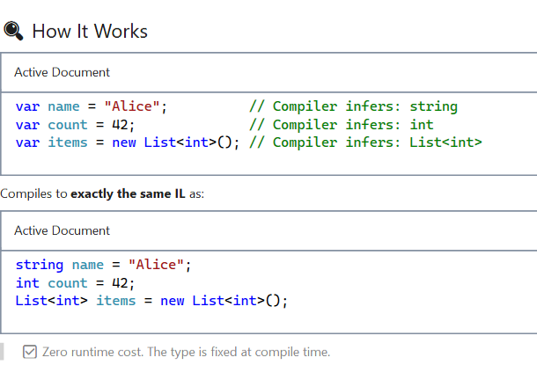

What is a Delegate? -
A delegate in C# is essentially a type-safe function pointer or a reference to a method. Think of it as a variable that holds a method instead of data. It allows you to pass methods as parameters, store them in variables, and invoke them dynamically.
The key benefit is decoupling - you can write code that accepts any method matching a specific signature, without knowing what that method does at compile time.
Built-in Delegates (What We Use in Production):
Func<T, TResult> - Returns a value
Action<T> - Returns void (no result)
Predicate<T> - Special Func returning bool
Every LINQ method (Where, Select, OrderBy, etc.) uses delegates.
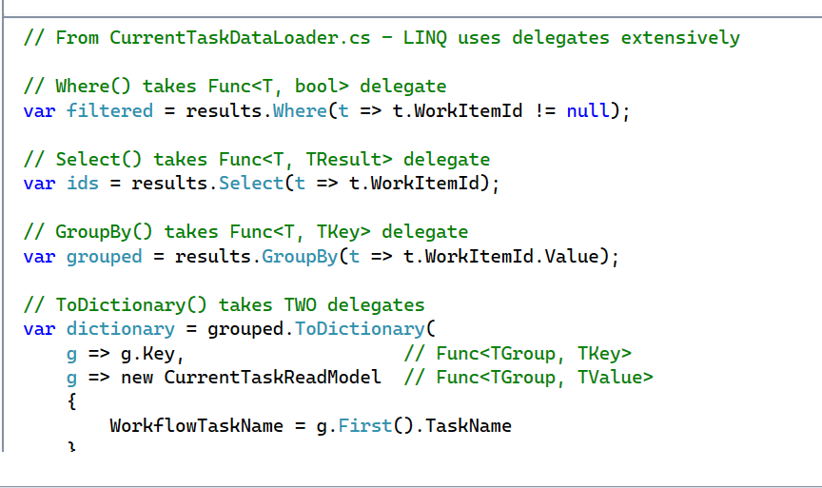
Multicast Delegate:
A delegate that holds references to multiple methods, all of which are invoked in sequence when the delegate is called.
Every C# delegate inherits from System.MulticastDelegate, so all delegates are multicast-capable.
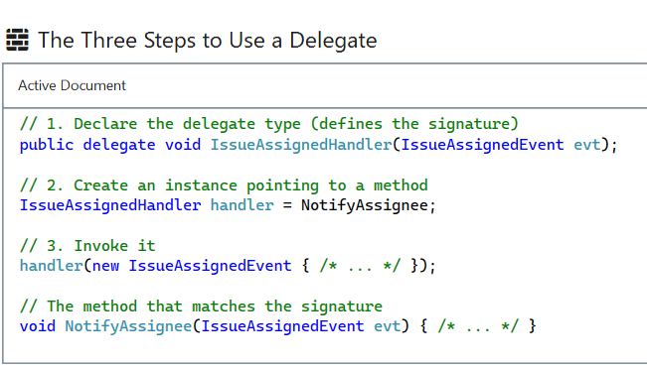
*************************************************************
What are expression trees and where are they used?
An expression tree is an in-memory, tree-shaped data structure that represents code as data.
Instead of executing the code, it lets me inspect, transform, translate, or compile it at runtime. They live in System.Linq.Expressions.
same C# lambda compiles to two completely different things depending on the target type. If I assign it to a Func<T>, the compiler emits an executable delegate. But if I assign it to an Expression<Func<T>>, the compiler emits a tree of Expression objects describing the code — BinaryExpression, MemberExpression, MethodCallExpression, and so on.
real-world use is LINQ to SQL — that's how EF Core takes a C# lambda like db.Users.Where(u => u.Age > 18) and turns it into a SQL WHERE clause. Without expression trees, you'd have to write SQL by hand. They're also why IQueryable<T> is fundamentally different from IEnumerable<T> — IEnumerable carries delegates, so filters run in memory; IQueryable carries expression trees, so the provider can translate them into SQL, OData, MongoDB filters, Azure Search filters, or whatever.
We uses them heavily through [UseProjection], [UseFiltering], and [UseSorting] attributes that build expression trees from incoming GraphQL queries and push them straight into EF Core, so we only fetch the columns the client actually requested. Th
Managed vs Unmanaged Code - Interview Answer
"Managed code runs on a runtime environment like the .NET CLR (Common Language Runtime) which provides automatic memory management, type safety, and security. Unmanaged code runs directly on the operating system without a runtime layer—you manually handle memory allocation and deallocation, like in C or C++."

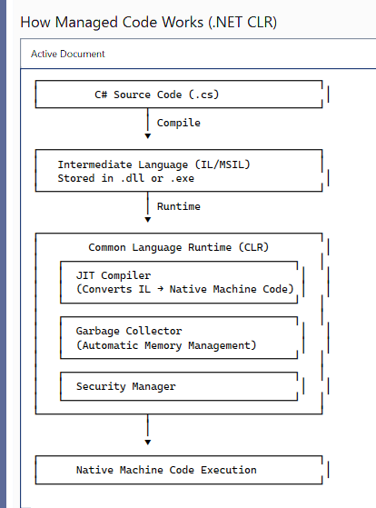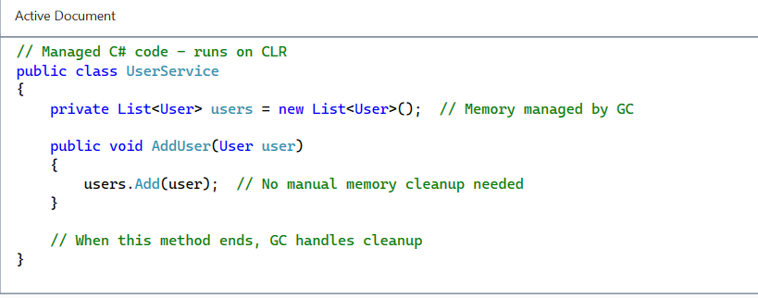
How Garbage Collection Works?
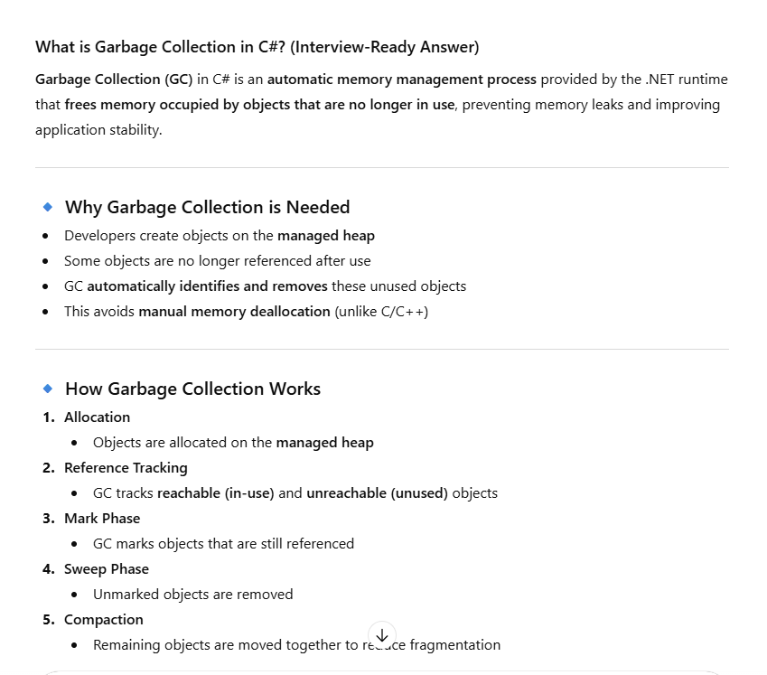
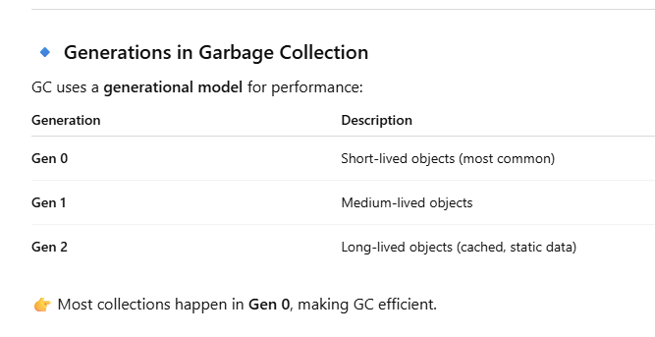
*********************************************************************
What are memory leaks in managed code and how do they occur?

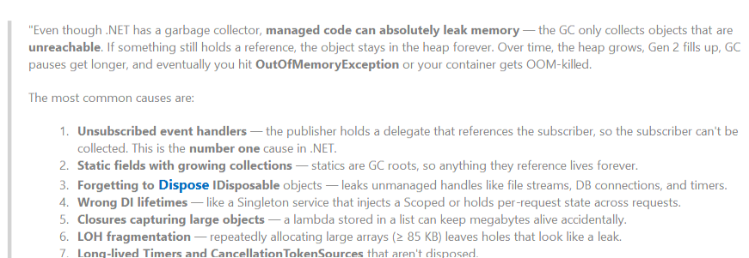
difference between finalise and finally in c#?
finally is a block in exception handling that always runs to clean up resources, while Finalize is a destructor method called by the garbage collector to clean up unmanaged resources non-deterministically.
IDisposable: IDisposable is interface that provides a deterministic way to release unmanaged resources (file handles, database connections, network sockets, etc.) before the garbage collector reclaims memory. It defines a single method: Dispose().
In .NET 8, we also have IAsyncDisposable for async resource cleanup with DisposeAsync().
"The using statement ensures Dispose() is called even if exceptions occur—equivalent to try-finally"
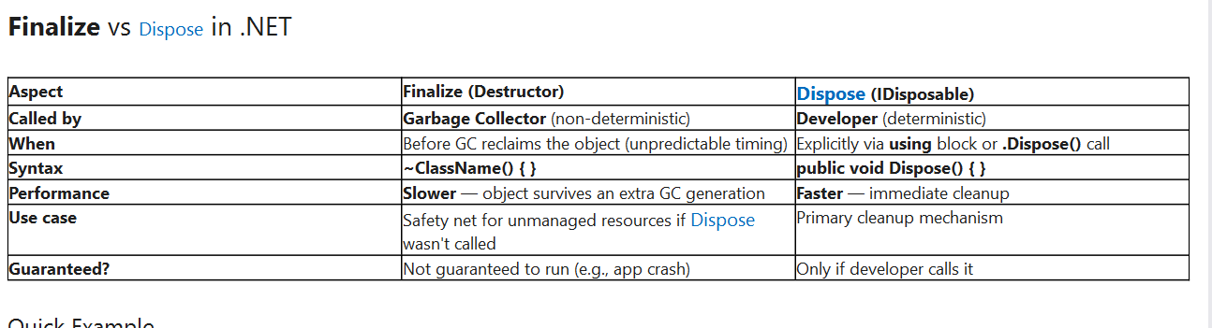
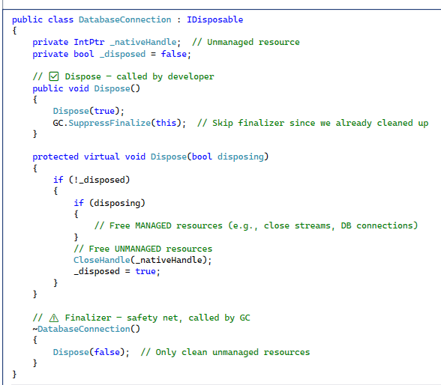

*********************************************************

Explain the .NET memory model and stack vs heap.
The stack is a small, fast, per-thread region that uses LIFO allocation. It stores method call frames, local variables, method parameters, and value types like int, bool, and struct. Because allocation is just moving a pointer, it's extremely fast — and memory is reclaimed automatically when a method returns.
The heap is a larger, shared region managed by the Garbage Collector. All reference types — classes, strings, arrays — live there. When I write var x = new IssueAssignedEvent(), the reference x lives on the stack, but the actual object lives on the heap. The GC tracks references and reclaims objects when no one is using them anymore.
StackOverflowException- Excessive recursion or huge stack-allocated data.
OutOfMemoryException-Heap exhaustion — leaks, huge objects, or LOH fragmentation
The .NET GC is generational — it splits the heap into Gen 0, Gen 1, and Gen 2, plus the Large Object Heap for objects above 85 KB. Most objects die young, so collecting Gen 0 is very cheap. Long-lived objects get promoted to Gen 2, which is collected less often because it's expensive.
A common gotcha is boxing — when a value type is assigned to an object, it gets copied to the heap, which causes GC pressure. In hot paths, I avoid that by using generics, Span<T>, or stackalloc.

Difference between Ref and Out keywords in C#
- ref: The variable must be initialized before passing to the method
- out: The variable doesn't need initialization, but the method must assign a value before returning"
Q: Can you use ref and out with async methods?
A: "No, you cannot use ref or out parameters with async methods. The compiler will give an error because async methods may be executed across different threads, and ref/out parameters require consistent memory addresses.
- *****************************************************************
- When to Use Abstract Classes in C#
An abstract class is a class that cannot be instantiated directly and is designed to be a base class for inheritance. It can contain both abstract members (no implementation) that derived classes must implement, and concrete members (with implementation) that can be shared across all derived classes. Use abstract classes when you need to define a common template with shared behavior for related classes.
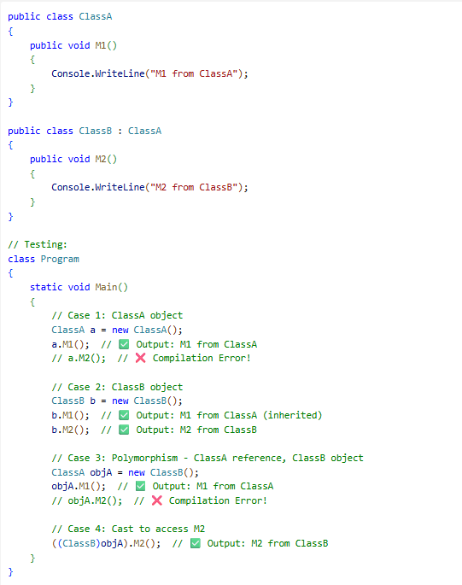
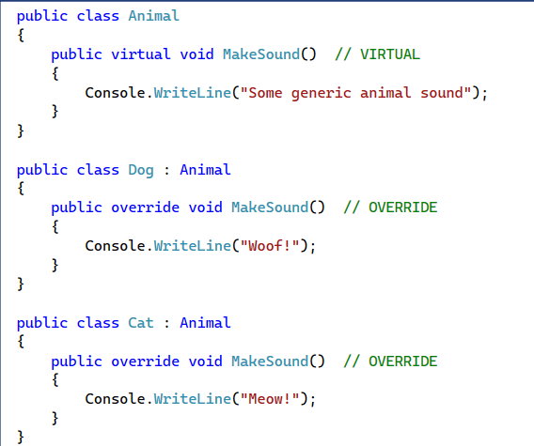
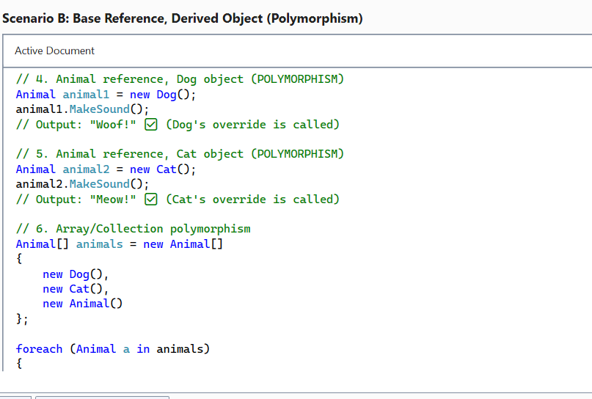
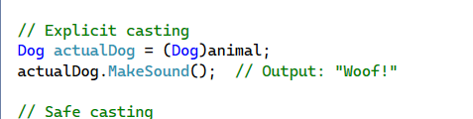
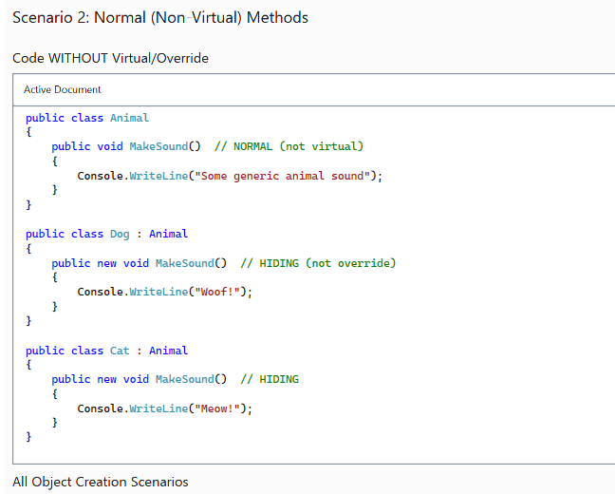
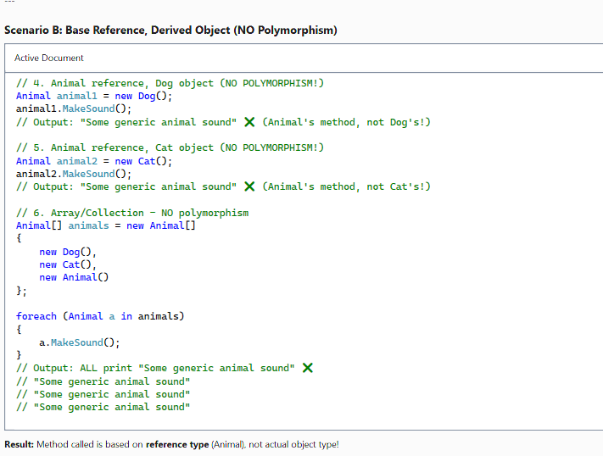
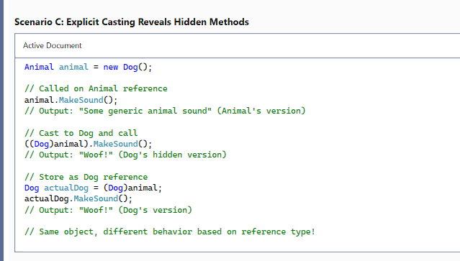
4. Dep table and Emp table , write query emp count by Dep using Sql, Linq,EntityFramecore
- 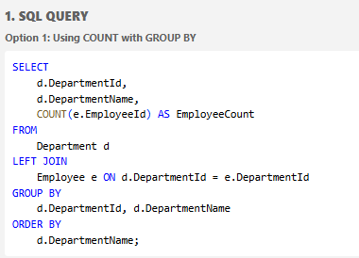
- 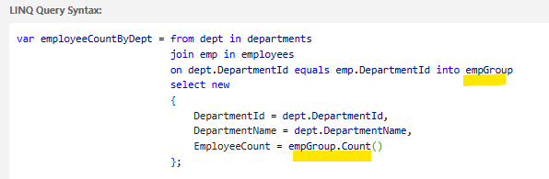
- 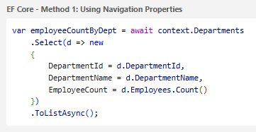

When Should a Method Be Declared as Sealed in C#?
A method should be declared as sealed when you want to prevent derived classes from overriding a virtual or abstract method that was already overridden in the current class. It's used to 'lock down' an implementation in an inheritance chain while still allowing the class itself to be inherited.
Can you seal a non-virtual method?
A: "No. You can only seal methods that are already virtual or abstract. The sealed keyword only makes sense in the context of overriding.

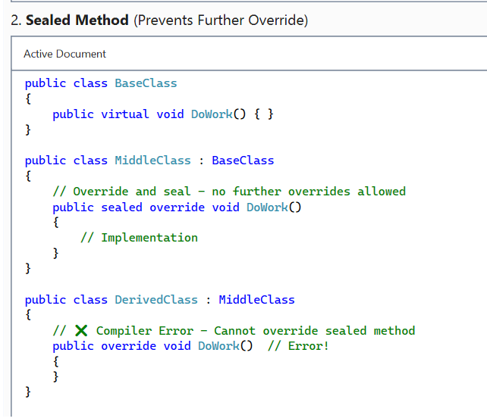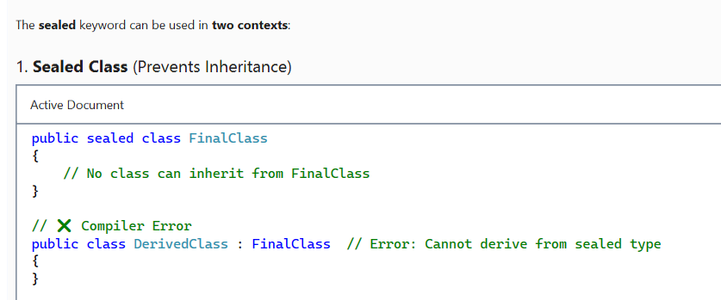
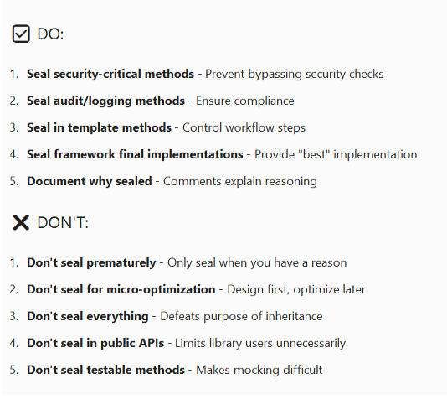
Can we overload methods in the same class?
Yes, absolutely! Method overloading allows you to define multiple methods with the same name in the same class, as long as they have different parameter signatures (different number of parameters, different types, or different order of parameters.
Method Overriding vs Method Hiding in C#
Method Overriding uses the override keyword to replace a base class's virtual or abstract method implementation, providing runtime polymorphism. Method Hiding uses the new keyword to hide a base class method with a new implementation, but it's based on compile-time type rather than runtime type. Overriding is preferred for true polymorphism; hiding should be used sparingly and only when necessary.

What is the difference between System exceptions and Application exceptions?
Exception handling in C# uses try-catch-finally blocks to manage runtime errors. The flow is: code executes in try, if an exception occurs, execution jumps to the matching catch block, then finally always executes for cleanup.
System exceptions are thrown by the CLR for runtime errors, while application exceptions are custom exceptions you create for business logic errors. Modern C# recommends inheriting from Exception directly rather than using Application Exception.
What Happens if the Finally Block Throws an Exception?
If a finally block throws an exception, it overrides/suppresses any exception that was thrown in the try or catch block.
The original exception is lost unless you explicitly handle it. This is dangerous and should be avoided.
Modern C# provides ExceptionDispatchInfo and aggregate exceptions to preserve both exceptions
how have you used serialisation in your project?
Serialization is the process of converting an object or data structure into a format that can be stored, transmitted, or reconstructed later. Deserialization is the reverse process—converting the serialized format back into an object. Common formats include JSON, XML, and binary.

External API Integration:
For our CEM GraphQL client, we use System.Text.Json to serialize GraphQL query requests and deserialize responses. It's faster than Newtonsoft.Json and built into .NET 8, making it ideal for modern HTTP communication.
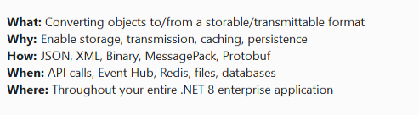
What is mutable & Immutable object. how you will handle the scenario where immutable class contains mutable object
Mutable Objects-Objects whose state (field/property values) can be changed after creation.
// Built-in mutable types
List<int> numbers = new List<int> { 1, 2, 3 };
numbers.Add(4); // State changed - MUTABLE
StringBuilder sb = new StringBuilder("Hello");
sb.Append(" World"); // State changed - MUTABLE

Immutable Objects-Objects whose state cannot be changed after creation. Any "modification" creates a new object.
// Built-in immutable types
string text = "Hello";
text = text + " World"; // Creates NEW string, doesn't modify original.
DateTime dt = DateTime.Now;
dt = dt.AddDays(1); // Creates NEW DateTime, doesn't modify original
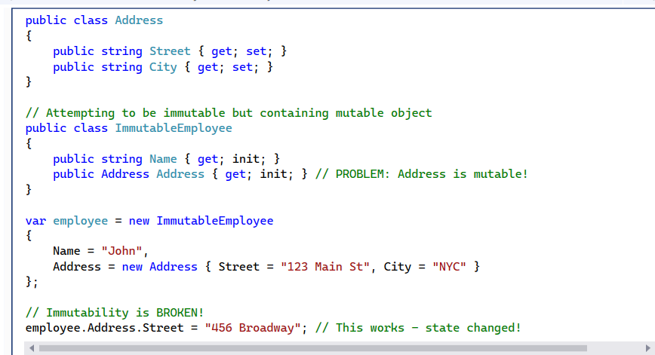
What is a Private Constructor?
A private constructor is a constructor with private access modifier that prevents external instantiation of a class. It can only be called from within the class itself.
How we can access method whose class having private constructor
- Singleton Pattern - Static Instance property provides the single instance
- Static Factory Method - Static method creates and returns instances
- Builder Pattern - Nested builder class creates the object
- Reflection - Force instantiation (not recommended for production)
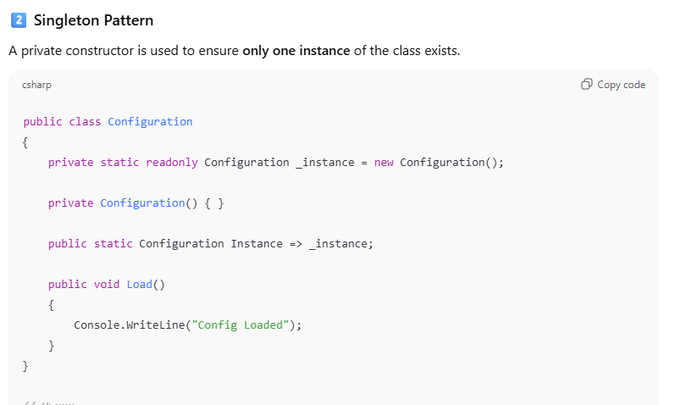
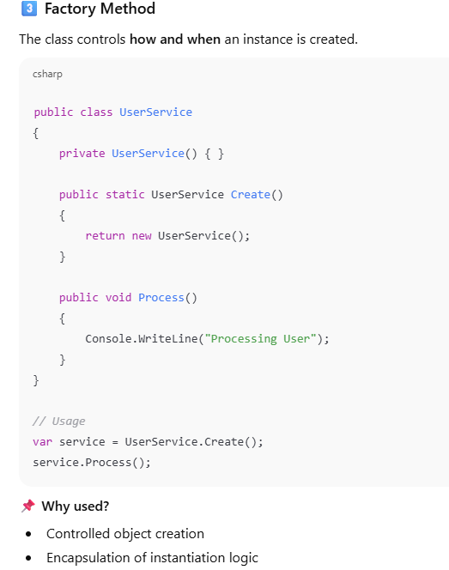
What is Boxing and Unboxing in C#? Is it good or bad?
Boxing converts a value type to a reference type and unboxing does the reverse.
It causes heap allocation and performance overhead, so it should be avoided in performance-critical code by using generics
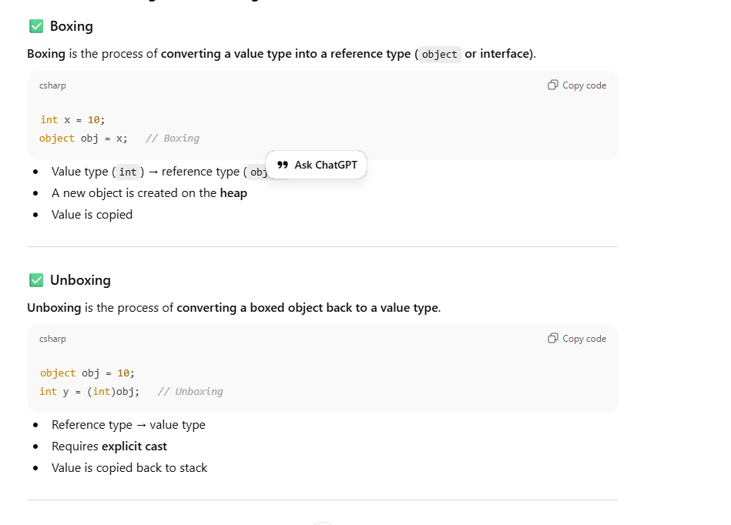
Separation of Concerns (SoC) - Interview-Ready Answer for 8+ Years Full-Stack .NET Developer
Separation of Concerns is a fundamental design principle where we divide a software system into distinct sections, each addressing a specific aspect of functionality. The goal is to reduce complexity by ensuring that each component has a single, well-defined responsibility."
"Think of it like organizing a company - you don't have one person doing sales, accounting, and engineering. Similarly, in software, we separate:
- Presentation logic (UI)
- Business logic (rules & workflows)
- Data access logic (database operations)
- Infrastructure concerns (logging, caching, messaging)
This separation makes code more maintainable, testable, and scalable."

Is vs As operator keyword in C#?
is checks whether an object is of a given type,
while as tries to cast an object to a given type without throwing an exception.
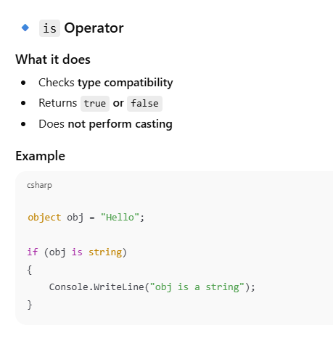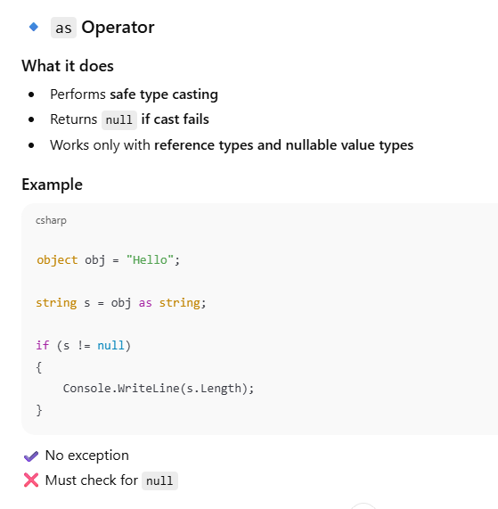
What is the use of Require Https in dot net core
- app.UseHttpsRedirection() - Automatically redirects all HTTP requests to HTTPS
- app.UseHsts() - Adds HTTP Strict Transport Security headers
what is Bundling and Minification in dot net core
Bundling combines multiple files into one to reduce HTTP requests, while
minification reduces file size by removing unnecessary characters, improving application performance.

Attribute routing takes precedence. If a controller has [Route] attribute, convention-based routes are ignored for that controller."
You can use [HttpGet], [HttpPost], [HttpPut], [HttpPatch], [HttpDelete], or generic [Route] with [HttpMethod] attribute. In our project, we use specific HTTP verb attributes for clarity.
How does API versioning work with attribute routing We use [ApiVersion("2")] attribute and route template v{version:apiVersion}. The framework substitutes the version automatically: /api/clients/{guid}/v2/workitem. This is configured in AddApiVersioning() middleware."
both are equally performant once the routing table is built."
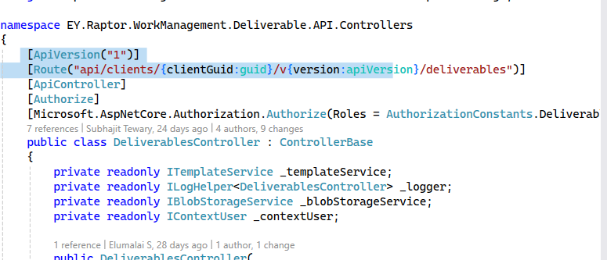

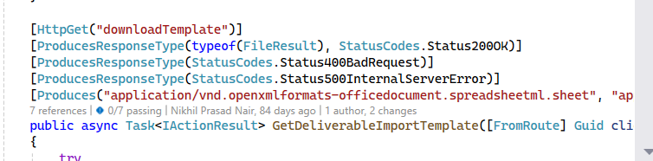
What is Content Negotiation in Web API?
Content negotiation in ASP.NET Core Web API is the mechanism that selects the response format based on the client’s Accept header and available formatters, such as JSON or XML.
ASP.NET Core handles content negotiation automatically using output formatters, but we can customize or restrict it for consistency and performance
What Happens if Format Is Not Supported?
API returns: 406 Not Acceptable
🔹 Most Important Status Codes (Interview Focus)
200 – OK
201 – Created
204 – No Content
400 – Bad Request – Invalid input- Validation Failure)
401 – Unauthorized-(invalid token)
403 – Forbidden-( Role-based access)
404 – Not Found
405- Method Not Allowed –(Wrong API Call)
409 – Conflict
500 – Internal Server Error
503 – Service Unavailable

Why is Web API Versioning Required?
when have breaking changes: changing response models, removing properties, changing data types, modifying validation rules, or altering authentication requirements. Non-breaking changes like adding optional parameters or new endpoints can be added to existing versions
How do you handle deprecation- Mark the old version as deprecated using [ApiVersion("1", Deprecated = true)], set a sunset date, communicate to clients via response headers (api-deprecated-versions), documentation, and email notifications. Provide a migration guide. After grace period (typically 6-12 months for enterprise APIs), remove support.

Role-Based vs Policy-Based Authorization
Role based limitation- What if you need "User can edit work items only if they're assigned to them AND the work item is not completed"? Roles can't express that.
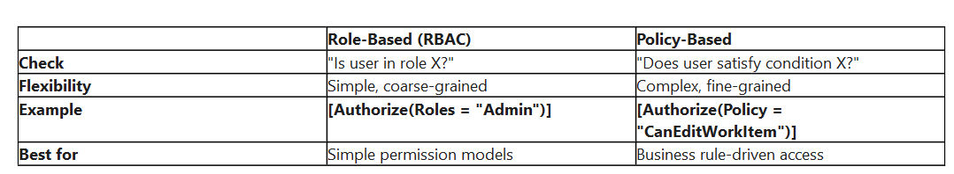
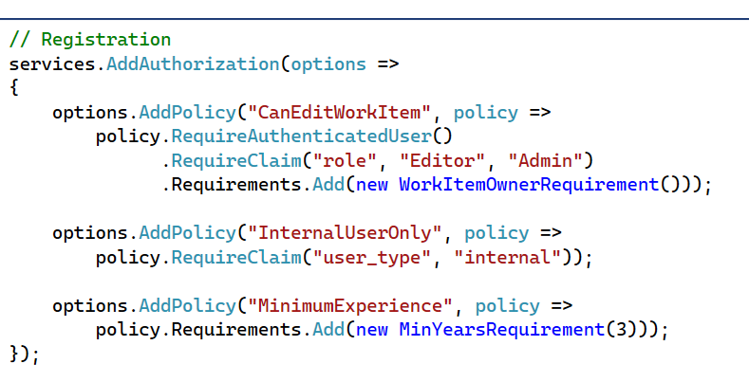

If REST applications are supposed to be stateless, how do you manage sessions?
REST APIs are stateless, meaning the server doesn't store session data between requests. In our EY Raptor Work Management API, we manage 'sessions' using token-based authentication. When a user authenticates with Azure AD, they receive a JWT token containing all session data—user identity, roles, permissions, client context, and entity access. This token has a 60-minute expiration and acts as the 'session.'
On every request, the client sends this token via the Authorization: Bearer {token} header. Our middleware pipeline validates the token's signature and expiration, then extracts claims to populate the IContextUser service with user context. No server-side session storage is needed.
This approach provides true horizontal scalability—any server instance can handle any request without session affinity or shared session stores. The token is self-contained, cryptographically signed, and includes all necessary context. When the token expires, the client uses a refresh token to obtain a new one, effectively creating a new 'session.' This is fully REST-compliant, stateless, and scales perfectly across our Azure App Service instances.
Refresh Token:
While access tokens (JWT) expire quickly (60 minutes in your project) for security, refresh tokens allow users to obtain new access tokens without re-entering credentials, providing a balance between security (short-lived access tokens) and user experience (no frequent re-login).
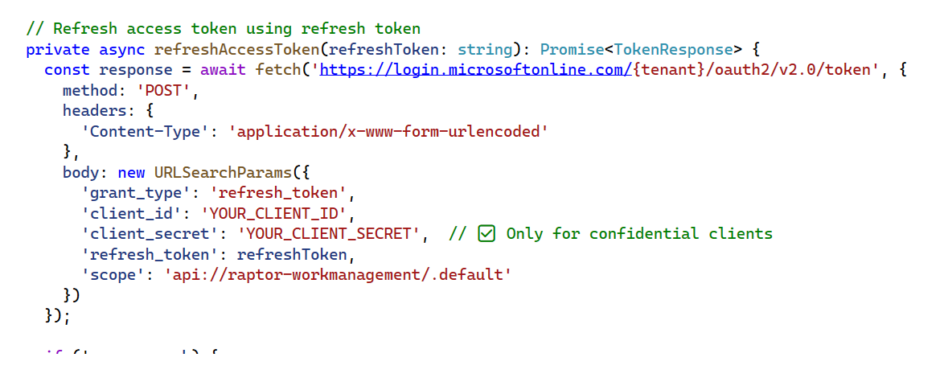
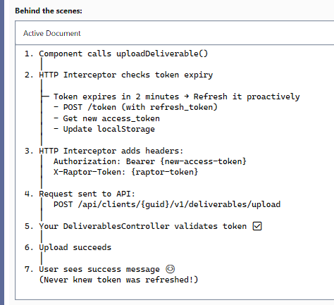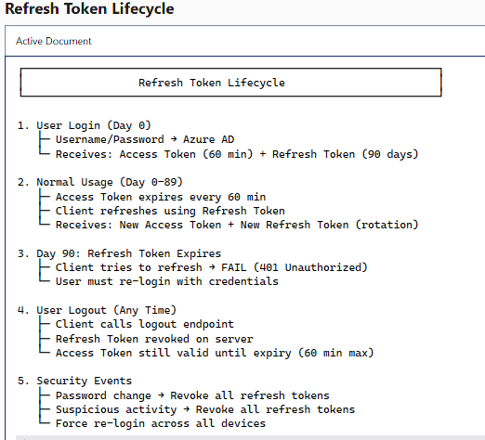
Important Return Types in .NET Core Web API:
IActionResult for maximum flexibility with multiple status codes,
ActionResult<T> for type-safe responses with Swagger support,
FileContentResult for Excel template downloads, and
Task<T> for all async operations.
We consistently use [ProducesResponseType] attributes for API documentation, follow RESTful HTTP semantics (200, 400, 404, 500), and implement structured error responses with error type and user-friendly messages."

How Can we assign an alias name for ASP.NET Web API Action?
ASP.NET Core Web API, we assign alias names to actions using the Name parameter in HTTP verb attributes like [HttpGet(Name = "GetWorkItemDetails")] or [HttpPost(Name = nameof(CreateWorkItem))].
// ✅ Pattern 1: String literal alias
[HttpGet("{workItemGuid}/WorkItemDetails", Name = "GetWorkItemDetails")]
// ✅ Pattern 2: nameof for type safety
[HttpPost(Name = nameof(CreateWorkItem))]
// ✅ Pattern 3: Descriptive business name
[HttpPost("validate", Name = "WorkItemNameExists")]
//Named Routes in Multi-Version APIs
[ApiVersion("2")]
[Route("api/clients/{clientGuid:guid}/v{version:apiVersion}/workitem")]

What is an HTTP Message handler in .NET core Web API Application?
"HTTP Message Handlers are components in the HttpClient request/response pipeline that intercept and process HTTP messages.
They inherit from DelegatingHandler and override SendAsync to add cross-cutting concerns like authentication, logging, retry logic, caching, or correlation IDs.

"In our EY Raptor Work Management API, we use HTTP Message Handlers for external service integrations with MAD Service, File Service, Notifications Service, CEM Service, and JIT Access Service.
For example, our RaptorTokenHandler adds the X-Raptor-Token header to all outgoing requests, similar to how our middleware adds it to incoming requests. We also have a SanitizedLoggingHandler that logs requests and responses using our ILogHelper with LogErrorSanitized to ensure no sensitive data is logged.
These handlers are registered by HttpClient in our dependency injection configuration. When a service injects IHttpClientFactory.CreateClient("MadService"), all registered handlers execute automatically in the pipeline—adding tokens, logging, implementing retries, etc.—without the service code needing to know about these concerns.
The handler pipeline flows both ways: before the request (adding headers, logging), then after the response (logging, error handling). Each handler calls await base.SendAsync(request, cancellationToken) to invoke the next handler in the chain, ultimately reaching HttpClientHandler which makes the actual HTTP call.
We can also integrate with Polly for resilience patterns like retry, circuit breaker, and timeout policies, which work seamlessly with message handlers. This gives us a powerful, testable, and maintainable way to handle cross-cutting concerns in our microservices communication."
What do you mean by Parameter Binding in Web API?
Parameter binding is the automatic process where ASP.NET Core maps HTTP request data to action method parameters.
Using binding source attributes like [FromRoute], [FromQuery], [FromHeader], [FromBody], and [FromForm], the framework extracts values from URL paths, query strings, headers, request bodies, or form data and converts them to strongly-typed .NET objects. With the [ApiController] attribute,
many bindings are implicit based on conventions—route parameters bind from URL, simple types from query strings, complex types from body."

Can we drop a table that has dependent views on it?
SQL Server, NO - you cannot drop a table if there are views (or other objects like stored procedures, functions, or foreign keys) that depend on it. SQL Server will raise an error to prevent breaking dependencies.
What is the difference between a Temporary Table and a Table variable?
"In our Work Management API, we strategically use temp tables for large datasets where we process thousands of work items with multiple joins."
We use table variables for small lookup sets like filing method categorization in usp_BulkUpdateFilingWorkItems where we only have 2-3 rows."
A critical gotcha: table variables don't work with dynamic SQL - that's why usp_GetDeliverables uses #tempResultSet even though it's batch-scoped."
Transaction safety is important in bulk operations - temp tables participate in ROLLBACK, but table variables don't for DML operations."
- "The lack of statistics on table variables means SQL Server always estimates 1 row, which can destroy performance on larger datasets."
Can you create foreign key constraints on temporary tables?
Yes, you can create FOREIGN KEY constraints on temporary tables, but only if both the parent and child tables are temporary tables within the same session.Both temporary tables (#temp) and permanent tables can participate in foreign key relationships, but global temp tables (##temp) have restrictions.
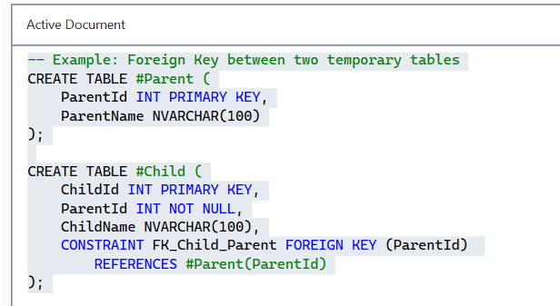
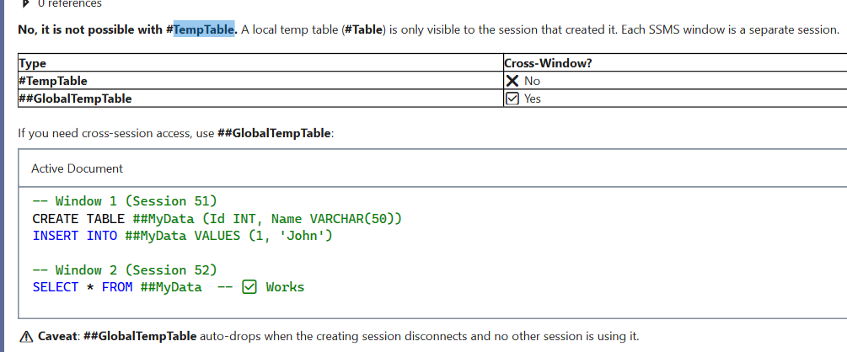
referential integrity in sql ?
Referential Integrity ensures that:
- Every foreign key value in a child table must exist as a primary key in the parent table
- OR the foreign key value must be NULL (if allowed)
- Prevents orphaned records - child records without valid parent references
- Maintains data consistency across related tables

what is sql injection?
SQL Injection is when attackers manipulate SQL queries by injecting malicious code through user inputs"
It's prevented through parameterized queries, never string concatenation"
Occurs when input is treated as executable code rather than data"
Can lead to data breaches, data modification, or complete system compromise"
In our Work Management API, we use Dapper with parameterized queries and EF Core LINQ which automatically parameterizes
Our stored procedures always use @Parameters, never dynamic string concatenation
We implement defense in depth: input validation + parameterization + least privilege DB access
I've seen SQLMap detect vulnerabilities in code reviews - always test with security tools"
What are inserted and deleted or what are magic tables?
INSERTED and DELETED are magic tables automatically created by SQL Server in triggers
INSERTED contains new/current values, DELETED contains old/previous values
In UPDATE operations, both tables are populated—DELETED has old, INSERTED has new
They have the same schema as the base table and can contain multiple rows for bulk operations
I've used INSERTED/DELETED to build comprehensive audit trails in multi-tenant systems
In our Work Management platform, we track WorkItem status changes by comparing INSERTED and DELETED
I've implemented cascading soft deletes using triggers that check DELETED.IsDeleted vs INSERTED.IsDeleted
For performance, I always use set-based operations on INSERTED/DELETED, never cursors
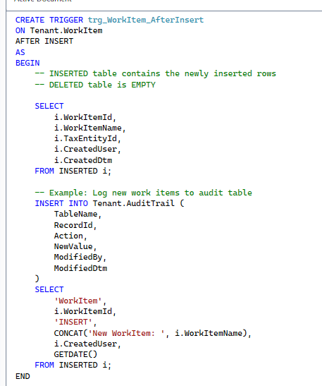
what is use of group by and having clause?
GROUP BY collapses rows into summary groups, enabling aggregate functions like COUNT, SUM, AVG, MIN, MAX"
HAVING filters grouped results (after aggregation), while WHERE filters individual rows (before grouping)"
You cannot use aggregate functions in WHERE—only in HAVING or SELECT"
Execution order: FROM → WHERE → GROUP BY → HAVING → SELECT → ORDER BY"
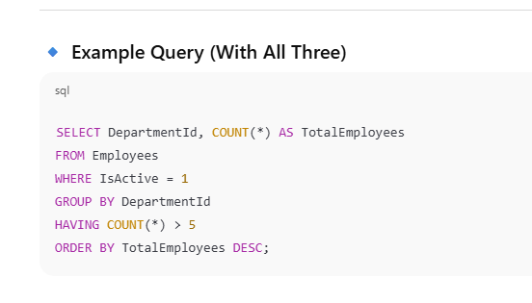

How to replace null value in sql server:
ISNULL(column, default) is SQL Server-specific, fastest for single-column NULL replacement
COALESCE(col1, col2, ..., default) is ANSI standard, evaluates multiple columns, returns first non-NULL
NULLIF(expr1, expr2) converts a specific value to NULL—useful for avoiding division by zero
CASE expressions provide complex conditional NULL handling for business logic
✅ Show Experience:
- "In our Work Management system, I use COALESCE for multi-level user fallback: AssignedTo → ApprovalUser → CreatedBy → 'Unassigned'"
- "I use ISNULL extensively in aggregates: SUM(ISNULL(PaymentAmount, 0)) to treat NULL as zero"
- "We use NULLIF in division calculations to prevent divide-by-zero errors: TotalAmount / NULLIF(ItemCount, 0)"
- "For data quality reports, I use CASE expressions to score completeness based on NULL counts"

Can we write a Trigger on View?
No, you cannot create standard DML triggers (AFTER/FOR triggers) directly on views in SQL Server. However, you can create INSTEAD OF triggers on views, which intercept INSERT, UPDATE, or DELETE operations and execute custom logic instead of the default action. This is particularly useful for updatable views, complex joins, partitioned views, and implementing business rules when modifying data through views
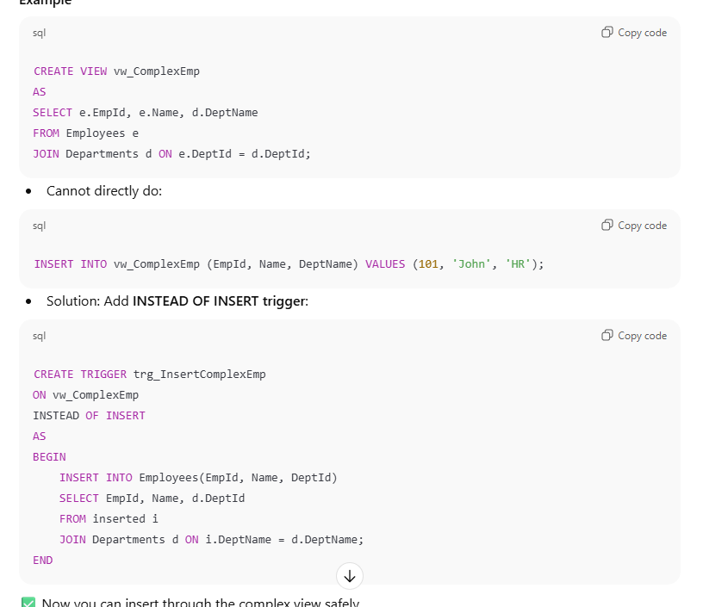1q1
Explain cte expression in SQL?
A CTE (Common Table Expression) is a temporary named result set defined within a single query using the WITH clause. It acts like a temporary view that exists only for the duration of the query. CTEs improve code readability, enable recursive queries, simplify complex joins, and help avoid redundant subqueries. They're particularly useful for hierarchical data, breaking down complex logic into manageable steps, and making SQL more maintainable.
- "Use temp tables if data is large and referenced many times—avoid CTE re-evaluation overhead"
- "Always add OPTION (MAXRECURSION n) to recursive CTEs to prevent infinite loops"
- "Use meaningful CTE names that describe the data they contain"
- "Chain CTEs with commas, not multiple WITH keywords"
- "For complex queries, break logic into multiple CTEs for maintainability"
- 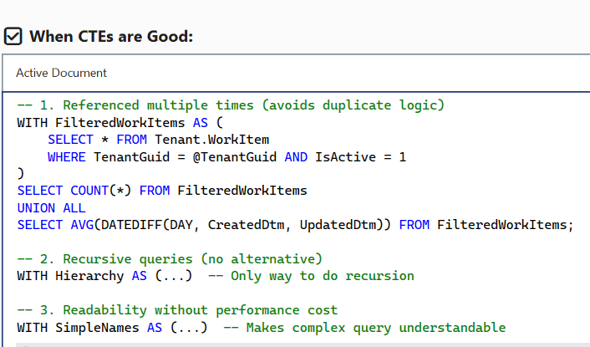
- 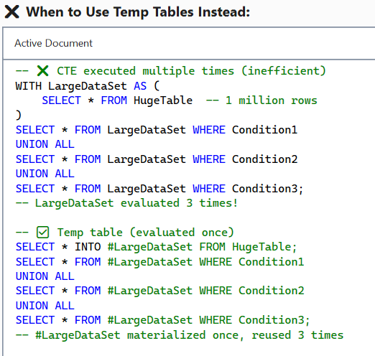
- 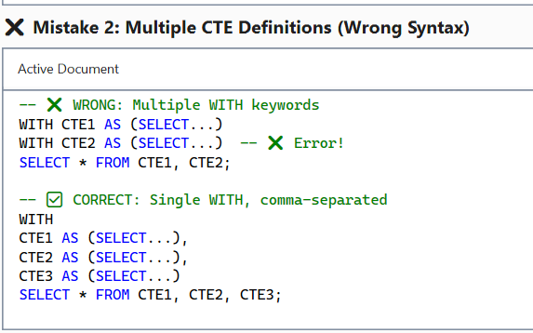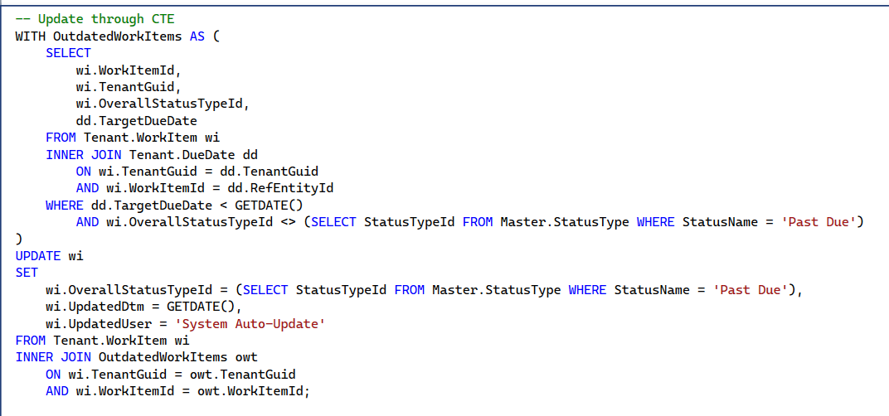
difference between function and Stored procedure.
- "Functions MUST return a value, stored procedures don't require it—they can use OUTPUT parameters or return result sets
- "Functions can be used in SELECT/WHERE, stored procedures cannot"
- "Scalar functions don't allow DML operations, stored procedures have full INSERT/UPDATE/DELETE support"
- "Stored procedures support transactions and TRY-CATCH, functions don't"
*************************
What happens if you run git pull and there is a conflict?
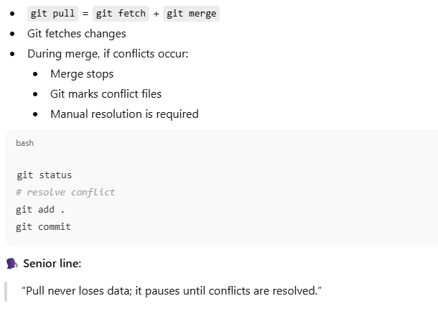
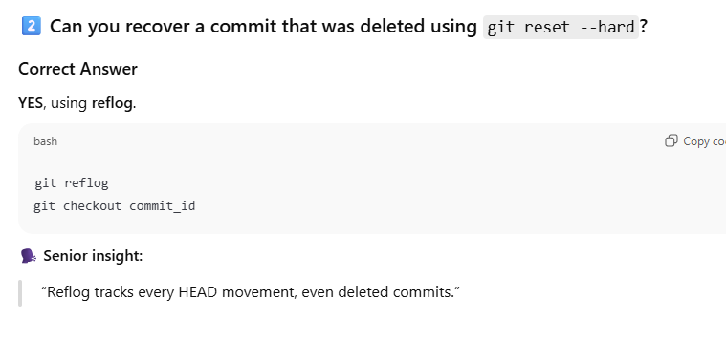
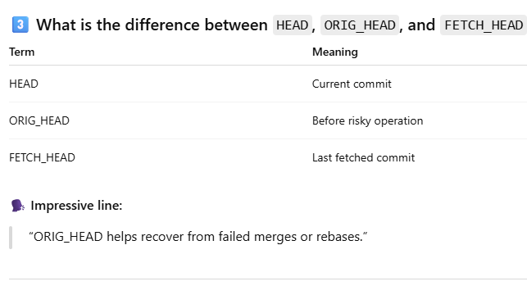
Why is git rebase dangerous on shared branches?
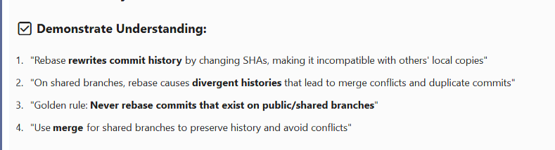
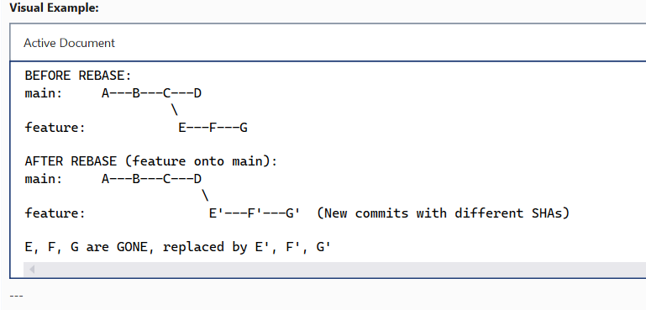
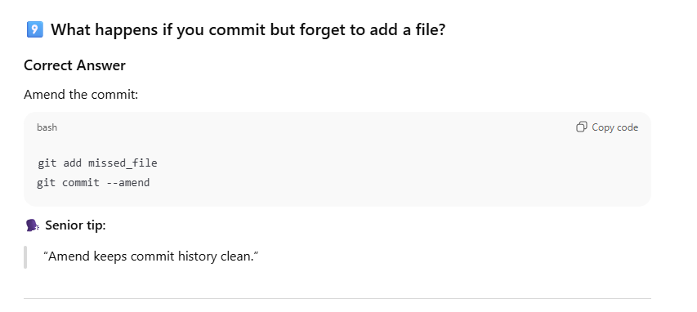
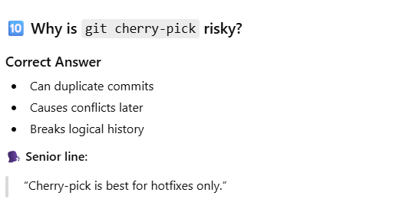
Why is Git Rebase Dangerous on Shared Branches?
Git rebase is dangerous on shared branches because it rewrites commit history, changing commit SHAs.
When you rebase a branch that others have already pulled, their local history becomes incompatible with the rewritten remote history, causing merge conflicts, duplicate commits, and potential data loss. The golden rule: never rebase commits that have been pushed to a shared/public branch—use git merge instead for collaborative work."

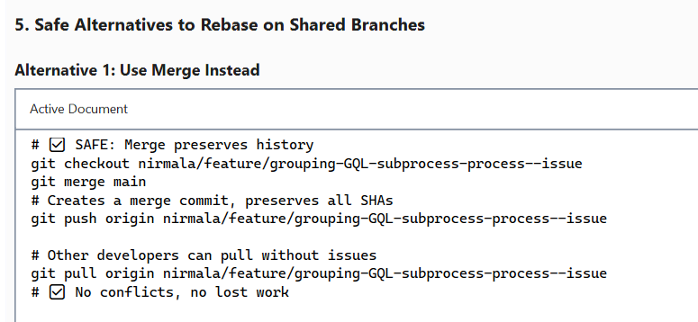
******************************************************88
Liskov Substitution Principle (LSP) in .NET
Objects of a derived (child) class should be replaceable with objects of the base (parent) class without breaking the application behavior.
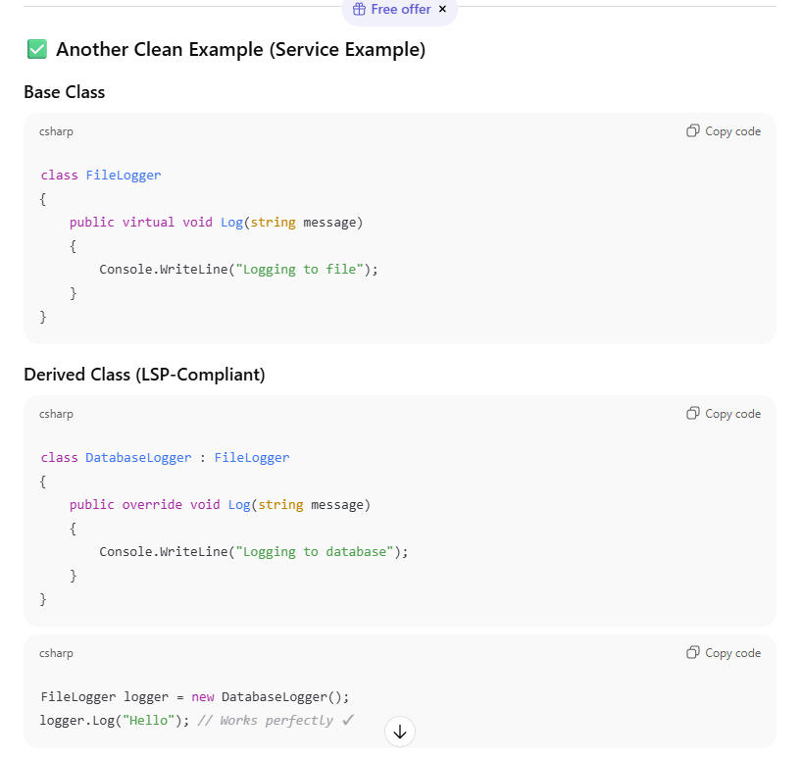

What observable in angular ?
An Observable in Angular is a stream of asynchronous data that can emit multiple values over time and is consumed by subscribing to it.
Angular uses RxJS Observables extensively for handling HTTP calls, events, and async operations.
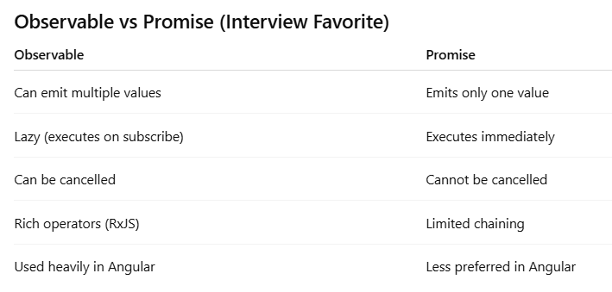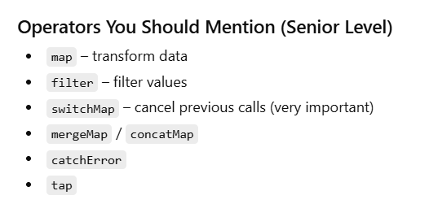
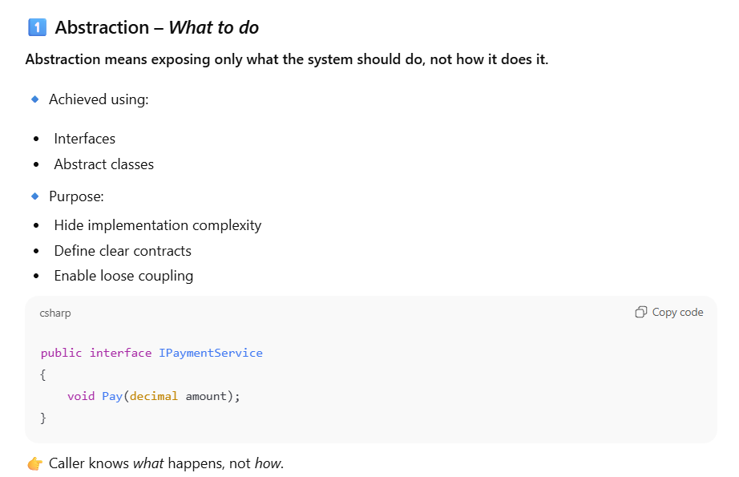
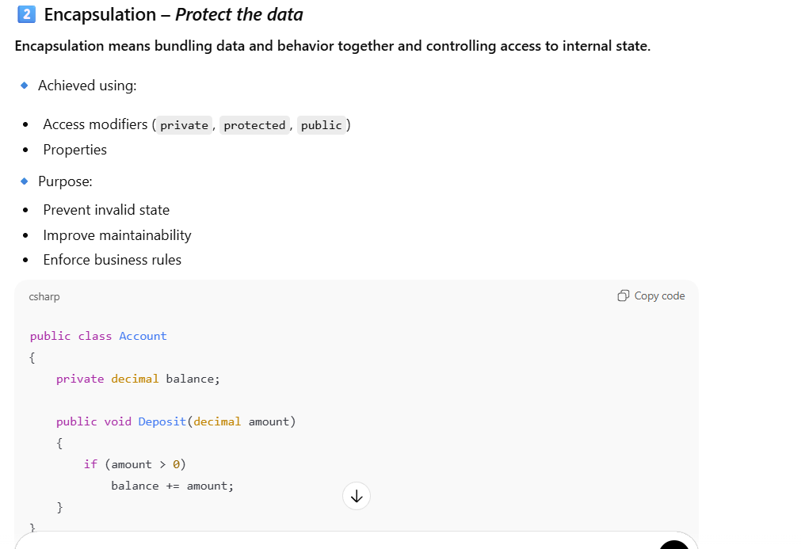
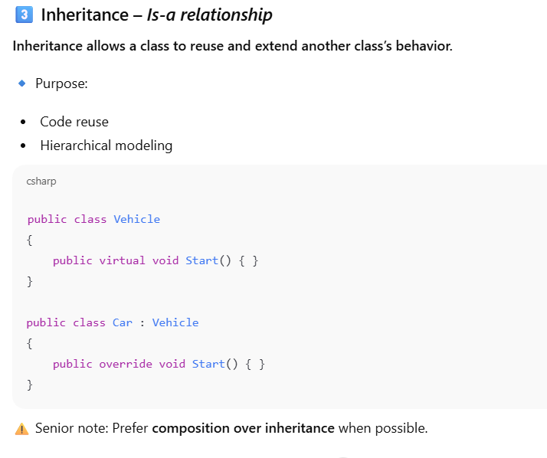
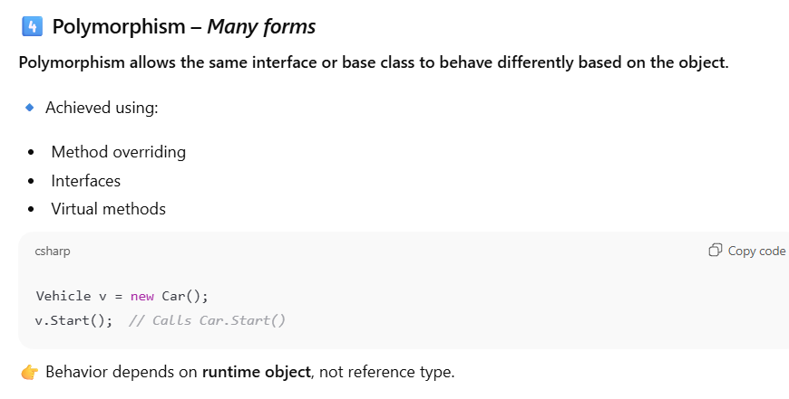
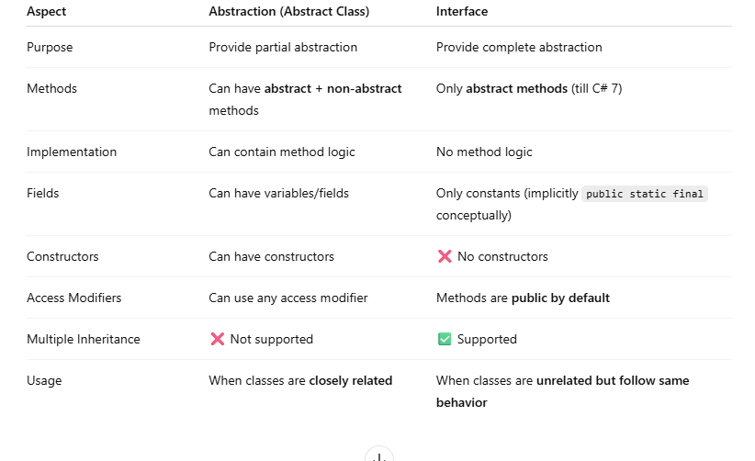
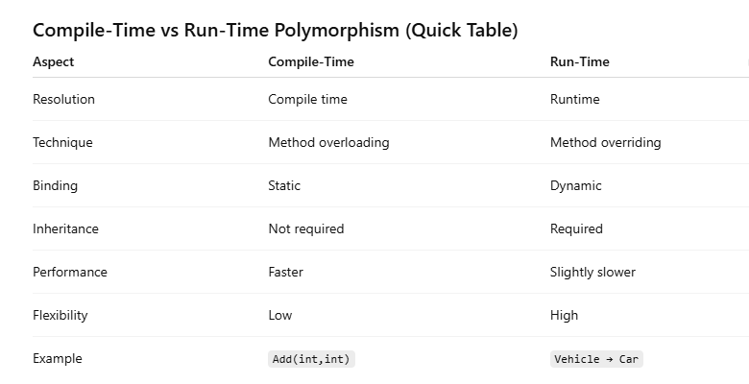
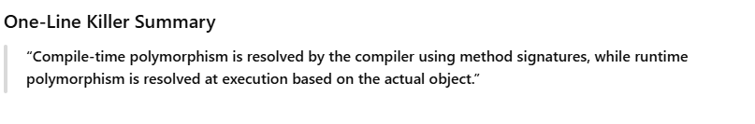
*****************************************************************
Difference between value type and reference type
“Value types :
1) hold data directly and are copied by value ex. int, struct, bool, enum.
2) they copied by value, so assignments create independent copies
3) I use value types for small immutable data like `int`, `DateTime`, and structs,
reference types:
1) hold a reference to data stored on the heap.” Ex.- class, string, array, delegate
2) reference types copy references, so multiple variables can point to the same object
3) reference types for shared mutable state and complex domain models.
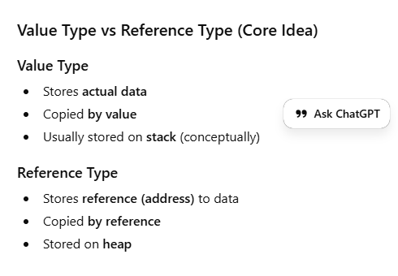
**********************************************************************************
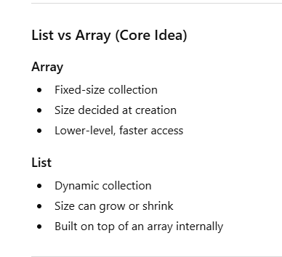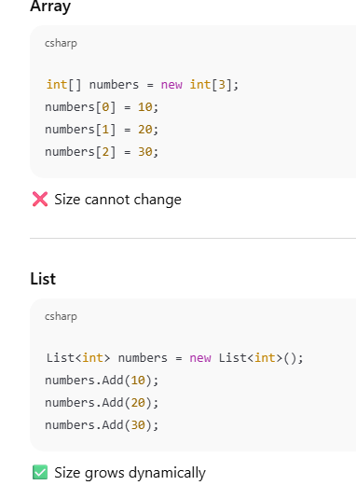
*************************************************************
What is IEnumerable vs ICollection vs IList?
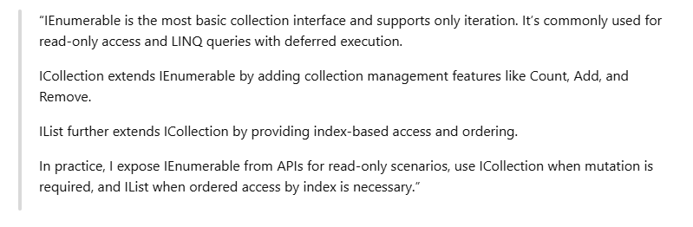
**************************************************************************
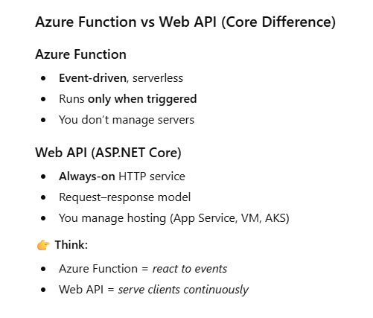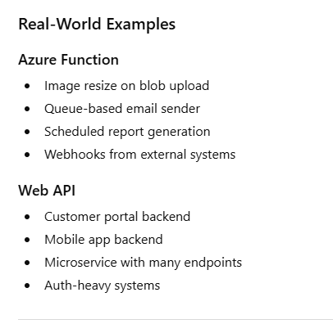
***********************************************************************
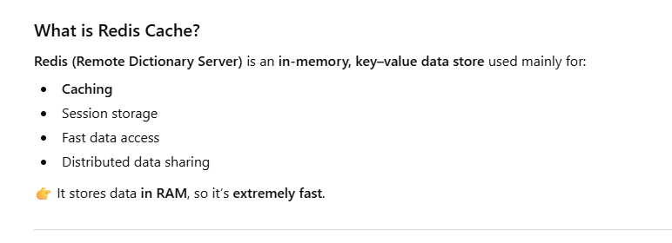
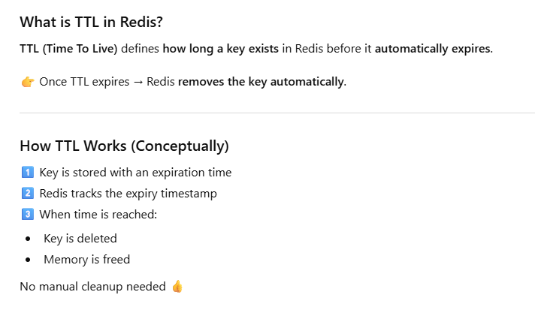
************************************************************************
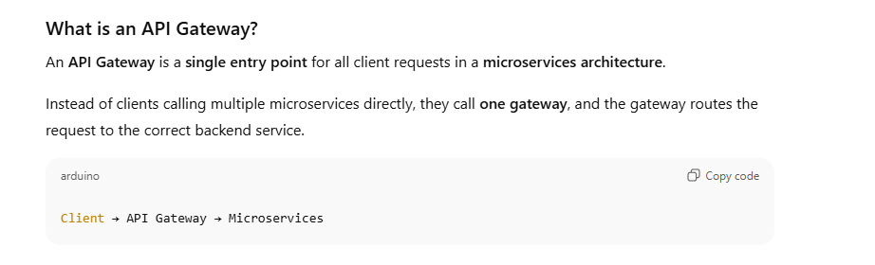
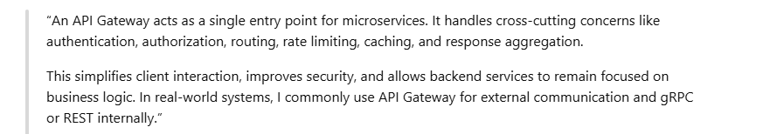
*****************************************************************
What is event-driven architecture?
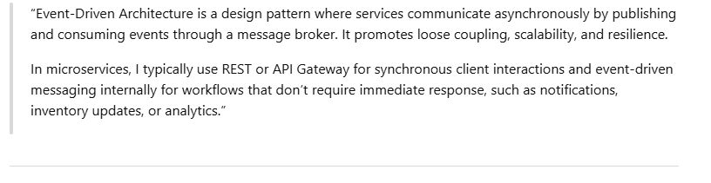
*********************************************************************
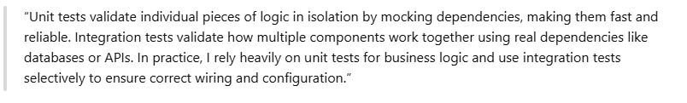
***************************************************************
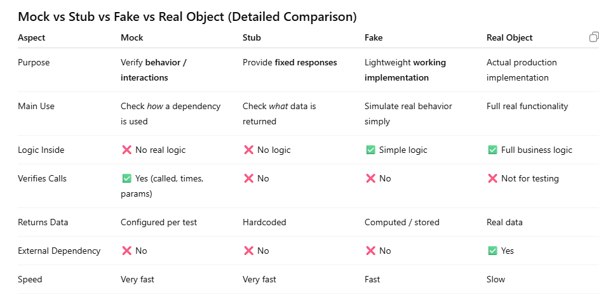
***********************************************************************
How do you handle large payloads?
streaming,
chunking
compression,
async processing, and
external storage to reduce memory usage and improve performance
**********************************************************************
How do you handle role-based routing? Inangular -- Route guards
In Angular, I handle role-based routing using CanActivate guards combined with route data. User roles are stored in the JWT or AuthService. The guard reads allowed roles from the route configuration and compares them with the user’s role. Unauthorized users are redirected. I also conditionally render UI elements based on roles, and ensure backend APIs validate roles to prevent unauthorized access.
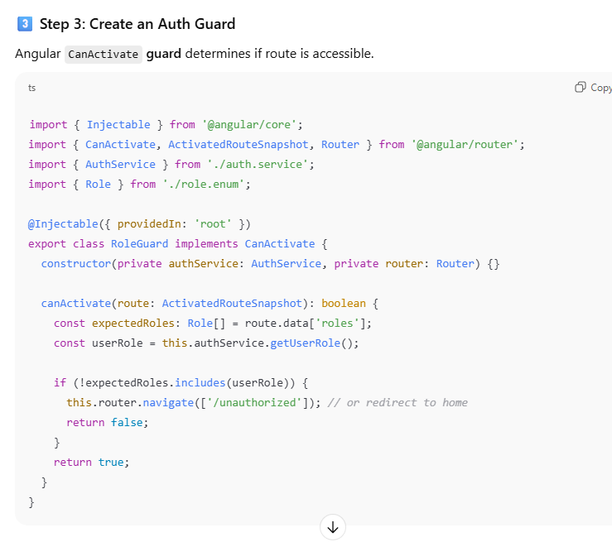
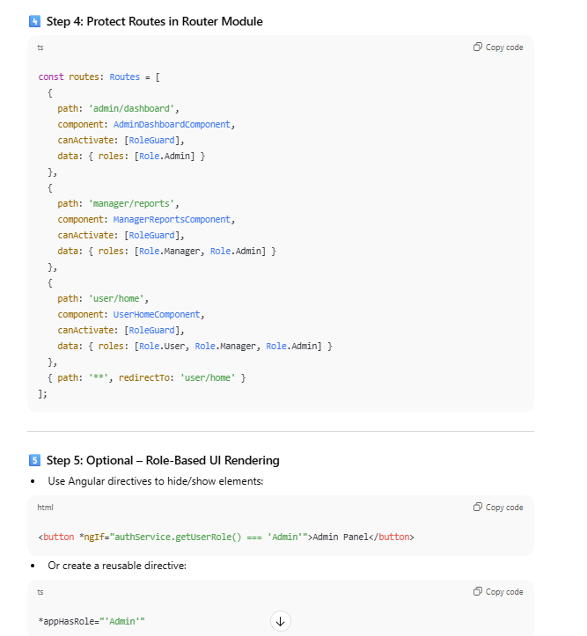
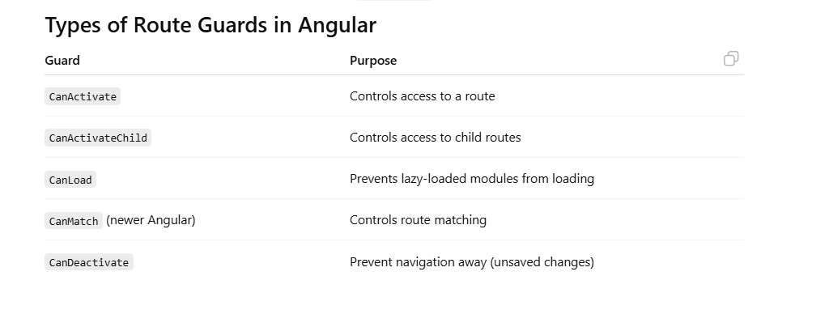
**************************************************************
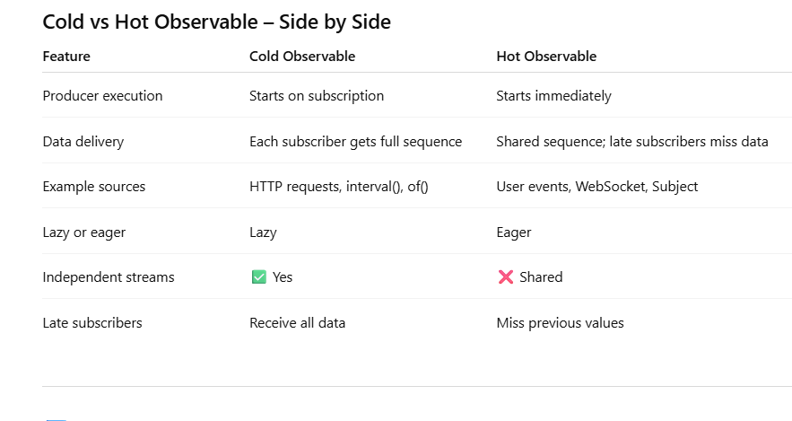
****************************************************************************
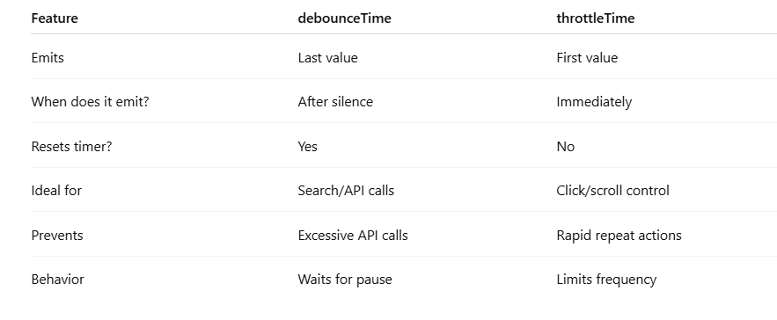
********************************************************************
RxJS error handling is done using catchError, retry, and finalize, while ensuring streams don’t unexpectedly terminate and errors are handled centrally.
**********************************************************************
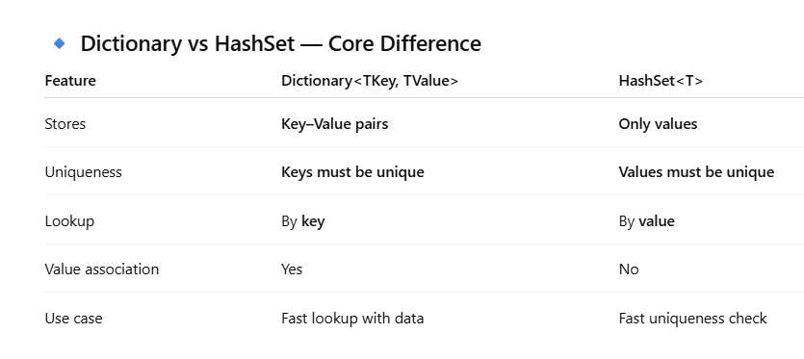
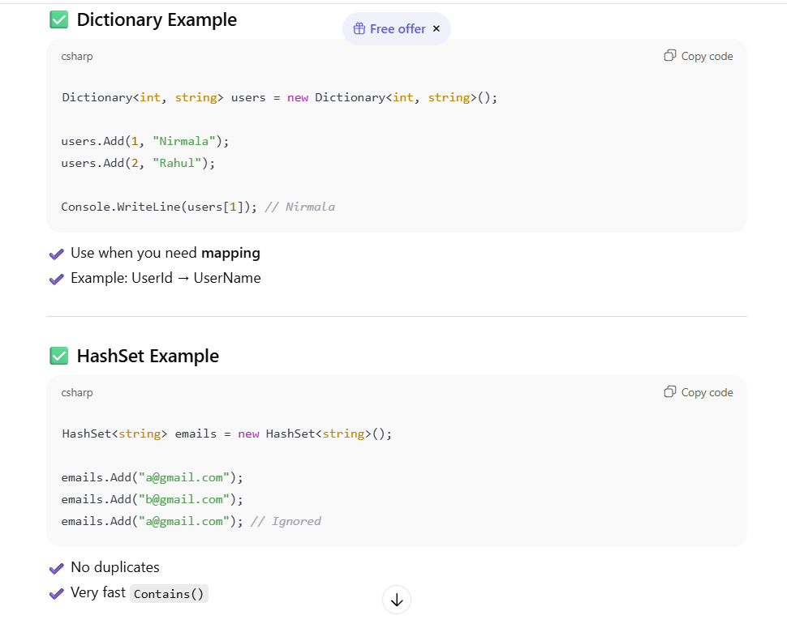
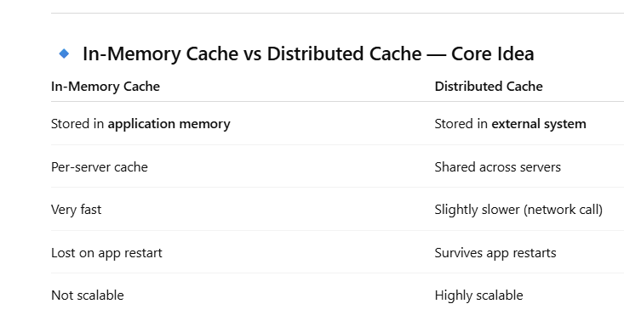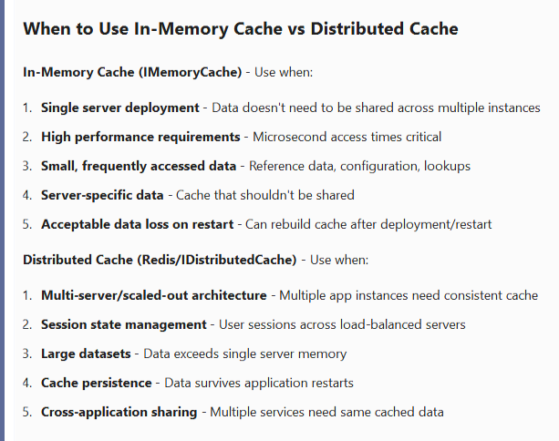
What is an Extension Method in .NET?
Extension methods allow you to add new methods to existing types without modifying the original source code, creating a derived type, or recompiling. They appear as instance methods but are actually static methods defined in a static class.
The key requirements are: it must be a static method in a static class, and the first parameter must use this keyword to specify which type we're extending.
First - DateTime Extensions for Business Logic:
We have a Between extension method that checks if a date falls within a range. Instead of writing repetitive comparison logic everywhere, we can simply call date.Between(startDate, endDate). We also have an overload that handles nullable DateTime, which prevents null reference exceptions and makes the code much cleaner.
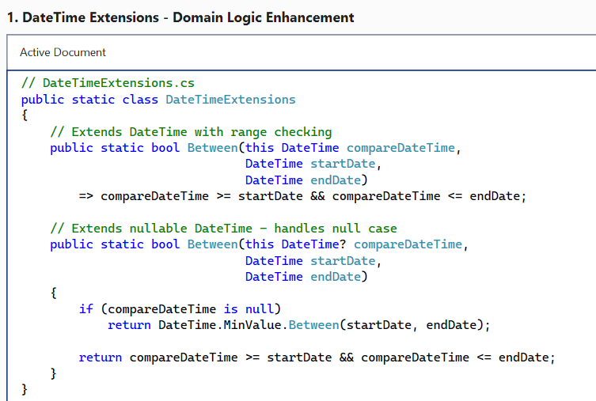
How to consume keyvault in web api to access the secret?
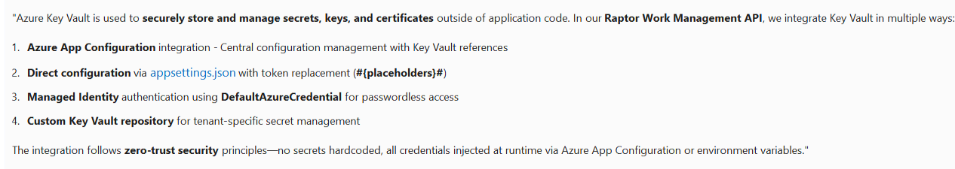
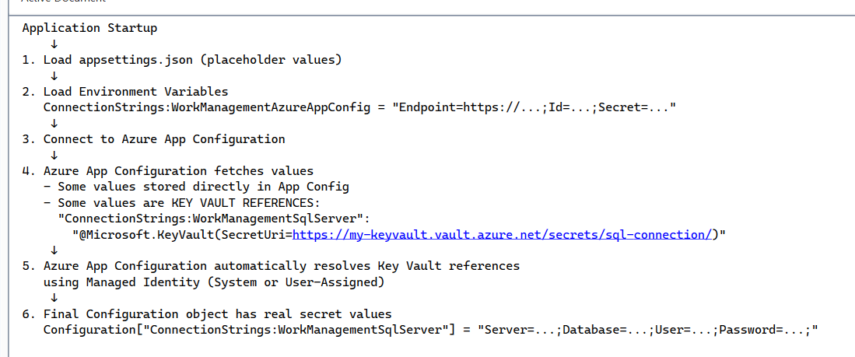
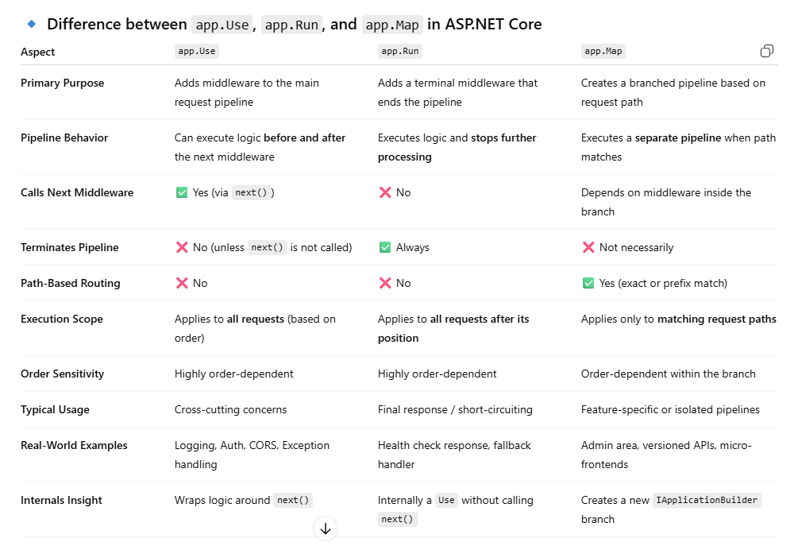
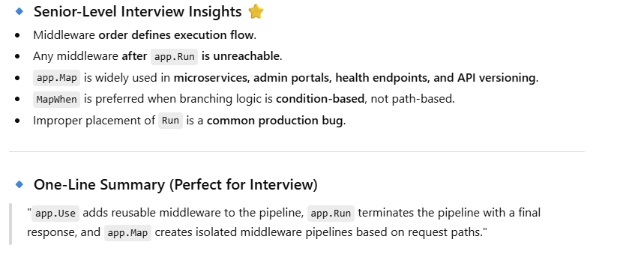
**************************************************************************
What Is AAA in Angular Testing?
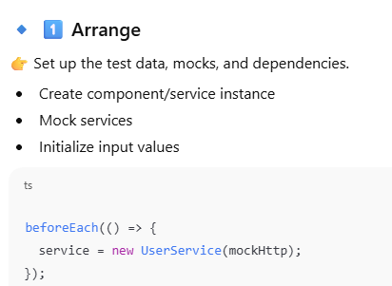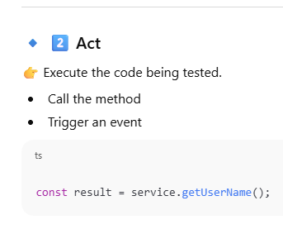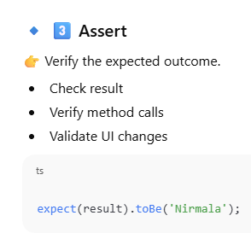
*******************************************************************************
Why Rate Limiting & Throttling Are Required
Rate limiting is about setting a maximum number of requests a client can make in a time window - like 100 requests per minute. If they exceed that, we reject their requests with a 429 Too Many Requests error.
Throttling is about controlling the processing rate - instead of rejecting, we might slow down or queue requests to maintain system stability.
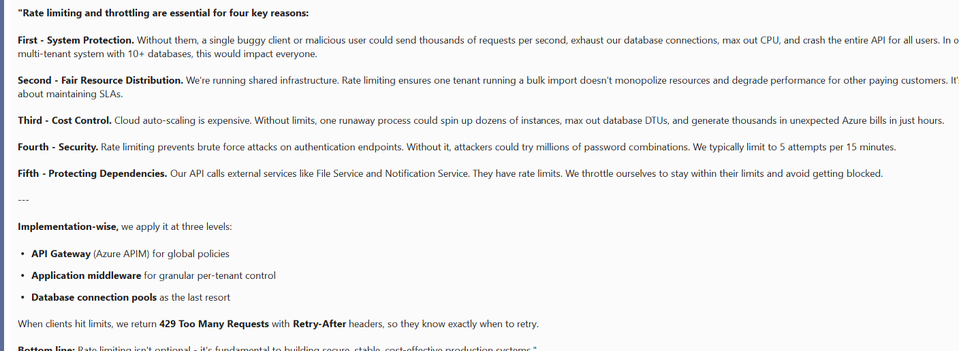
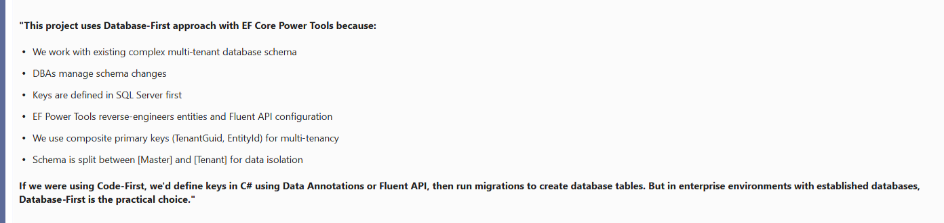
Difference between SaaS, PaaS, and IaaS
SaaS, PaaS, and IaaS differ mainly in who owns what responsibility in the system, and I usually explain it in terms of control versus convenience, with real project usage.
IaaS, or Infrastructure as a Service, gives us maximum control. The cloud provider manages the physical hardware, but we manage everything above that—operating system, runtime, security patches, and the application itself.
For example, in one of my projects, we had a legacy .NET Framework application that required custom Windows configurations and specific middleware. We deployed it on Azure Virtual Machines, because PaaS wouldn’t give us that level of control. So IaaS worked best there.
PaaS, or Platform as a Service, removes most infrastructure concerns. The provider manages OS, runtime, scaling, patching, and availability, and the team focuses only on writing and deploying code.
For example, for a REST API built using .NET Core, we used Azure App Service. It gave us built-in auto-scaling, easy CI/CD integration, and zero-downtime deployments. This helped us release features faster and reduced operational overhead significantly.
SaaS, or Software as a Service, is the highest abstraction. Everything—including the application—is managed by the provider, and we just consume the service.
For instance, instead of building our own ticketing or HR system, we used ServiceNow and Microsoft 365 as SaaS solutions. That allowed the team to focus on core product development rather than maintaining internal tools.
What is Azure CDN?
Azure CDN (Content Delivery Network) is a globally distributed caching service provided by Microsoft Azure that delivers static and semi-static content (like images, CSS, JavaScript, videos, fonts, and even APIs) from edge locations closest to the user. Key Components & How It Works:
- Origin Server: Your source application (e.g., Azure Storage, Web App, or custom origin)
- Edge Nodes/PoPs (Points of Presence): Distributed servers worldwide that cache content
- CDN Profile: Container for CDN endpoints
- CDN Endpoint: The URL users access (e.g., yourapp.azureedge.net)
Flow: User → Nearest Edge Server → (if cache miss) → Origin Server → Edge Server (caches) → User
how microservices are communicate with each other
In the Raptor Work Management system, we use a hybrid architecture combining a modular monolith for operational simplicity with event-driven microservices for scalability. Synchronous communication uses Refit with Polly for resilience, while asynchronous patterns leverage Azure Event Hub for high-throughput event streaming and Service Bus for reliable command processing. We secure inter-service calls using OAuth2 On-Behalf-Of token exchange, and provide a unified query interface via GraphQL. This architecture allows us to maintain simplicity while keeping options open for future microservices extraction."
---
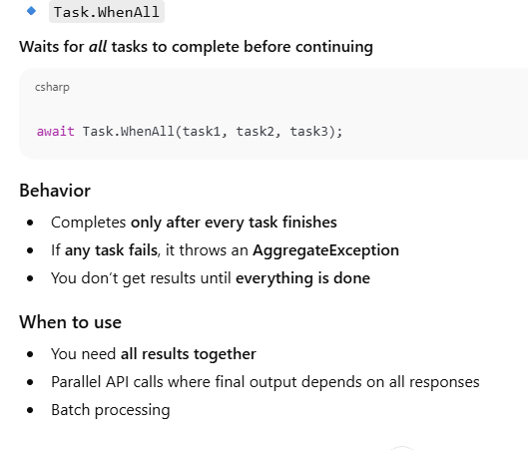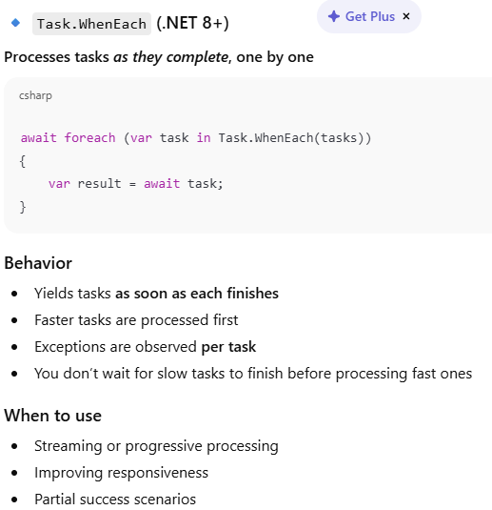
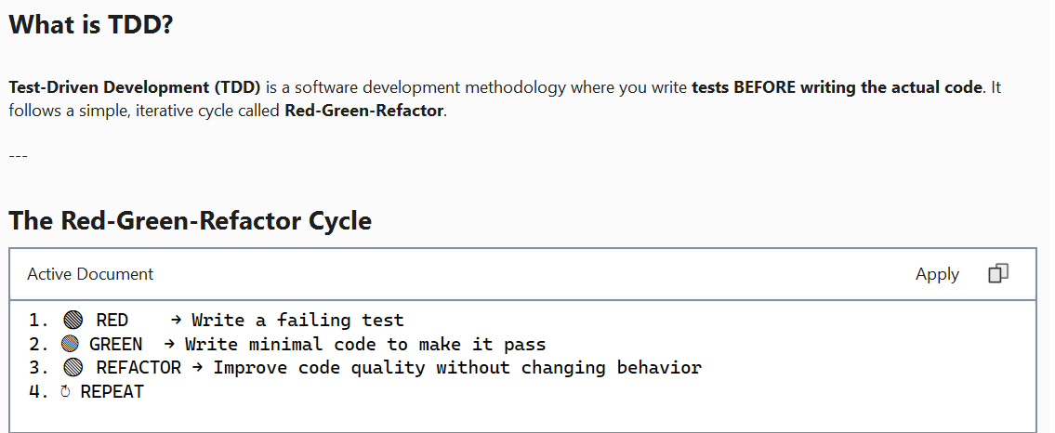
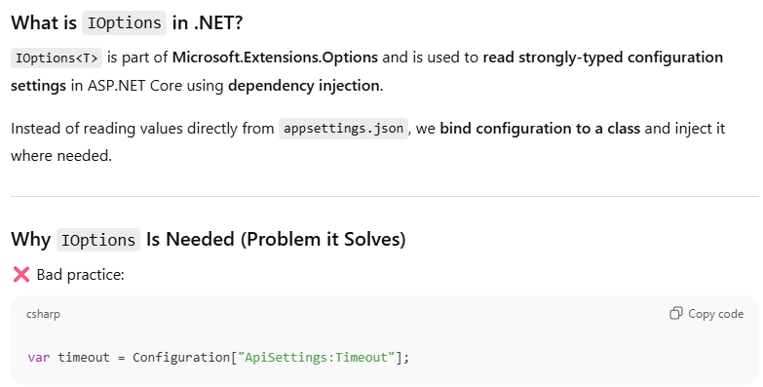
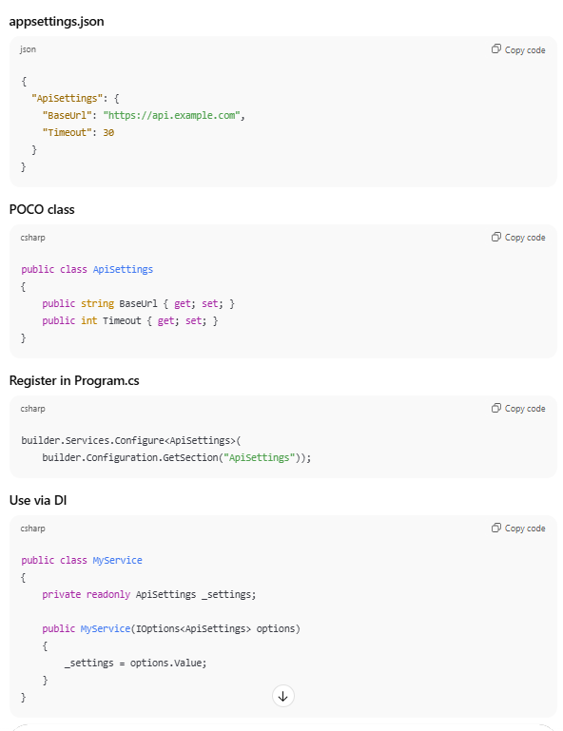
different form of routing in angular
Angular supports multiple routing forms like static, parameterized, nested, lazy-loaded, guarded, and resolver-based routing. In enterprise apps, we mainly use lazy loading with guards and child routes to improve performance and maintainability.”
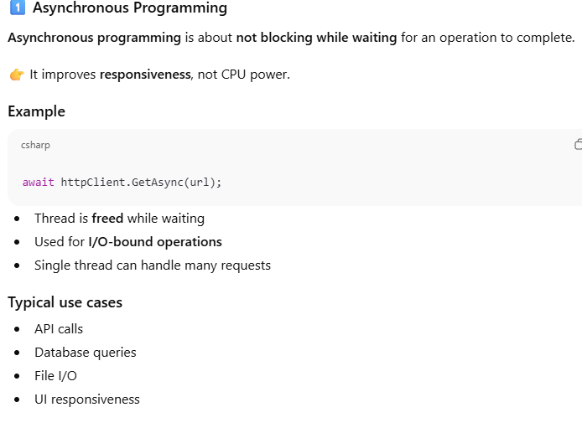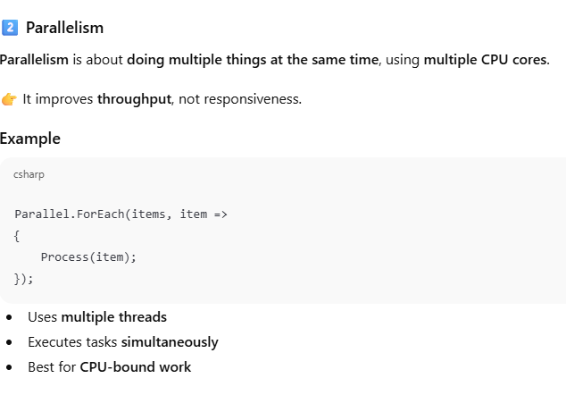
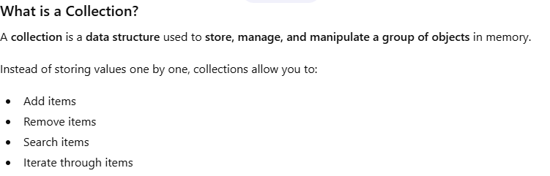
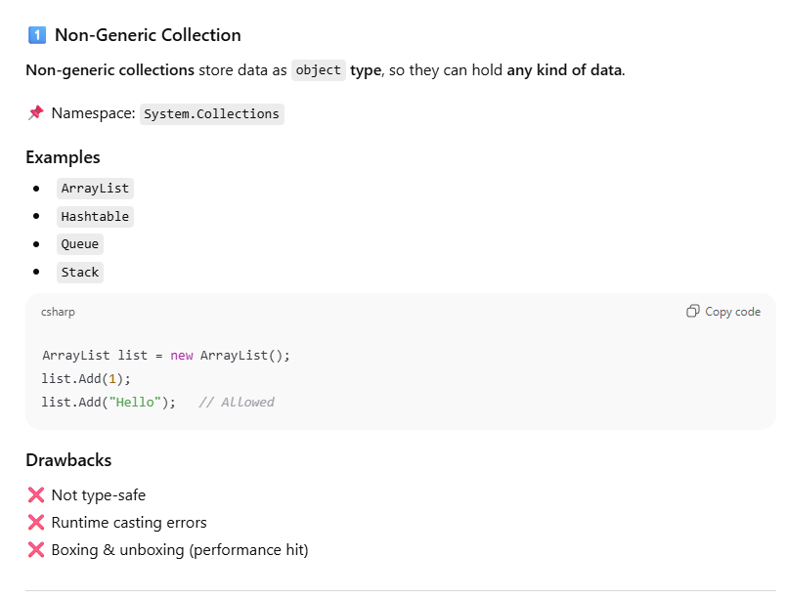
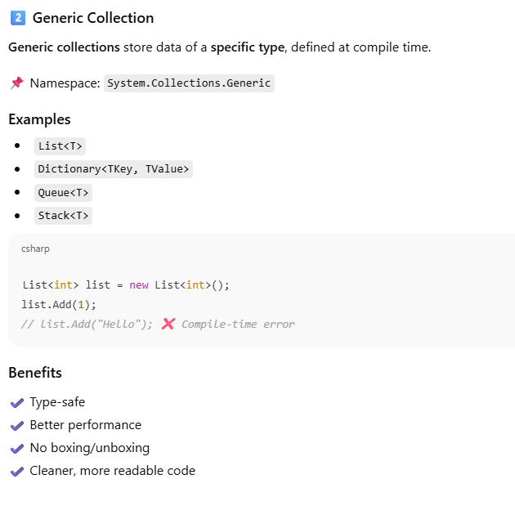

Kafka vs RabbitMQ vs Azure Service Bus:
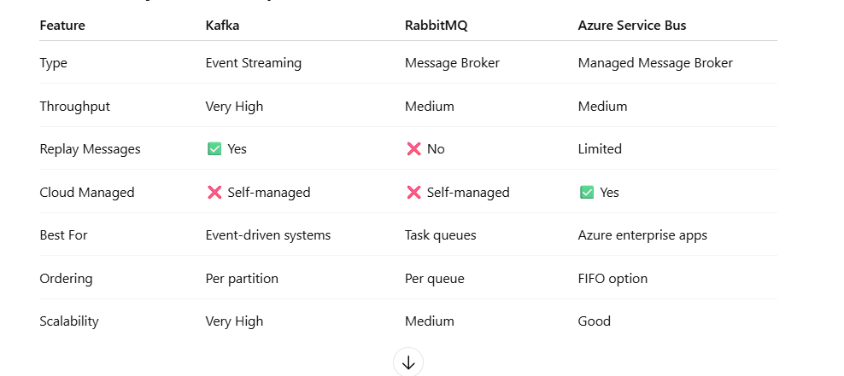
***********************************************************************
What is a dead-letter queue?
A Dead-Letter Queue (DLQ) is a special sub-queue (e.g., Azure Service Bus's $DeadLetterQueue) that automatically captures messages that can't be processed — due to repeated failures, TTL expiry, or filter mismatches — keeping the main queue flowing while preserving failed messages for diagnosis and replay.
It acts as a "hospital" for failed messages — preventing them from blocking the main queue and giving developers a chance to investigate what went wrong.
In your raptor-workmgmt-api, DLQs are critical for Enrichment, MadSync, MessagingGateway, and SqlToNoSqlMigrationJob components that rely on Azure Service Bus for asynchronous processing.
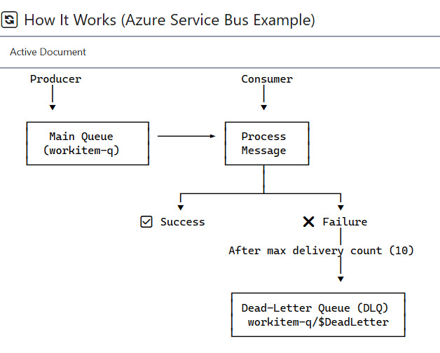

Task vs Thread vs ValueTask
A Thread is the lowest level — it's an actual OS thread. Each one costs about a megabyte for its stack, plus kernel resources, and you have to manage its lifecycle manually. In modern .NET, I rarely use Thread directly — only for truly long-running, dedicated work where I need full control.Task is an abstraction of work that may run on a thread.”
A Task is a high-level abstraction over asynchronous or concurrent work. It represents an operation that may complete in the future. For CPU-bound work, it borrows a thread from the Thread Pool, but here's the really important part — for I/O-bound work, like a database call or HTTP request, an awaited Task uses no thread at all while waiting. The OS handles the I/O via completion ports, and the continuation is scheduled when the I/O finishes. That's why .NET can handle thousands of concurrent connections with just a handful of threads. Task is heap-allocated, which is fine for
most code.
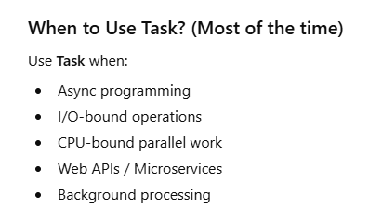
A ValueTask :is a struct-based, allocation-free alternative to Task, introduced in .NET Core 2.0. It's designed for hot paths where the result is often available synchronously — like a cache lookup that hits 95% of the time. Instead of allocating a Task for every call, ValueTask can return the result directly without any heap allocation. The trade-off is strict rules — you can only await it once, you can't store it in a field, and you can't pass it directly to Task.WhenAll.
Difference between Template vs Reactive forms
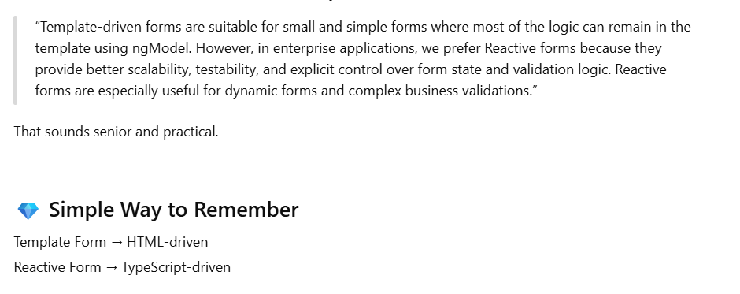
Stored procedure vs ORM
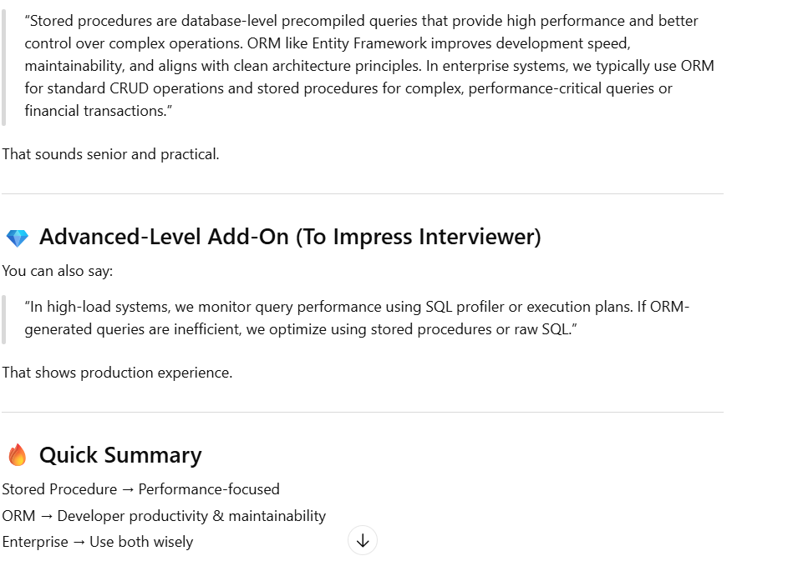
App Service vs VM
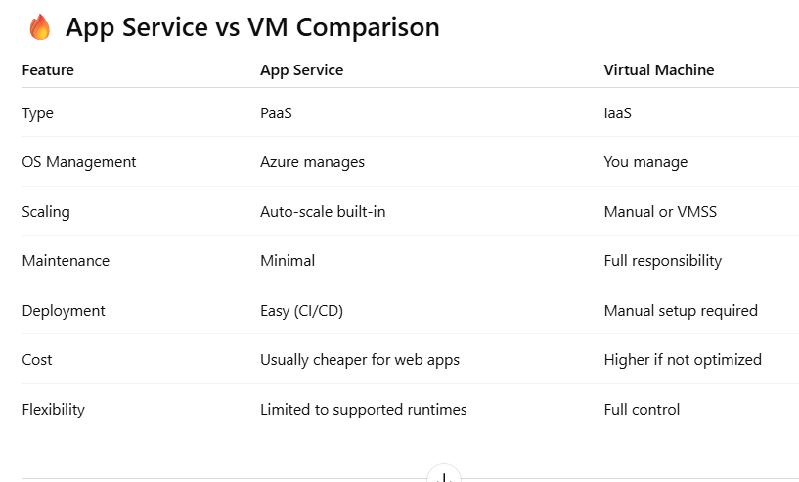
Azure Function limitation:
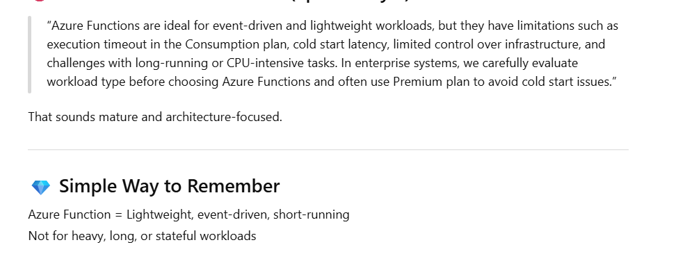
Redis Cache usage
Redis is an in-memory distributed cache used to improve application performance by reducing database load.
It’s commonly used for caching frequently accessed data, session storage, distributed locking, and rate limiting in microservices architecture.”

How Circuit Breaker is implemented
Circuit breaker is a resilience pattern used in microservices to prevent cascading failures.
When a downstream service repeatedly fails, the circuit opens and temporarily blocks further calls, allowing the system to recover.
In .NET Core, we typically implement it using Polly. It is especially useful when calling external APIs or critical services like payment gateways.”
Your project uses Polly library for resilience patterns including:
- Retry Policy (with exponential backoff)
- Circuit Breaker (implicit through retry exhaustion)
- SQL Server Retry Policy
- Event Hub Retry Policy
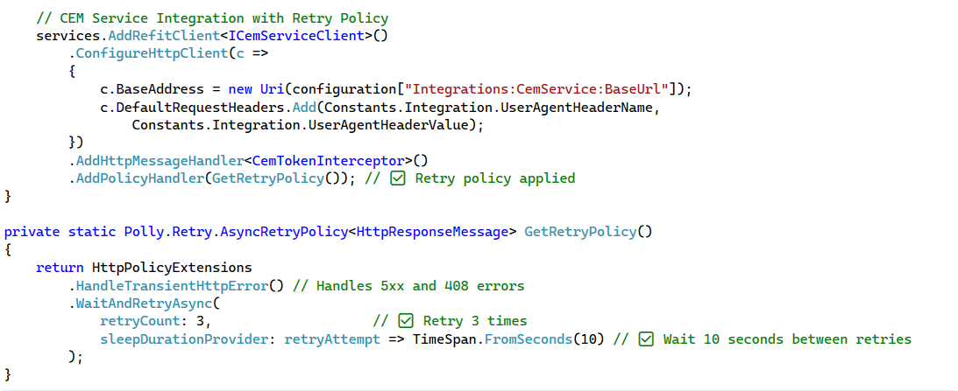
What's the difference between First() and Single()? FirstOrDefault() and SingleOrDefault()?
First(): Returns the first element; throws if sequence is empty. Multiple matches are OK.

"Single(): Returns the only element; throws if zero or >1 elements. Enforces uniqueness.

"FirstOrDefault(): Returns first element or default (null for reference types); no exception if empty.

"SingleOrDefault(): Returns only element or default; throws if >1 element.

I use Single/SingleOrDefault with unique identifiers (GUIDs, primary keys) to enforce business logic. First/FirstOrDefault when multiple matches are valid but I only need one.
Example from my code:
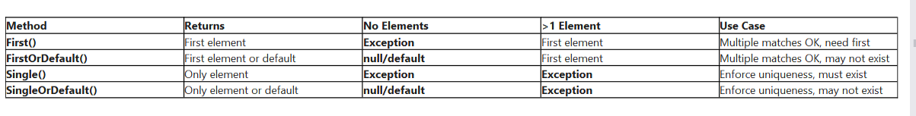

Explain the difference between Select() and SelectMany(). Provide examples.
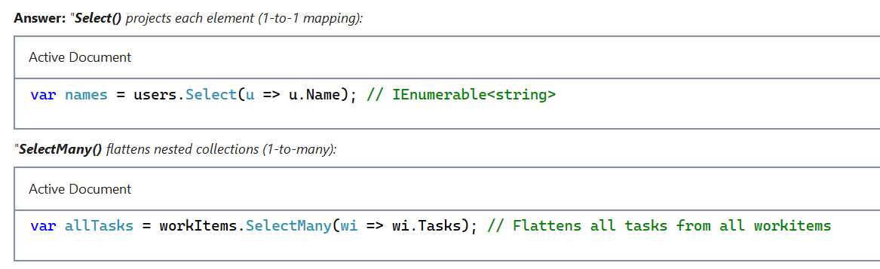
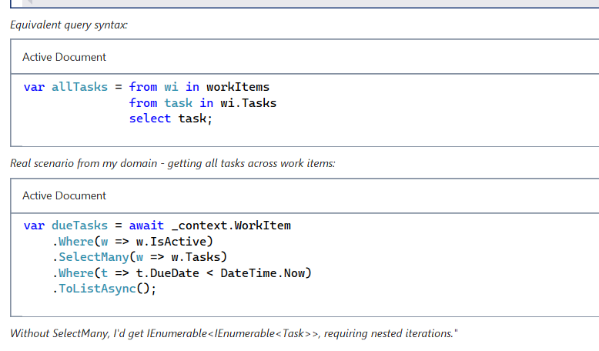
What's the performance difference between Count() and Any()? What about Count() vs Count(predicate)?
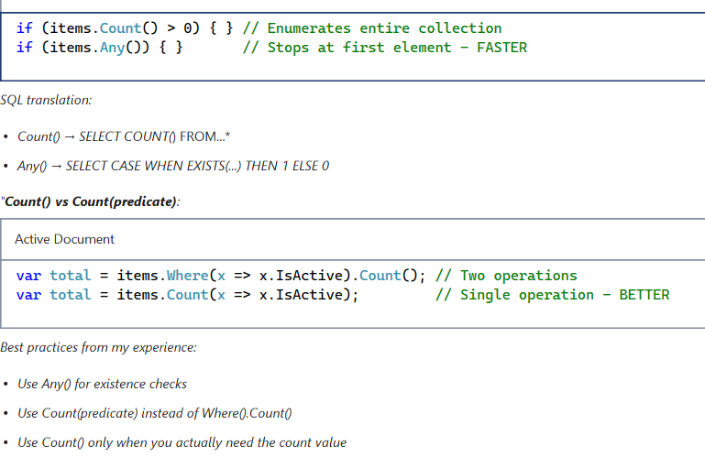
What's the difference between AsNoTracking() and tracked queries? When and why should you use each?
"Tracked queries (default behavior) means EF Core creates snapshots of entities for change detection. When you call SaveChanges(), EF compares current state with snapshot to generate UPDATE/DELETE SQL.
"AsNoTracking() disables change tracking. EF Core doesn't maintain snapshots, improving performance for read-only scenarios.
Performance tip: Use ChangeTracker.QueryTrackingBehavior = QueryTrackingBehavior.NoTracking in DbContext constructor if most queries are read-only."
What is ConfigureAwait(false) and when to use?
When you await a task, by default it captures the current synchronization context and resumes on it. ConfigureAwait(false) tells the runtime: "I don't need to resume on the original context."
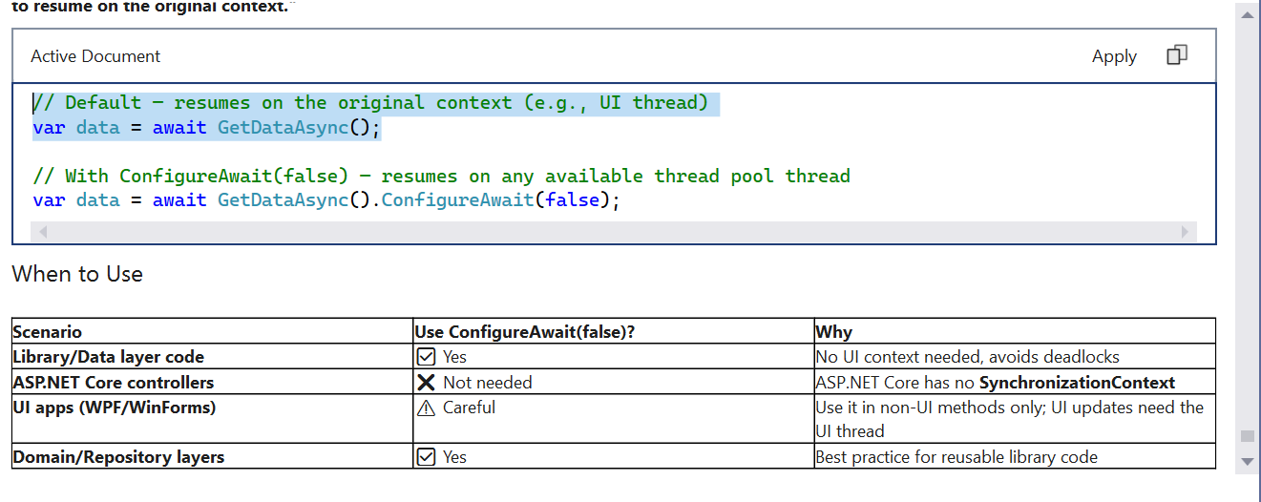
When do you normalize data and when do you denormalize in product systems
I normalize transactional schemas to reduce anomalies and maintain integrity. master tables like Service, StatusType, and WorkItemType are fully normalized with foreign keys.
I denormalize read models when query performance or reporting demands it, but with clear ownership of update paths. It’s a trade-off between write complexity and read speed.- audit trails where we need point-in-time snapshots (WorkItemAudit stores the full state, not just FKs

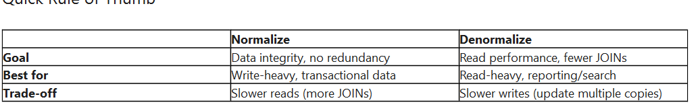
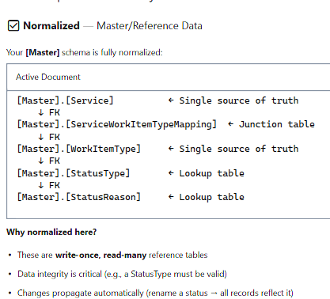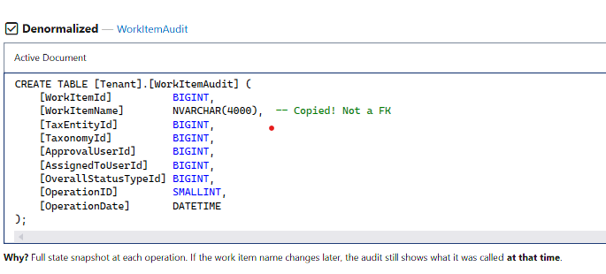
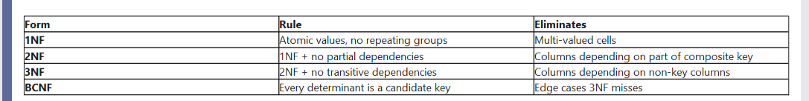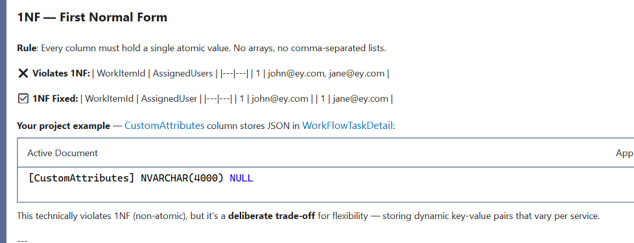
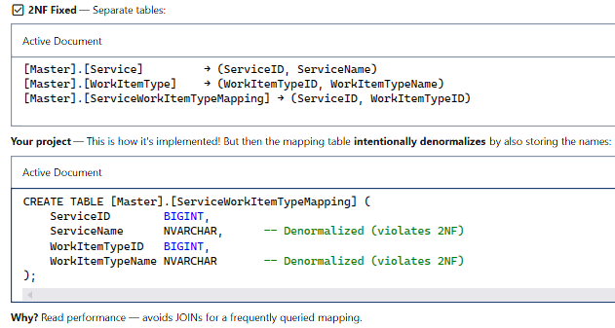
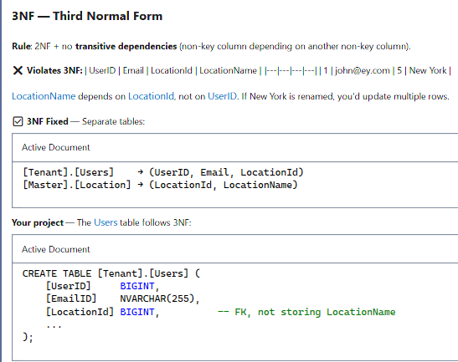
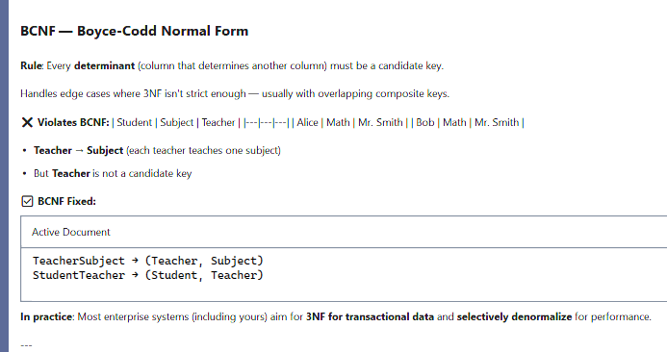
how do you design for scalability and high availability in Azure?
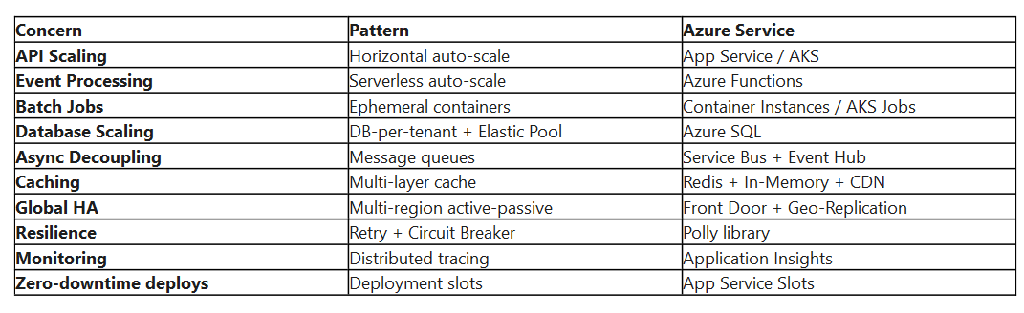
***************************************************
Window Functions in SQL:
A window function performs a calculation across a set of rows related to the current row — WITHOUT collapsing them into a single row like GROUP BY does.
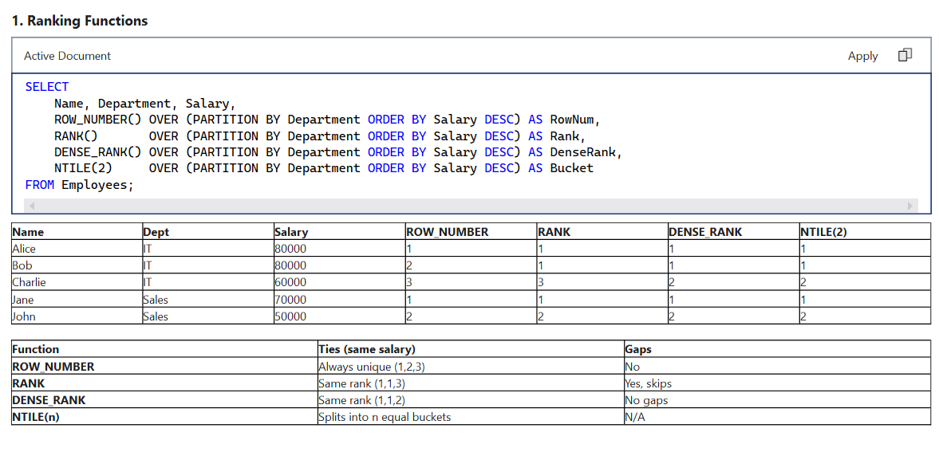
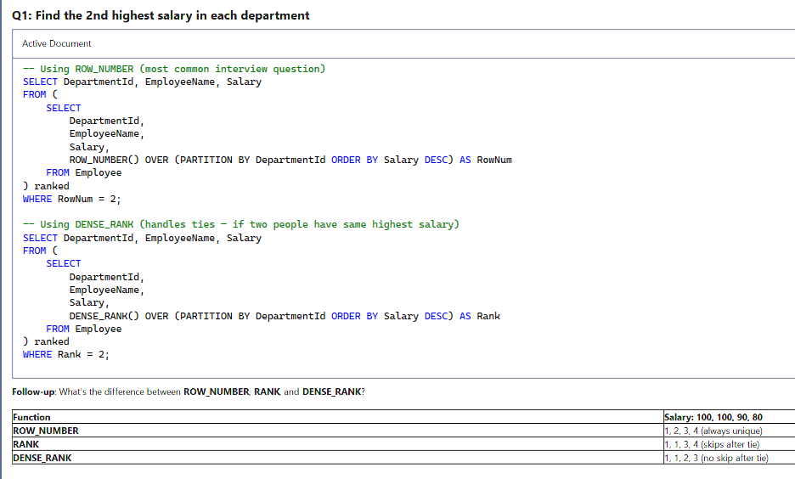
***********************************************************************
Value/Offset Window Functions :
Value/Offset functions let you access data from a DIFFERENT row relative to the current row — without a self-join.
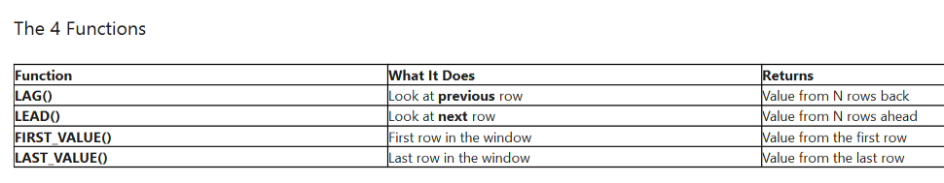
**********************************************************************************
OFFSET in SQL:
OFFSET skips a specified number of rows before returning results. Used with FETCH NEXT for pagination.
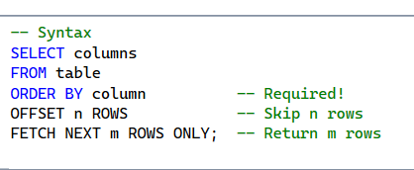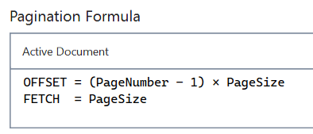
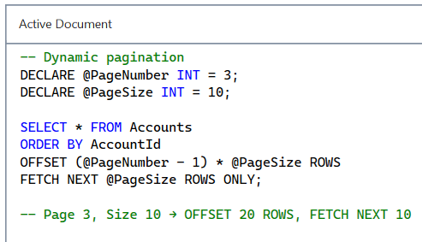
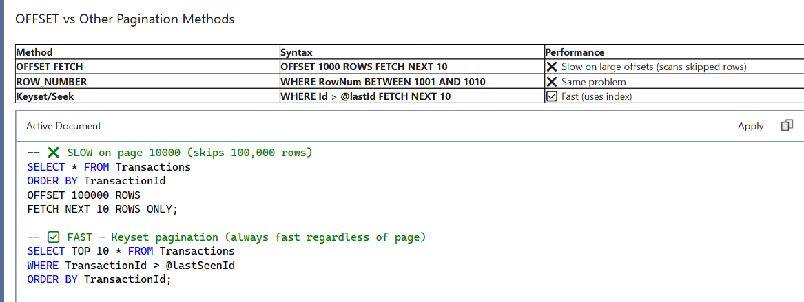
********************************************************************************
What is Sharding?
Sharding is horizontally splitting a database across multiple servers using a shard key.
In our project, we use tenant-based sharding — each client gets their own Azure SQL database, and the Catalog database acts as a router that maps clientGuid to the correct connection string.
This gives us data isolation for compliance, independent scaling per tenant, and eliminates noisy-neighbor problems.
The shard key is the clientGuid in the URL, resolved by our client routing middleware before any repository call
*********************************************************************
Eager Loading & easy Loading Difference:
Eager Loading = Load everything now in one query (.Include()).
Lazy Loading = Load related data later, on demand, in many queries (virtual + proxies).
Explicit Loading = Load related data manually when you decide (.Load() / .LoadAsync()).
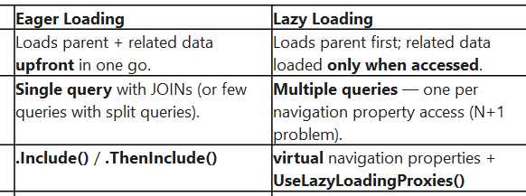
************************************************************************
What is CORS preflight request?
A CORS preflight request is an automatic HTTP OPTIONS request sent by the browser before the actual cross-origin request, to check whether the server permits the actual request based on its origin, method, and headers.
It's part of the CORS (Cross-Origin Resource Sharing) protocol defined by the W3C, designed to protect servers from unauthorized cross-origin requests.
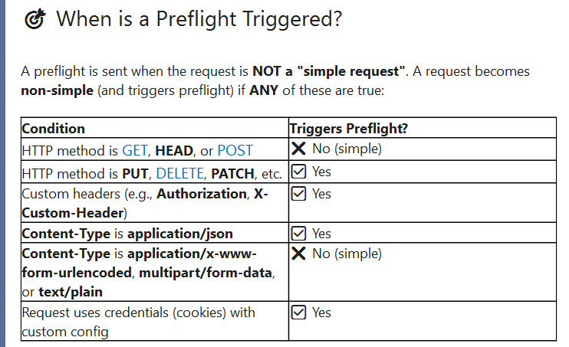
**************************************************************
What is a race condition?
A race condition is a concurrency bug that occurs when two or more threads (or processes) access shared data simultaneously without proper synchronization, causing unpredictable results that depend on timing — fixed with lock, Interlocked, SemaphoreSlim, ConcurrentDictionary, or optimistic concurrency at the database level.
Race Condition vs Deadlock vs Starvation:
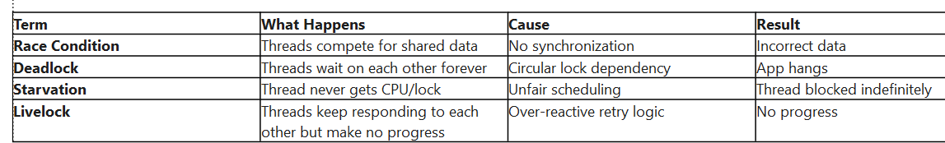

What is thread pool starvation and how do you detect it?
Thread pool starvation happens when all the threads in the .NET Thread Pool are busy and new work items keep queuing up faster than threads become available. The classic signature is growing latency and timeouts even though CPU is low — because threads aren't doing CPU work, they're blocked, usually on .Result, .Wait(), or a long-held lock.
What causes deadlocks and how do you prevent them?
deadlock is when two or more sessions each hold a lock the other needs, forming a cycle. SQL Server's lock monitor detects the cycle, picks the cheapest session as the victim, kills it with error 1205.
lock-order cycles, made worse by long transactions, missing indexes, and high isolation.
Prevention: consistent access order, short transactions, RCSI, supportive indexes, single-statement read-modify-write, and a 1205 retry policy.
Capture: read xml_deadlock_report from system_health for ad-hoc, run a dedicated XEvent file session for production, and on Azure SQL stream the Deadlocks diagnostic category to Log Analytics for retention."
Tell me about a deadlock issue you faced and how you fixed it.
“We encountered deadlocks mainly in our Test Automation Client where multiple test runs were executing delete operations concurrently.
From the deadlock graph, we observed that several DELETE statements on the TaxableIncome table were running at the same time.
The root cause was a foreign key relationship from TaxableIncome to ComplexTaxReclassMapping.
When deletes occurred, SQL Server had to check the child table for referential integrity. Since the foreign key column in ComplexTaxReclassMapping was not indexed, SQL Server performed table scans and acquired higher-level locks, which led to deadlocks under concurrent deletes.
To fix this, I added a non-clustered index on TaxableIncomeId in the ComplexTaxReclassMapping table.
This allowed SQL Server to perform efficient index seeks during the FK checks, significantly reducing lock duration and contention.
After adding the index, the deadlocks stopped occurring, and delete operations became much more stable even under parallel test execution.”

***********************************************************************
What is optimistic concurrency token?
An optimistic concurrency token is a special column/property on an entity used to detect conflicts when multiple users or processes try to update the same record concurrently — without locking the row.
value attached to an entity that EF Core checks during UPDATE/DELETE — if it has changed since the read, EF throws DbUpdateConcurrencyException, allowing you to detect and resolve lost-update conflicts without database locks.

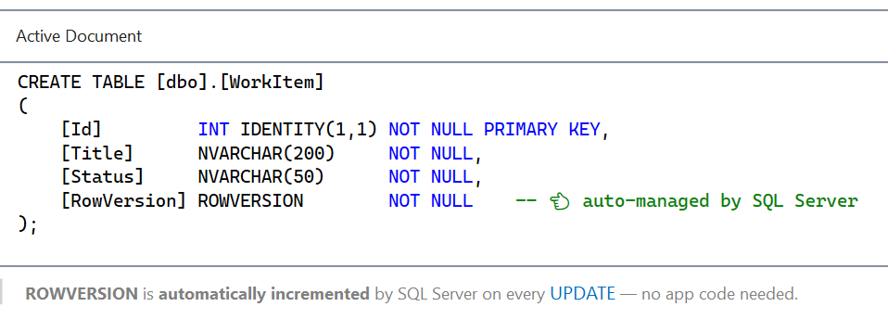
***********************************************************************
What is the difference between `const`, `readonly`, and `static readonly`?
In C#, const, readonly, and static readonly are all used to define values that shouldn't change — but they behave very differently.
Const: is a compile-time constant.
Its value must be known at compile time, so it's limited to primitive types, strings, and enums.
It's also implicitly static, meaning it belongs to the type, not to any instance. The catch is that the compiler inlines the value directly into the calling assembly. So if I change a const in a shared library and don't recompile the consumers, they'll still use the old value. That's the famous versioning problem with const.
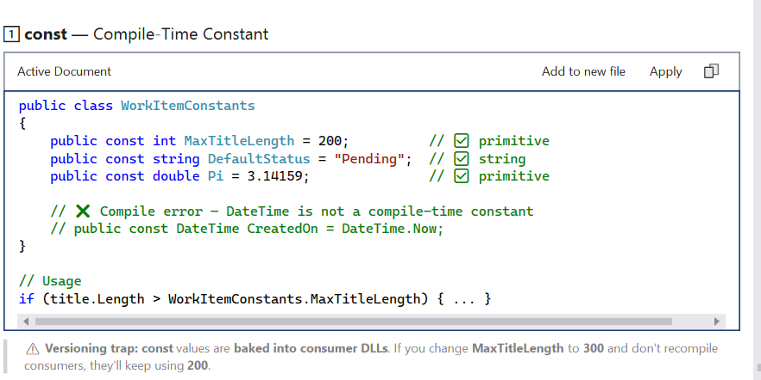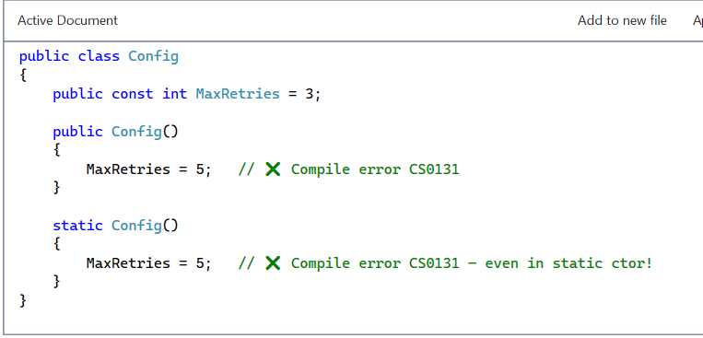
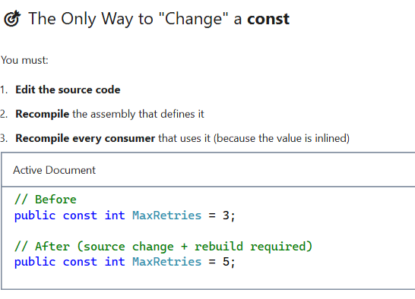
Readonly: Per-Instance Runtime Constant
readonly is a runtime constant.
The value can be assigned either at the point of declaration or inside a constructor — and after that, it can't be changed.
It's per-instance, so different objects can hold different values. It also supports any type, including reference types like DateTime, Guid, or custom classes — which const doesn't allow.
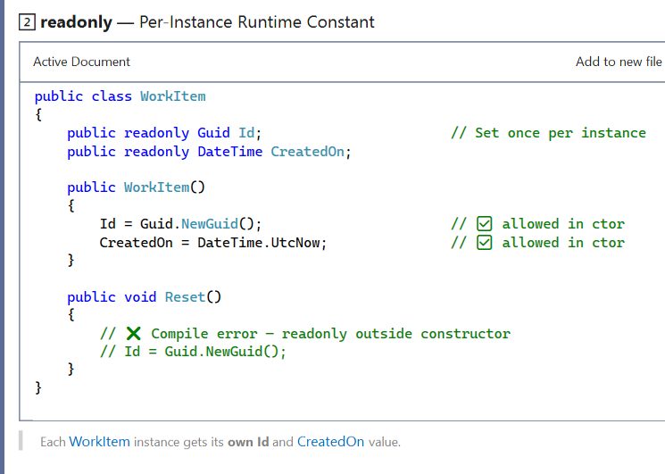
static readonly — Type-Level Runtime Constant
static readonly is the combination — it's a runtime constant that belongs to the type itself, not to an instance.
You can set it at declaration or inside the static constructor.
It's the safest choice for shared library constants because the value is resolved at runtime — so if I change it and ship a new DLL, all consumers automatically pick up the new value without recompilation.
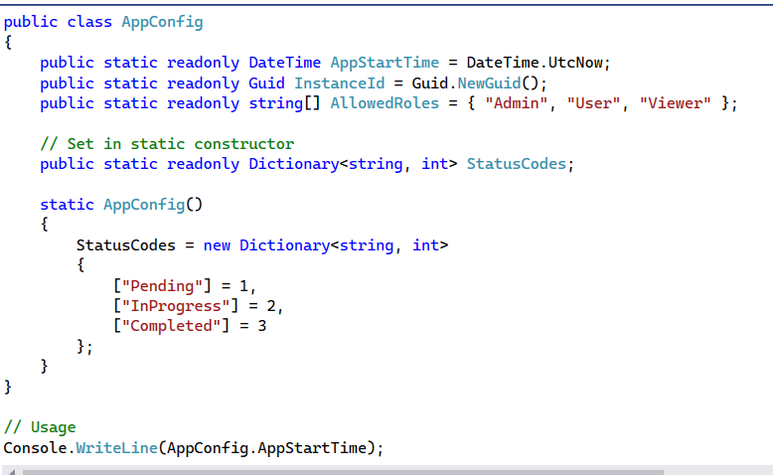
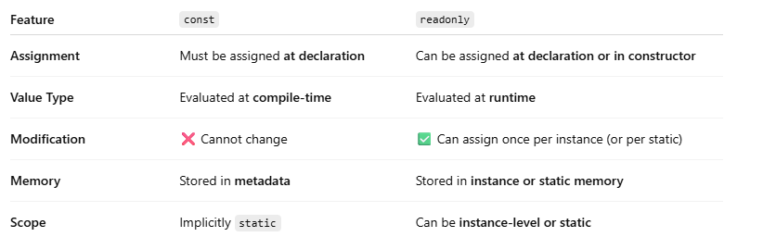
***************************************************************************
What is nullable reference type and why use it?
"Nullable Reference Types are a C# 8 feature — enabled by default in .NET 6 and later — that brings compile-time null safety to reference types.
Before this, every reference type could secretly be null, leading to the most common runtime bug in .NET — the NullReferenceException.
With NRTs, I now declare intent explicitly. string means 'this is never null', and string? means 'this might be null.' The compiler then warns me whenever I might dereference a possibly-null reference, return null from a non-nullable method, or forget to initialize a required field.
It's a purely compile-time feature — runtime behavior is unchanged. No exceptions are thrown by the feature itself. It just helps me catch bugs before shipping.

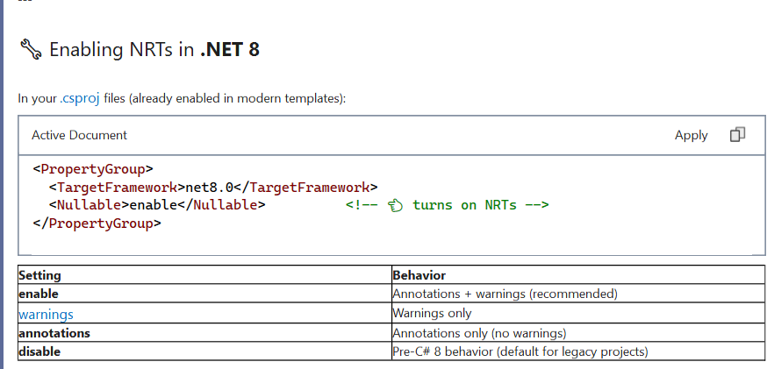
*******************************************************************************
Difference between `==` and `.Equals()`?
Both == and. Equals() are used to compare objects in C#, but they work very differently.
== is an operator that's resolved by the compiler at compile time based on the declared type of the operands.
.Equals(), on the other hand, is a virtual method on System.Object, so it's resolved at runtime using the actual type of the object .
By default, for reference types, both check reference equality — meaning whether two variables point to the same object in memory. But many types like string, record, or any type that overrides Equals and overloads == change this to value equality.
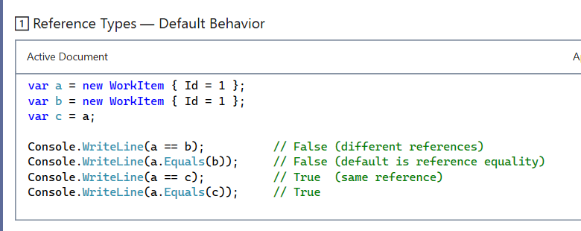
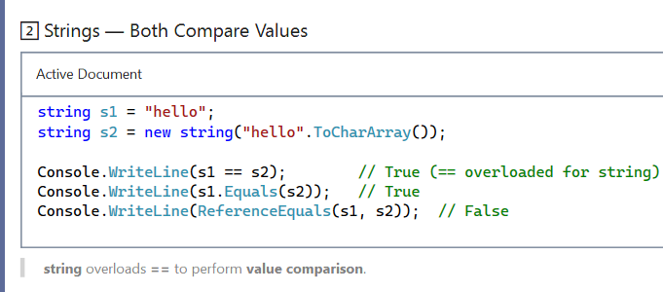
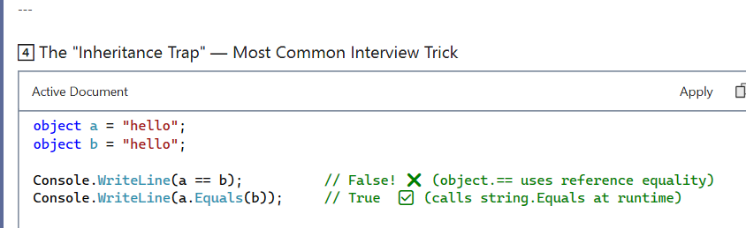
In the the declared type is object, but the runtime type is string
.a == b is resolved by the compiler at compile time, based on the declared type — object. The == operator on object does reference equality, so it just checks if both variables point to the same memory location. If the strings happen to be interned, it returns true;.
****************************************************************************
What are records in C# and where are they useful?
A record (introduced in C# 9, expanded in C# 10) is a reference type (or value type with record struct) designed for immutable data models with value-based equality built in by the compiler.
Think of a record as: "a class optimized for holding data, not behavior."
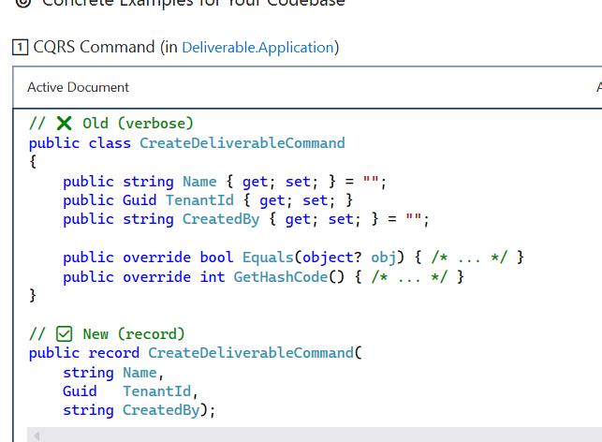
***********************************************************************
Explain reflection use cases and performance impact.
Reflection is .NET's ability to inspect and invoke types at runtime via System.Reflection .
it's extremely powerful but slow, typically 50 to 500 times slower than direct code, and it breaks compile-time safety.
The main use cases are everywhere in modern .NET. Serialization with System.Text.Json or Newtonsoft.Json, ORM mapping in EF Core, dependency injection resolving constructors, testing frameworks like xUnit discovering test methods, mocking with Moq, mapping libraries like AutoMapper, GraphQL schema generation in HotChocolate, plugin systems loading assemblies dynamically, and attribute processing for things like [Authorize], [FromBody], or [FunctionName].
*******************************************************************
What C# features from latest versions have you used in production?
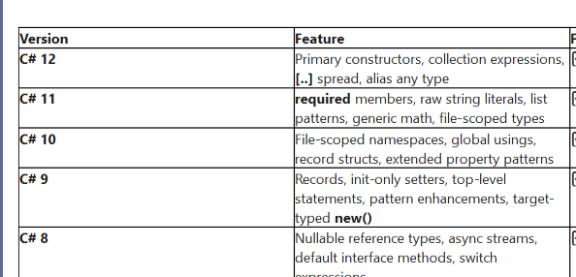
Primary Constructor:
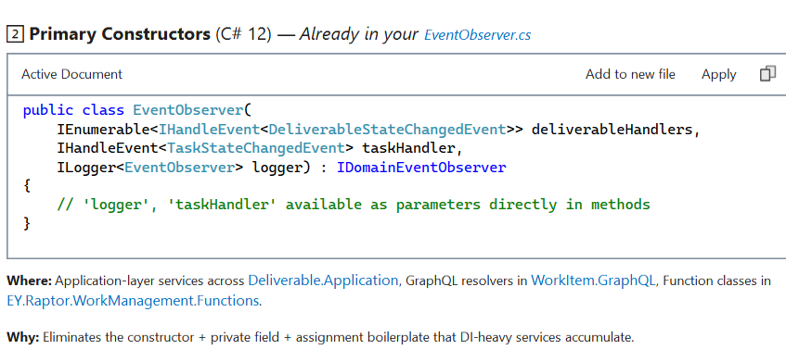
Required Members:
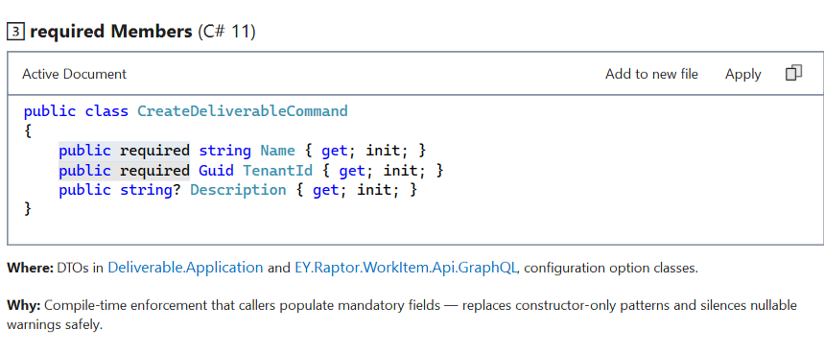
File-Scoped Namespaces (C# 10):
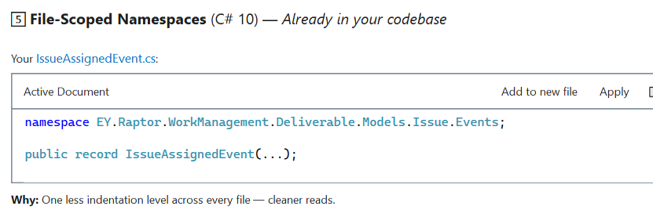
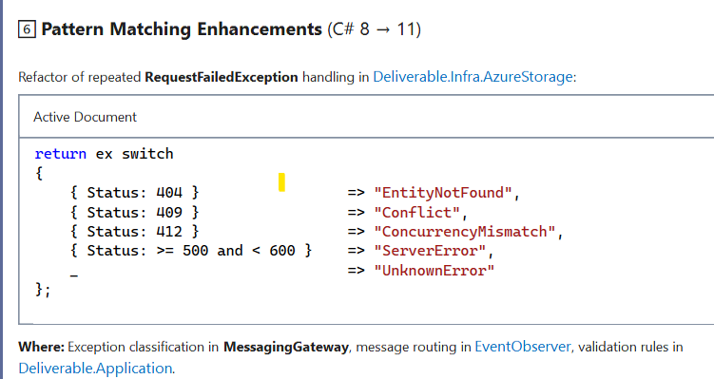
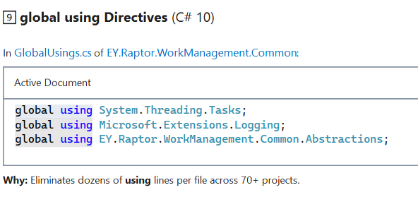
***********************************************************************
What changed in newer Angular versions?
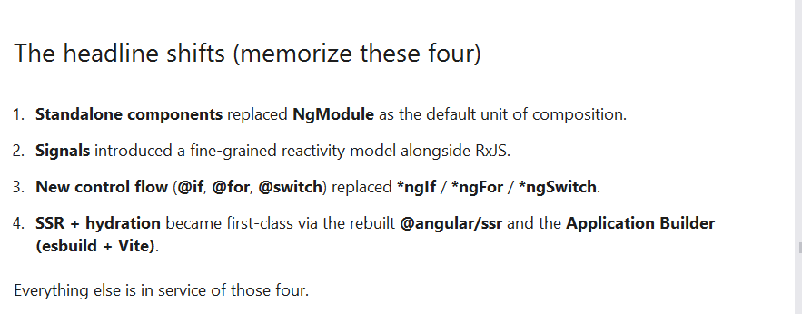
**************************************************************
What are REST constraints ?
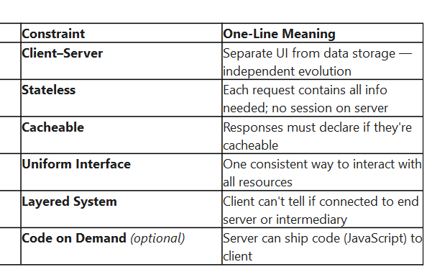
************************************************************************
Difference between PUT and PATCH
PUT means 'replace the entire resource' — the request body must contain the complete new representation. Any field you don't send is treated as 'set to default or null,' because PUT semantically says 'this is now the whole resource.
' PATCH, on the other hand, means 'apply this partial change' — you send only the fields or operations that should change, and everything else stays untouched.
PUT is always idempotent — sending the same PUT request five times leaves the resource in exactly the same state. PATCH is usually idempotent, but the spec doesn't guarantee it — for example, a JSON Patch operation that appends to an array isn't idempotent because each call adds another item.
PUT can create a resource at a given URI if it doesn't exist — that's called PUT-as-create or upsert. PATCH cannot — the resource must already exist, otherwise the server should return 404.
****************************************************************
How do you document APIs (Swagger/OpenAPI)?
OpenAPI is the specification — a language-agnostic JSON/YAML contract that describes endpoints, schemas, auth, and responses.
Swagger is the tooling ecosystem built around it (Swagger UI, Swagger Codegen, Swashbuckle). In .NET we use Swashbuckle.AspNetCore (or NSwag) to generate the OpenAPI document from our controllers and XML comments at runtime, and serve Swagger UI on top of it."
Each API version (v1, v2, …) gets its own swagger.json, and deprecated ones are flagged in OpenApiInfo.Description.
